Factors influencing cyclometalations in platinum(II) complexes with tertiary phosphine ligands.

Martin Sojka* a,b , Jaromír Toušek b, Marek Nečas a,b

a Department of Chemistry, Masaryk University, Kotlářská 2, 61137 Brno, and b CEITEC – Central European Institute of Technology, Kamenice 5, 62500 Brno, Czech Republic

* martin.sojka@mail.muni.cz

Intramolecular activation reactions of C-H bonds on aromatic rings are frequently studied in transition metal complexes since resulting cyclometalated complexes are tested and applied in variable areas of research.[1,2] However, factors influencing proclivity of single complex for cyclometallation are far from being fully understood. We recently performed study of cyclometallations in Pt(II) complexes with phosphinoamine and phosphinophenol ligands via C-H thermal activation to evaluate the importance of ligand substitution on the reactivity of the starting compounds. The presence and positioning (*ortho* and *para*) of the substituents combined with intramolecular hydrogen interactions were found to be crucial for a successful cyclometalation. We have therefore prepared a series of organophosphorus ligands and synthesized their *cis-*Pt(II) complexes from PtCl2(cod). By means of 31P NMR spectroscopy we investigated their propensity for cyclometalation via thermal C-H bond activation on aromatic moieties as well as possible isomerization of *cis* complexes into *trans* isomers. We support our experimental findings by single crystal X-ray diffraction and quantum-mechanical calculations.

**Figure 1** Synthetic route to cyclometalated Pt(II) complexes

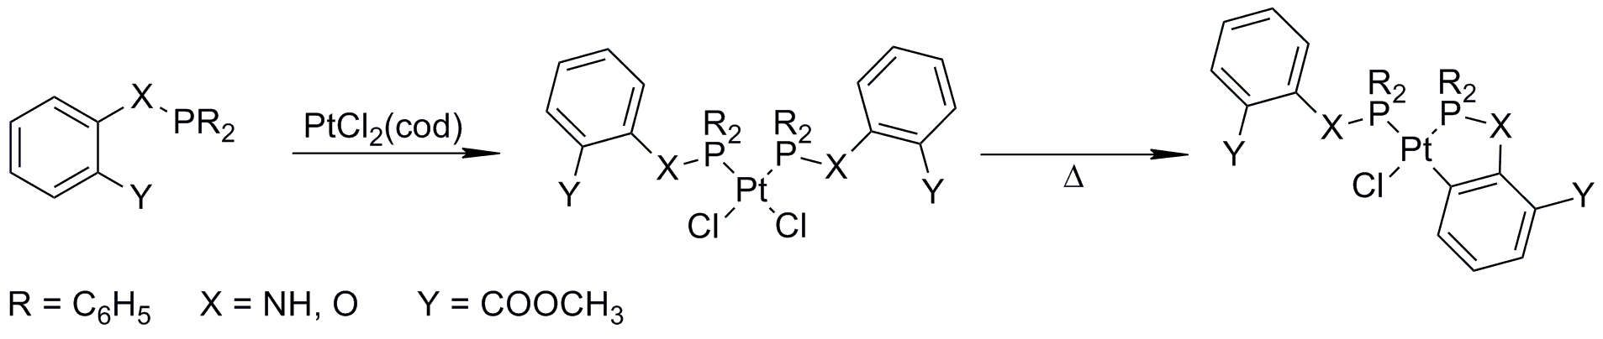

1 M. Beller, H. Fischer, W. A. Herrmann, K. Öfele, C. Brossmer, *Angew. Chemie Int. Ed. English* **1995**, *34*, 1848.

2 M. Albrecht, *Chem. Rev.* **2010**, *110*, 576.