Name and UČO:

1. Briefly describe rules for good fermentation practice and bioreactor operation. What are the critical factors in industrial bioprocesses?
2. Analyze data from batch fermentation in following figure.

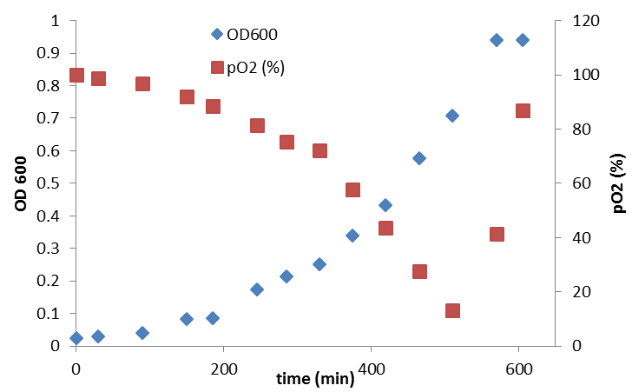

1. Open dataset named ferm_Bi7430c.xlsx and calculate the growth rate of the bacterial culture and Time of metabolic response (tMR)
2. What characterizes the culture in lag phase?
3. How can you influence the length of the lag phase?
4. In the fermentation above, the cascade was not applied. How can the actual oxygen tension be helpful for bioreactor operation and culture phase analysis?
5. In some cases, the growth curve of the culture looks like this:

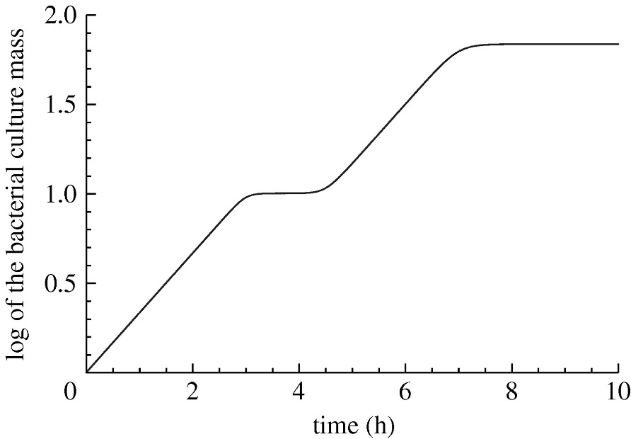

1. How would you interpret such growth curve?
2. When preparing the bioreactor for fermentation, polarization and calibration of the oxygen probe is important. After that, it is always good to calculate kLa (oxygen mass transfer coefficient). Commonly used method is the simple dynamic method, in which medium is first saturated with nitrogen and resaturated with air after.

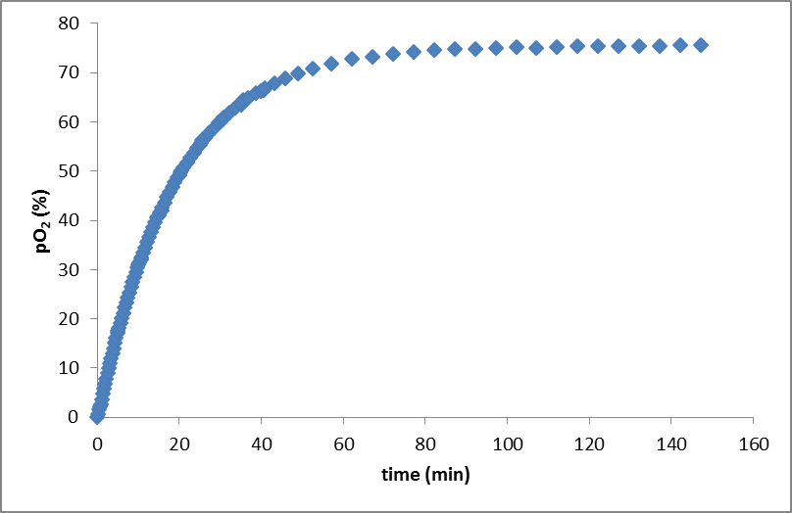

1. Open the datafile kLa_data_Bi7430c.xlsx and calculate the kLa value for this particular fermentation.
2. What factors can influence the oxygen transfer?
3. How can you prevent oxygen limitation in the bioreactor?