**Introduction** <https://www.youtube.com/watch?v=o52UIdTVJy8> 2.04 - 4.03

**Task 1 Writing a summary from key words**

* Work with a partner. You will get a text to read.
* First, select the key words in the text.
* Then agree on your list of key words with your partner.
* Swap your final list with another pair of students.
* Use the list of words that you have got now to reconstruct a written summary.

**Task 2 Differentiating fact from opinion**

**Categorize the statements according to whether they express a fact or an opinion.**

1. a) When Italy’s first McDonald’s franchise opened at the heart of Rome in 1986, the opposition [came from all angles](http://www.nytimes.com/1986/05/05/style/romans-protest-mcdonald-s.html).

b) It was Americanization of Italy; it ruined the historic centre and its odour was unbearable.

2. a) Carlo Petrini is a revolutionary who changed the way we think about eating.

b) He joined representatives of 15 countries in Paris for the signing of the [Slow Food Manifesto](http://www.slowfood.com/about_us/eng/manifesto.lasso) in 1989.

3. a) Cities contain urban public spaces.

b) The design of public spaces has a significant impact on people’s mood and behaviour.

4. a) Community development is the main factor in determining the welfare of the population in general.

b) The social welfare of any population is linked to many factors, such as community development.

**Task 3 Read the text below which is a beginning of a journal article. Find these parts in the text:**

Adapted from E. de Chazal, Oxford EAP B2, Chapter 8

* General introduction to the topic
* Citation of other researchers in the field Which of them are based on the author’s opinion?
* Rationale for writing the text

**Art spaces, public space, and the link to community development**

An ongoing concern in a wide range of urban-related fields is the increasing commercialization and privatization of public space. Many scholars cite the rise of shopping malls and other ‘invented streets and reinvented places’ (Banerjee, 2001) as supplanting traditional public space that once provided site for civic participation and democratic debate (Habermas, 1989) or the anonymity, diversity, openness, and spontaneity of the street (Jacobs, 1961). Others argue that public life in fact occurs in bars, cafes, beauty salons, and other ‘third places’ that exist outside home and work life (Oldenburg, 1989). Further, despite the rise of pseudo-public spaces, people adapt and appropriate the street, sidewalk, and other unclaimed spaces in many neighbourhood and commercial areas (Chase, Crawford and Kaliski, 1999; Franck and Stevens, 2007). These alternative or quasi-public spaces represent sources of local uniqueness that may help to build community interaction and attract neighbourhood investment in the face of globalization’s tendency toward homogenization and privatization (Carr and Servon, 2009). As such, they represent important yet often overlooked resources in the community development process.

SOURCE: Grodach, C. (2010). Art spaces, public space, and the link to community development. *Community Development Journal,* 45(4)

**Task 4 Authors’ Stance and Perspective**

**A) Are the following statements true or false?**

**Give reasons and correct the false statements by replacing words or phrases.**

**1.** The author claims that public spaces are becoming used for commercial and private purposes and people involved in urban affairs continue to be concerned.

**2.** According toBanerjee (2001), the increasing number of offices are to blame for the increasing commercialization of public space.

**3.** Oldenburg (1989) looks at the concept of public life from a social perspective.

**4.** The public don’t succeed in making use of public spaces for their own use once they are commercialized. (Chase, Crawford and Kaliski, 1999; Franck and Stevens, 2007)

**5.** According to the author, the potential of certain public spaces for developing communities is given considerable attention.

**B) Identify the perspective in the text which relates to each cited author below. There may be more than one answer. Use the given words.**

*physical political democratic commercial developmental civic*

1. (Banerjee, 2001)
2. (Habermas, 1989)
3. (Jacobs, 1961)
4. (Chase, Crawford and Kaliski, 1999; Franck and Stevens, 2007)
5. (Carr and Servon, 2009)

**Task 5 In-text references: Author–date system**

* What are the reasons for citing other authors?
* What kind of citation system did you use?

**Study these examples of in-text referencing and discuss the questions below:**

1. … as supplanting traditional public space that once provided site for civic participation and democratic debate (Habermas, 1989)
2. … people adapt and appropriate the street, sidewalk, and other unclaimed spaces in many neighbourhood and commercial areas (Chase, Crawford and Kaliski, 1999; Franck and Stevens, 2007)
3. Oldenburg (1989) argues that public life in fact occurs in bars, cafes, beauty salons, and other ‘third places’ that exist outside home and work life.

**Which one is an in-text reference to:** multiple authors

a single author

author placed first, emphasizing the author rather than the idea**?**

**Find the components in the in-text reference system:** bracket

surname

comma remember where they are placed

semicolon

date

**Task 6 Using different perspectives**

<http://thecityfix.com/blog/cities-learn-porto-alegre-inclusive-planning-citizen-participation-luisa-zottis/>

**Porto Alegre** (*Joyful Harbor*) is the capital and largest city of the [Brazilian](https://en.wikipedia.org/wiki/Brazil) state of [Rio Grande do Sul](https://en.wikipedia.org/wiki/Rio_Grande_do_Sul).

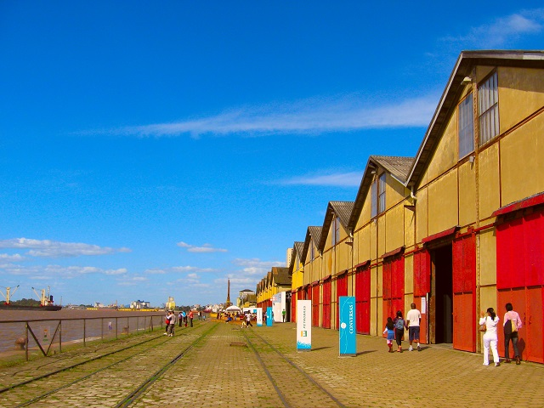

Porto Alegre is a city full of life and history, and its famous port contributes to the local culture. However, this important piece of public space has been closed since redevelopment began in 2013.

The city chose a proposal that integrates the dock area with the river. But there have been two controversies surround the selected proposal. The first is that the population was left out of the planning process. The second is that the proposal included plans to construct two 14-20 floor office towers near the road to city hall.

The competing proposal by Cais Mauá de Todos, the citizen-driven movement, has widespread support from technical experts—like architects, sociologists, historians, lawyers—as well as the general public.

**Compare the two designs.**

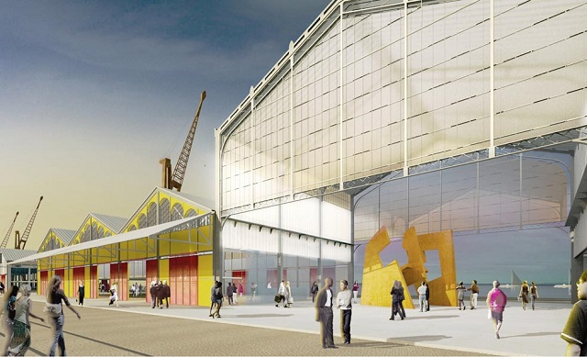 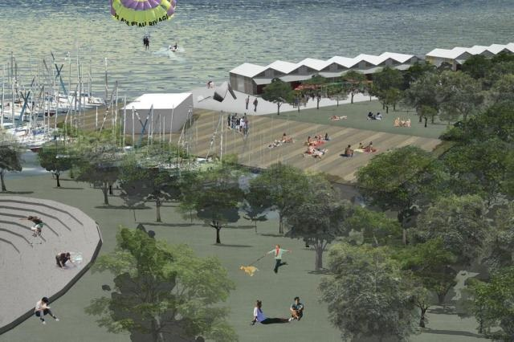

* If you were a Brazilian, born and living in Porto Alegre, which proposal would you support?

**Describe a public space that you are familiar with (a square or open area). Suggest some changes to make it more citizen-friendly. Use the following stages to help you.**

1. State your opinion of the value of the public space to the local community. (attractive / useful / boring/…)
2. Examine the space from different perspectives, such as social, economic, communal, environmental.
3. Propose how you think the space could be used more or improved from different perspectives.
4. Use simple visuals (sketches) to indicate the scale and type of changes that you propose.
5. Describe the impact that the propose changes might have on people’s lives.
6. Give evidence and examples for why you believe that the proposed changes might have such an impact.