**Task 1 Comparing different transport systems**

Adapted from D. Waugh: Geography, An Integrated Approach, 2002, p. 605

1. **Find the equivalents of the words below in your language**.

shelter –

negotiate –

gradient –

haulage-

navigable –

detour -

reclamation –

lock –

freight –

economical –

bulk –

slurry –

leakage –

cruise –

discharge -

1. **You will get 36 cards. Sort them out into six groups under the following topics.**
2. WEATHER PROBLEMS
3. RELIEF FACTORS
4. SPEED
5. PASSENGERS / GOODS
6. CONGESTION
7. ENVIRONMENT
8. **Now put the cards into a square 6 by 6 where in lines you have the topics (from ex.1b) and in columns there will be different transport systems. Name the systems.**
9. **Choose two transport systems and compare them mentioning advantages and disadvantages.**

**Use these comparing / contrasting language structures (try using all of them):**

*similar in … differ in that …*

*resemble … in terms of / with respect to… differ from … fundamentally*

*several features in common major difference between … in …*

*are alike in that … on the other hand*

Possible connectors between sentences: *additionally, moreover, although, despite, as well, …*

**Task 2 Hong Kong’s airports: referring to visual information using prepositions**

Source E. deChazal, L. Rogers: Oxford EAP B1+, OUP, 2013, p107

* Brainstorm in pairs what you know about Hong Kong.
* Find two Hong Kong’s airports on the map.
* Which one do you think is the old airport and which is the new one?
* What could have been the reasons for the construction of a new airport, in your opinion?

**The pictures are shown in a presentation. Complete the prepositions in the descriptive sentences referring to location or direction.**

Use *in, on, off, to*

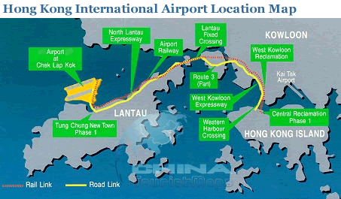

<http://www.chinatouristmaps.com/travel/hong-kong/airport/location-map.html>

… the right-hand side, you can see the old airport, Kai Tak - it’s situated …. the north-east of the city.

The island known as Chek Lap Kok is here, … the left of the slide, … the north coast of Lantau.

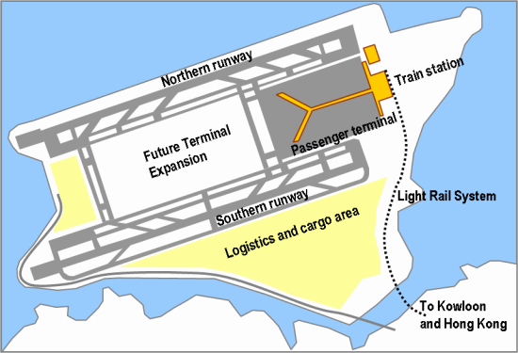

Near the top of the slide is the passenger terminal, … the east side, there.

The cargo area is … the bottom half of the slide, … the south.

The other area … the centre of the slide is currently not developed.

**Listen to the speaker (extract 1) and tick the expressions you hear:**

A in the top right hand corner

B on the left-hand side of the slide

C at the top of the slide

D on the opposite side

E on the left of the slide

F on the north-west side

G to the south

H situated to the west of the city

I in the centre of the slide

**Use the expressions from above to complete the text.**

As you can see **1**_________ , in Hong Kong International Airport, the northern runway is situated **2**_________ of the island of Chek Lap Kok. **3**_________ is the southern runway, while **4**_________ of that is the logistic and cargo area. The train station is located **5**_________ of the island, and if you look here **6**_________ , there is a large area designated for expansion.

* **What makes the airport special, in your opinion?**
* **Would you be interested in travelling to the region and visiting the airport?**

**Task 3 San Francisco airport** (de Chazal, Edward, Mc Carter, Sam: Oxford EAP B2, OUP, 2012, p. 36)

* **How difficult is it for you to find your way in built-up spaces? What helps you?**
* **Work in pairs and describe the links between the following places in the system:**

1. Domestic Terminal 1 and Rental car centre
2. Garage A and West Field Road station
3. San Francisco (city) and International Terminal G

* **What other types of transport systems is it linked to?**

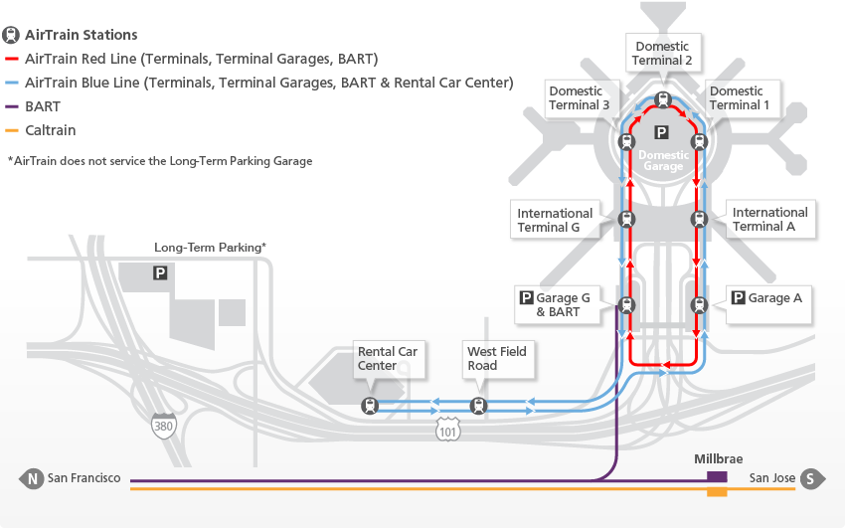

**You will watch an extract of a student presentation describing part of a transport system.**

**Read the passage and suggest words or phrases for the gaps.**

I’m going to give my presentation today on part of the transport system in the United States, specifically San Francisco airport, which is (1)______________ of an integrated transport hub with many accessible services. So an integrated transport hub (2)_____________ a centre where different types of transport meet.

If we look at the diagram on this first slide, we can see that the airport has a simple (3)__________. Starting at the top of the diagram here, we can see the (4)_______________ of the three domestic terminals, top right, at this end of the airport. Now in the middle are the international terminals, G and A. And at the bottom of the slide, you can see there are two car parks, G and A, with G being (5)_______________ to the Bay Area Rapid Transport system. And this is (6)_______________ BART.

**Identify parts of sentences which are used to draw attention to specific information in the scheme.**

**Recognizing noun phrases. In academic explanations, noun phrases are very common. Which of the sentences below contains a noun phrase?**

1. *The passengers are transported around the airport easily.*
2. *The transportation of passengers around the airport is easy.*
3. *The passengers are easily transported around the airport.*

**Watch extract 2 and note down two more examples of noun phrases.**

**Task 4 Asking questions about the presentation**

**Decide if the following questions are asking for more information (I), asking for clarification (C), or asking for repetition (R).**

1. You mentioned (that) … Can you go over (it) again?
2. When you said…, what exactly did you mean?
3. Can you tell us a little more about…?
4. You said that…, but can you repeat what you said about…?
5. Can you give a few more details about…?
6. Is there anything else we can learn from this?
7. Can you recap on the difference between…?
8. Are you saying that the …?

**Watch extract 3 and tick the phrases above that students use.**

**Task 5 Presenting a diagram**

**Select a system from your area of study, or one that you know well. Prepare a short speech (2-min max) about the visual representation of the system.**

**Work in pairs. The listener will try to record any noun phrases. S/he asks a question.**

**Homework**

Grammar: Facts & Figures (Oxford Grammar for EAP) p. 56 – 57