**1. Warm-up**

**Draw a mind map about the development in the area of economic activities.**

**Task 2 Technological progress** (Knox, Marston: Human Geography, 2007, p.55)

Beginning in the late 18th century, a series of technological innovations (in power, transportation and manufacturing) resulted in crucial changes in economic development. The innovations created new demands for natural resources, labour forces and markets. Each technology system dominated economic activity for several decades until improved technologies evolved.

**Here are 5 time periods. Which innovations and sources of power are relevant for each of them?**

1790-1840 1840-1890 1890-1950 1950-1990 1990-onward

**Do a team quiz – matching technological advances and periods of time**

# Task 3 Changes in industrial location patterns (Adapted from Kelly, Geography – Macmillan, 2013)

**Study this brief background information and complete the text with the missing phrases.**

In the past industry was **1**………………….. . This was because water wheels were **2**…………..…. . Then it changed to coalfield sites as coal was needed for the generation of steam. Nowadays, power **3**……………….. . It can come by electricity cables carried on steel pylons. Because of this industries are no longer **4**…………………. . New industries are located around towns and cities rather than **5**…………………… or being clustered around coalfields. Modern transport facilities are available in these places. These new industries are called footloose, and this change has made **6**…………………….. than before. It **7**………………….. and to areas of high emigration.

**A** the source of power less important

**B** rotated by fast-moving streams

**C** forming a linear pattern along rivers

**D**  tied to waterside locations

**E** has brought industry to rural towns

**F** tied to the old, traditional locations

**G** can be brought to sites that industry prefers

**Task 4 The role of the internet in economic activities** (Source: de Chazal, Oxford EAP, B1+, chapter 7)

* How does the internet support economic activities?
* What is a cloud?
* How has the cloud computing changed the way companies work?

**A) Listen to the introduction to a lecture. Match the following parts of phrases to make three sentences.** 7.1

Cloud computing internet became the size of a cloud

Growing number of users invitation for collaborators

Berners-Lee’s article about the web biggest creator of wealth in history

**B) Watch the first part of the lecture and find out what cloud computing is. Complete the quotations.** 7.3

William Gibson has argued that …

Larry Ellison has argued that…

**This is the lecturer’s statement.** *‘However, there’s still some debate about what cloud computing is, exactly’.*

**Why does she use the two quotations?**

**C) Before watching next part, read the phrases below. Which of them are used to give an example? Which give an explanation?**

*For example Let me clarify that If we take X as an example In other words*

*Let me explain what I mean by One scenario is Let’s look at a couple of examples*

*What I mean by this is For instance To put it another way such as*

**Watch the part about the advantages and disadvantages and their illustrations by examples and explanations. Note down dis/advantages and an example or explanation for each of them.**

**Advantages:**

**1.**

**2.**

**Disadvantages:**

**1.**

**2.**

**3.**

**Task 5 Make groups of three/four students and discuss your opinions. One of you leads the discussion.**

**If you had your own business, would you use cloud computing?**

**Do you see more pros or cons of cloud computing? Why?**

**Task 6 A case study:** **Facebook, Inc.** Adapted from <http://www.i-study.co.uk/igcsegeography/industry.html>

A) Look at the map of the US. You will get information about Facebook company. Where do you think their main offices and their data centres are?

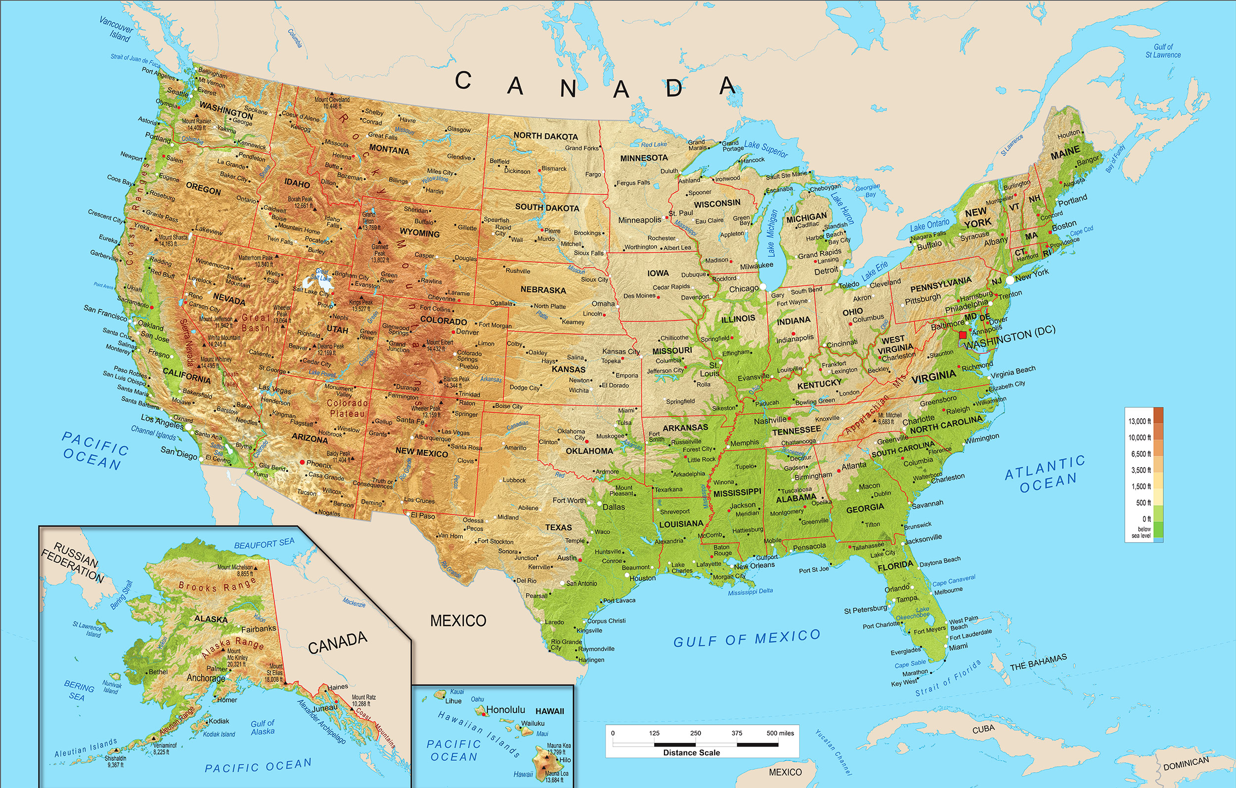

**B) Watch the company presentation and answer the questions:**

<https://www.youtube.com/watch?v=_r97qdyQtIk> 0.50 – 3.20

1. Where is home of Facebook?
2. How many engineers handle the users’ personal data?
3. What is the problem with so many users?
4. Where is all the data stored?
5. What is the area occupied by the Oregon centre?

What do you think the advantages of Oregon location are?

* *Watch another part to find out* 4.26 –5.46

Where do you think they should build new centres, not having enough space now?

**Task 7 Interview with an Economic Geography consultant**

Work in pairs and play two different roles. You will be given a text to read.

* One of you is a science journalist.

Read the text and prepare a few questions. One of them must include a conditional (If…). Ask about advantages and disadvantages.

* The other one is an expert on business locations currently working for Facebook, Inc.

Read the text and prepare some interesting information about advantages and disadvantages, with examples/explanations.

The journalist starts: greets listeners, introduces the topic and the expert, and continues - move from general to specific questions, e.g. *How are the patterns of industrial or business locations changing?*

Facebook have their main offices in California, the key inputs being highly skilled labour. California is home to many other high-tech firms as well as Stanford University which are both sources of highly skilled workers. The environment and urban areas are also desirable to live.

Their data centers are located far away though.

Just south of the Arctic Circle, in the Swedish town of Luleå, Facebook in June opened its latest mega-sized data center, a giant building that comprises thousands of rectangular metal panels and looks like a wayward spaceship. By all public measures, it’s the most energy-efficient computing facility ever built, a colossus that helps Facebook process 350 million photographs, 4.5 billion “likes,” and 10 billion messages a day. While an average data center needs 3 watts of energy for power and cooling to produce 1 watt for computing, the Luleå facility runs nearly three times cleaner, at a ratio of 1.04 to 1.

The location has a lot to do with the system’s efficiency. Sweden has a vast supply of cheap, reliable power produced by its network of hydroelectric dams. Just as important, Facebook has engineered its data center to turn the frigid Swedish climate to its advantage. Instead of relying on enormous air-conditioning units and power systems to cool its tens of thousands of computers, Facebook allows the outside air to enter the building and wash over its servers, after the building’s filters clean it and misters adjust its humidity. Unlike a conventional, warehouse-style server farm, the whole structure functions as one big device.

The next one will go online in Iowa, where cheap wind power is plentiful.

Adapted from [source](http://www.bloomberg.com/bw/articles/2013-10-03/facebooks-new-data-center-in-sweden-puts-the-heat-on-hardware-makers) http://www.bloomberg.com/news/articles/2013-10-04/facebooks-new-data-center-in-sweden-puts-the-heat-on-hardware-makers