Synthesis and NMR study of paramagnetic pyridine-based NAMI-A-type ruthenium complexes
Martin Sojka ^{a,b *}, Jan Novotný ^{b}, Radek Marek ^{a,b}, Marek Nečas ^{a,b}

ª Department of Chemistry, Masaryk University, Kotlářská 2, 61137 Brno, and ^{b} CEITEC – Central European Institute of Technology, Kamenice 5, 62500 Brno, Czech Republic
* martin.sojka@mail.muni.cz
We are interested in the synthesis of new Ru(III)-based complexes with promising anticancer activity. The paramagnetic nature of Ru(III) compounds usually makes routine 2D NMR experiments inapplicable and complicates the unambiguous interpretation of 1D NMR spectra. Thus, the assignment of experimentally detected ¹H and ¹³C NMR resonances is performed with close support of advanced quantum-chemical calculations.
Hereby we report a study of NAMI-A-type Ru(III) complexes with selected pyridine derivatives. For our NMR experiments we synthesized a series of Ru(III) complexes with pyridine ligands (Figure 1)¹ and their Rh(III) analogs. To determine the temperature-independent part of the NMR chemical shift (orbital contribution) we performed temperature-dependent NMR experiments and characterized the closed-shell Rh analogs. The experimental values will be compared with theoretical data obtained from DFT calculations employing SO-ZORA approximation and implicit model of solvent.
Figure 1 General synthetic approach for synthesis of Ru(III) NAMI-A-type complexes
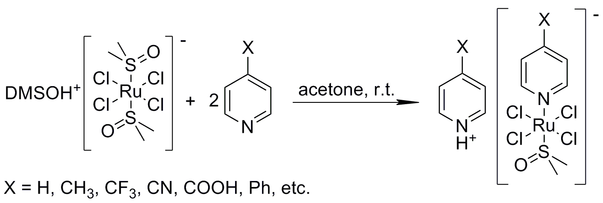

This work was supported by the Czech Science Foundation (15-09381S).

1 M. I. Webb, R. A. Chard, Y. M. Al-Jobory, M. R. Jones, E. W. Y. Wong, C. Walsby, Inorg. Chem. 2012, 51, 954.

