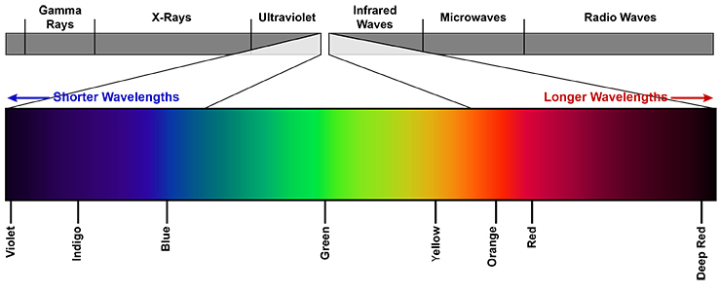**ANALYTICAL CYTOMETRY - PRACTICE 2018/2019**

16. – 18. 1. 2019, IBP



**Teachers:** Mgr. Stanislav Drápela, Mgr. Radek Fedr, Mgr. Karel Souček PhD.

**Group A**

[**Arcidiacono, Orazio Angelo**](https://is.muni.cz/auth/ucitel/student_info?fakulta=1431;obdobi=7304;predmet=1114935;infouco=478852), učo 478852 [MBBI], 1 kr.,

[**Fagherazzi, Paolo**](https://is.muni.cz/auth/ucitel/student_info?fakulta=1431;obdobi=7304;predmet=1114935;infouco=490520), učo 490520 [FYZZ], 1 kr.,

**[Kocandová, Veronika](https://is.muni.cz/auth/ucitel/student_info?fakulta=1431;obdobi=7304;predmet=1114935;infouco=395010)**, učo 395010 [SPBI], 1 kr.,

[**Krchová, Michaela**](https://is.muni.cz/auth/ucitel/student_info?fakulta=1431;obdobi=7304;predmet=1114935;infouco=423226), učo 423226 [SPBI], 1 kr.,

[**Kvokačková, Barbora**](https://is.muni.cz/auth/ucitel/student_info?fakulta=1431;obdobi=7304;predmet=1114935;infouco=487629), učo 487629 [FYZZ], 1 kr.,

**Group B**

[**Nevědělová, Kateřina**](https://is.muni.cz/auth/ucitel/student_info?fakulta=1431;obdobi=7304;predmet=1114935;infouco=451592), učo 451592 [SPBI], 1 kr.,

**[Pícková, Markéta](https://is.muni.cz/auth/ucitel/student_info?fakulta=1431;obdobi=7304;predmet=1114935;infouco=411211)**, učo 411211 [FYZZ], 1 kr.,

**[Vacek, Ondřej](https://is.muni.cz/auth/ucitel/student_info?fakulta=1431;obdobi=7304;predmet=1114935;infouco=423268)**, učo 423268 [FYZZ], 1 kr.,

[**Váňa, Petr**](https://is.muni.cz/auth/ucitel/student_info?fakulta=1431;obdobi=7304;predmet=1114935;infouco=108420), učo 108420 [SPBI], 1 kr.,

|  |  |  |
| --- | --- | --- |
| **Day 1 (16.1.)** | **A)** | **B)** |
| 9 - 14 hod | Intro  Hela 8 Fucci cells – analysis using flow cytometry (Verse) and CM  MLN-4924 treatment |  |
| 14- 18 hod |  | Úvod  Hela 8 Fucci cells – analysis using flow cytometry (Verse) and CM  MLN-4924 treatment |

|  |  |  |
| --- | --- | --- |
| **Day 2 (17.1.)** | **A)** | **B)** |
| 9 - 12 | Harvest and fixation of cells for proliferation and cell cycle analysis.  Analysis using flow cytometry. |  |
| 12-15 | Hela 8 Fucci – analysis on CM  Harvest and fixation of cells for proliferation and cell cycle analysis.  Analysis using flow cytometry. |
| 14-18 |  |

|  |  |  |
| --- | --- | --- |
| **Day (18.1.)** | **A)** | **B)** |
| 9 - 13.30 | Harvest of cells, immunophenotyping, analysis using flow cytometry |  |
| 13. 30 - 18 |  | Harvest of cells, immunophenotyping, analysis using flow cytometry |

**Protokol 1**

Fucci 8 cells – harvest, measurement, analysis of cell cycle using intracellular fluorescent proteins (both flow and CM)

**Protokol 2**

Simultaneous analysis of proliferation and cell cycle on DU145 cells after the treatment by inhibitor of neddylation.

**Protokol 3**

Immunophenotyping – staining of surface molecules CD24/CD44 and viability on DU145 cells.



**Protokol 1**

**Model HeLa 8 Fucci cells – cell cycle analysis using fluorescent proteins**



**Aims**

* to demostrate how to analyse cell cycle w/o any fixation and staining steps on living cells using flow cytometry and confocal microscopy
* analysis will be done on FACSVerse as one representative sample
* evaluation will be performed in FlowJo software

**Theory**

**Buněčná linie HeLa 8 Fucci**

* HeLa cells – human permanent cell line derived from cervical carcinoma
* one of the oldest and most common cell model used in cancer research
* Fucci probe (fluorescent ubiquitination-based cell cycle indicator) – enables visualisation of cell cycle progression in living cells
* cells in G1 phase emits red light, cells in S/G2/M green light
* find more info in PDF attached in your materials in IS

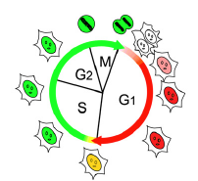

 (Sakaue-Sawano et al., 2008; materials)

**1) Flow cytometry analysis of cell cycle**

**Material**

- **HeLa 8 Fucci** cell line

- solution of **PBS+EDTA** – disturb cell-to-cell junctions

- **trypsin** – pancreatic enzyme

- non-**nesteril media with serum** – for trypsin inactivation

- **PBS** – for washing steps

**Process:**

**Cell harvest and sample preparation**

* soak up the media from the dish
* add 3mL of PBS+EDTA – 1-2 minutes than remove
* add 0,5 mL of Trypsin – let incubate in termostat (37oC) until the cells release from dish surface (cca 1-2 mins)
* add 2,5 mL of media with serum
* wash the dish with 1 mL PBS, add to the suspension into tube
* centrifuge 200g, 5 mins
* soak up supernatant
* resuspend pelet in v 1 mL PBS
* centrifuge 200g, 5 mins
* soak up supernatant
* resuspend pelet in 300 μl PBS and measure

**Results**

**Describe the proces of measurement and analysis of cell cycle in Hella 8 Fucci. Attach results (plots) acquired from FlowJo evalutation. 2) Confocal microscopy analysis**

**Process:**

**Day 1:** **Seeding of HeLa 8 Fucci cell for CM analysis.**

**Day 2: Treatment**

**MLN-4924** (stock 10 mM, working concentration 1 µM)

**TRAIL**  (100 ug/ml stock, 50 ng/ml working concentration)

**Mitomycin** (stock 1 mg/ml, working concentration 1 µg/ml)

**Add notes and descriptions to all drugs used - MLN-4924 (see protocol 2), TRAIL a Mitomycin (drug type, mechanism of action).**

**Count dilutions and volumes which will be used for the treatment.**

**Day 2-3: Analysis of cell cycle using confocal microscopy**

**Describe the analysis of cell cycle using CM. Describe the changes in cell cycle, observed after various treatments.**



**Protokol 2**

**Analysis of cell cycle, proliferation and cell viability on DU145 cells after the treatment by inhibitor of neddylation**



**Aims**

* to describe the effect of neddylation inhibitor (MLN-4924) on DU145 cells
* to use FACSVerse cytometr for sample analysis

**Theory**

**MLN-4924**

* ATP competitive inhibitor
* Phase I of clinical trials for lymphoma, myeloma, AML, ALL, melanoma and other non-hematological cancers
* creates stable aduct between NEDD8 and MLN-4924 which leads to the arres of neddylation pathway (figure **Soucy et al., 2010)**.
* proces of neddylation is necessary for the ubiquitine ligase Skp2SCF aktivity which play role in the regulation of various cell cycle processes
* one of the most important binding substrates are proteins regulating cell cycle (p27Kip1, p21cip1) or replication (Cdt1).

**Structure of MLN-4924 (Soucy et al., 2009)**

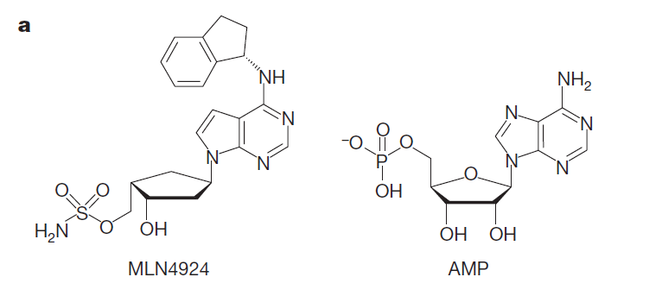

**Neddylation pathway arrest**

**(Soucy et al., 2010)**

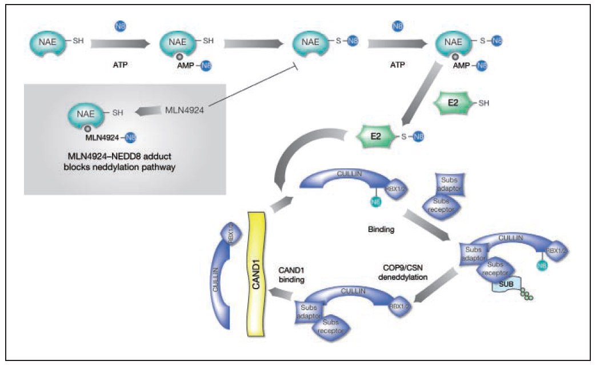

**Analysis of proliferation and cell cycle**

**Material**

* DU 145 cell line (untreated vs treatred)
* PBS+EDTA trypsin
* nonsterile media with serum
* nonsterile FACS tubes
* PBS + 1% BSA
* Live Dead Fixable stain kit Red
* Edu click-iT AF488 kit
* PO-PRO-1

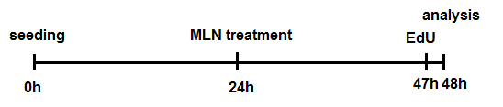**Process**

**1. Cell harvest and sample preparation**

* soak up the media from the dish
* add 3mL of PBS+EDTA – 1-2 minutes than remove
* add 0,5 mL of Trypsin – let incubate in termostat (37oC) until the cells release from dish surface (cca 1-2 mins)
* add 2,5 mL of media with serum
* wash the dish with 1 mL PBS, add to the suspension into tube
* centrifuge 200g, 5 mins
* soak up supernatant
* resuspend pelet in v 1 mL PBS
* centrifuge 200g, 5 mins
* soak up supernatant

**2. Viability stain**

* dilute viability marker in PBS (1:1000)
* add 100 µl/sample, incubate 15 mins, 4°C
* add 1 ml PBS + 1% BSA, centrifuge (200g, 5 min), soak up supernatant

**2. Fix**

* resuspend cells in 100 µl 4% PFA
* incubate 15 mins, RT
* add 1 ml PBS + 1% BSA, centrifuge (200g, 5 min), soak up supernatant

**2. Permeabilitation**

* resuspend cells in 100 µl 0,15% Tritonu X-100
* incubate 15 min, RT
* add 1 ml PBS + 1% BSA, centrifuge (200g, 5 min), soak up supernatant

**2. Click-iT reaction**

* divide saples into two tubes (ISO and SP)
* prepare click-iT reaction solution based on recipe bellow
* add 125uL of PBS + 1% BSA into ISO tubes; and 125uL of click-iT reaction solution into SP tubes
* incubate 30 mins, RT, dark
* than add 1 ml PBS + 1% BSA, centrifuge (200g, 5 min), soak up supernatant

|  |  |
| --- | --- |
|  | 1 reaction |
| PBS | 109,5 μl |
| CuSO4 | 2,5 μl |
| Fluorescent dye azide | 0,625 μl |
| Reaction buffer additive (dilluted) | 12,5 μl |
| Total reaction volume | 125 μl |

**2. Cell cycle staining**

* dilute PO-PRO-1 in PBS (1:10 000)
* add 500 µl/vzorek
* incubate 30 mins, RT, dark

**Results**

**Describe the process of measurement and analysis of results acquired using flow cytometry. Attach result plots from FlowJo evaluation. **

**Protokol 3**

**Analysis of DU145 cell phenotype**



**Aim**

* to analyse DU145 cell phenotype using two surface molecules CD24 and CD44 (primary Ab) conjugated with fluorescent probes on living cells

**Theory**

* DU-145 model is epithelial cell line derived from prostate cancer brain metastasis
* CD24 and CD44are characteristic markers of cancer stem cells (CSC) in prostate cancer
* CSC – cancer cell subpopulations responsible for progression of disease and metastasis
* CSC traits – self-renewal, increased expression of antiapoptotic molecules, expression of molecules responsible for multidrug resistance (ABC transporters) etc.

**CD44**

* surface molecule associated with proliferation, differantiation, migration and angiogenesis processes
* associated with worse prognosis in various types of malignancies
* ligands – osteopontin, fibronectin, collagen, hyaluronate
* in prostate cancer considered as a marker of cancer but also normal stem cells

**CD24**

* surface molecule
* marker of nondiferentiated hematopoetic cells
* play role in cell adhesion
* acts as receptor for P-selectin
* increased expression shown in breast, ovarium and prostate cancer **Material**
* DU-145 cells
* solution of PBS+EDTA
* trypsin
* nonsterile media with serum
* nonsterime FACS tubes
* PBS + 1% BSA
* antibodies – table bellow

**Count:**

**for 10 ml 1% BSA add ml 20 % BSA into ml PBS**

Antibodies:

|  |  |  |  |
| --- | --- | --- | --- |
| **antibody** | **fluorochrom** | **provider, cat. number** | **dilution** |
| **CD24** |  |  |  |
| **CD44** |  |  |  |
| **viabilita** |  |  |  |
| **IgG2a κ** |  |  |  |
| **IgG2b** |  |  |  |

**Samples:**

* 2 samples:

specific (SP)

isotype control (ISO)

**Process:**

**1. Sample preparation**

* soak up the media from the dish
* add 3mL of PBS+EDTA – 1-2 minutes than remove
* add 0,5 mL of Trypsin – let incubate in termostat (37oC) until the cells release from dish surface (cca 1-2 mins)
* add 2,5 mL of media with serum
* wash the dish with 1 mL PBS, add to the suspension into tube
* centrifuge 200g, 5 mins
* soak up supernatant
* add 1 ml PBS+1% BSA

- both sample divide into 2 tubes

* centrifuge 200g, 5 mins
* soak up supernatant

**2. CD24 a CD44 staining**

- add 100uL of antibodies or isotype controls diluted in PBS+1% BSA

**Count:**

**1. tube ISO – into 50 μl PBS+1% BSA add**

**μl IgG**

**μl IgG**

**2. tube SP – into 50 uL of PBS+ 1% BSA add**

**μl CD44**

**μl CD24**

* pippete the sample up and down twice

- incubate 20 mins in 4C

* add 1 ml PBS + 1% BSA
* centrifuge 200g; 5mins
* soak up supernatant

**3. viability staining**

* rozsuspend in 500 μl PBS
* add Propidium iodide (1:200)
* measure

**Results**

**Describe the process of measurement and analysis of results acquired using flow cytometry. Attach result plots from FlowJo evaluation.**