1. Look at the online poster advertising a conference, what key information can you receive from it?
2. Find on that poster phrases that refer to definitions below. First letters are given for you.
3. an early plan for the conference (some details may change later) – p p
4. look for further information – c b f u
5. money you must pay to attend the conference – r f
6. soon – i d c
7. the Internet must be used to send personal information for the conference – o r o
8. the last date that personal information can be sent to the conference organisers – a d
9. the most important presenters at the conference – k s
10. the organizers will only accept applications in the order they receive them –on f c f s b
11. to send a written summary of your research because you want to present a paper – s a
12. The diagram below shows how the adaptive immune system responds after vaccination with an attenuated (weakened) virus.
13. **In pairs, discuss what you think the diagram shows**

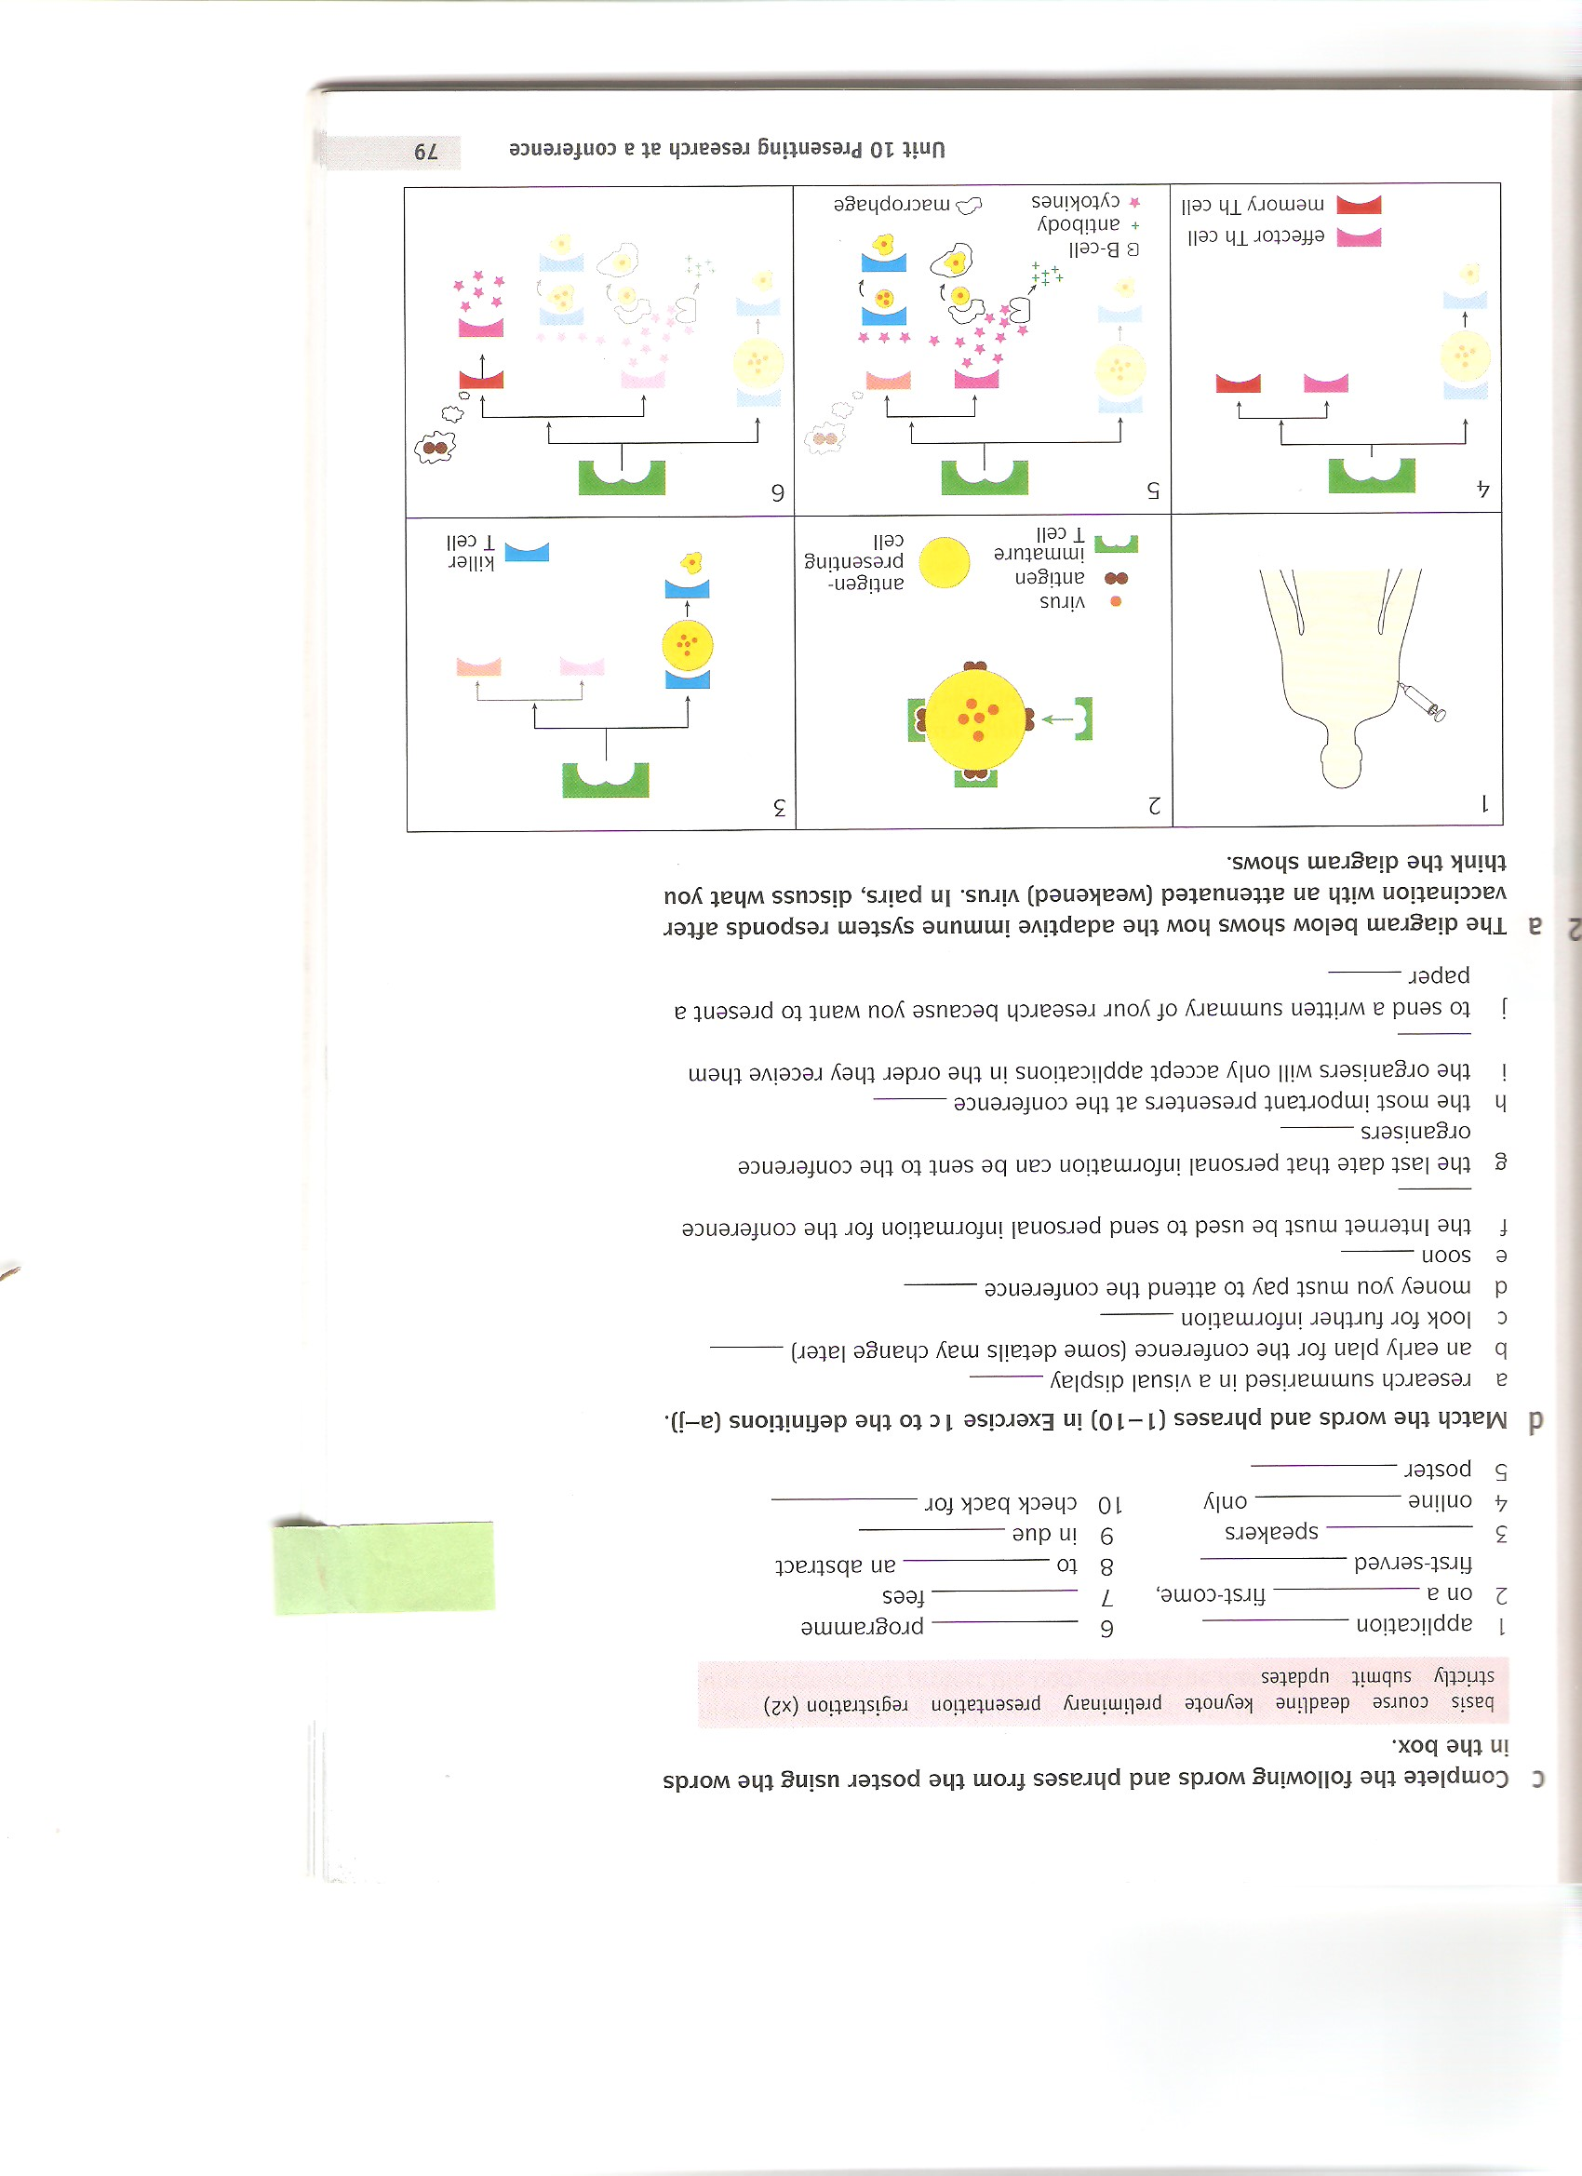

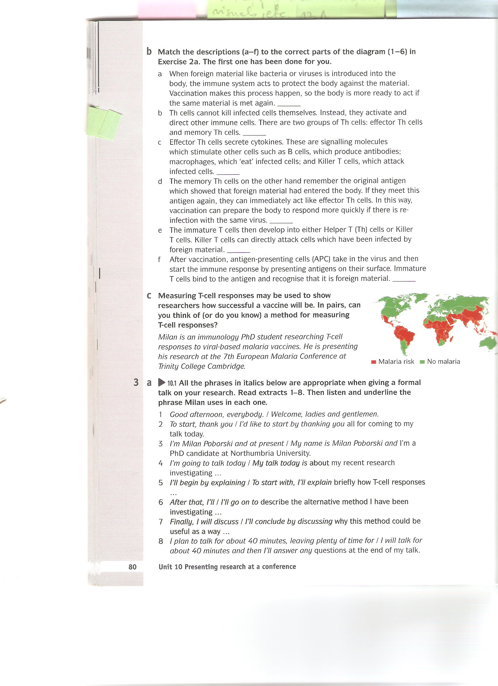

Milan is an immunology PhD student researching T-cell responses to viral-based malaria vaccines. He is presenting his research at the 7th European Malaria Conference at Trinity College Cambridge.

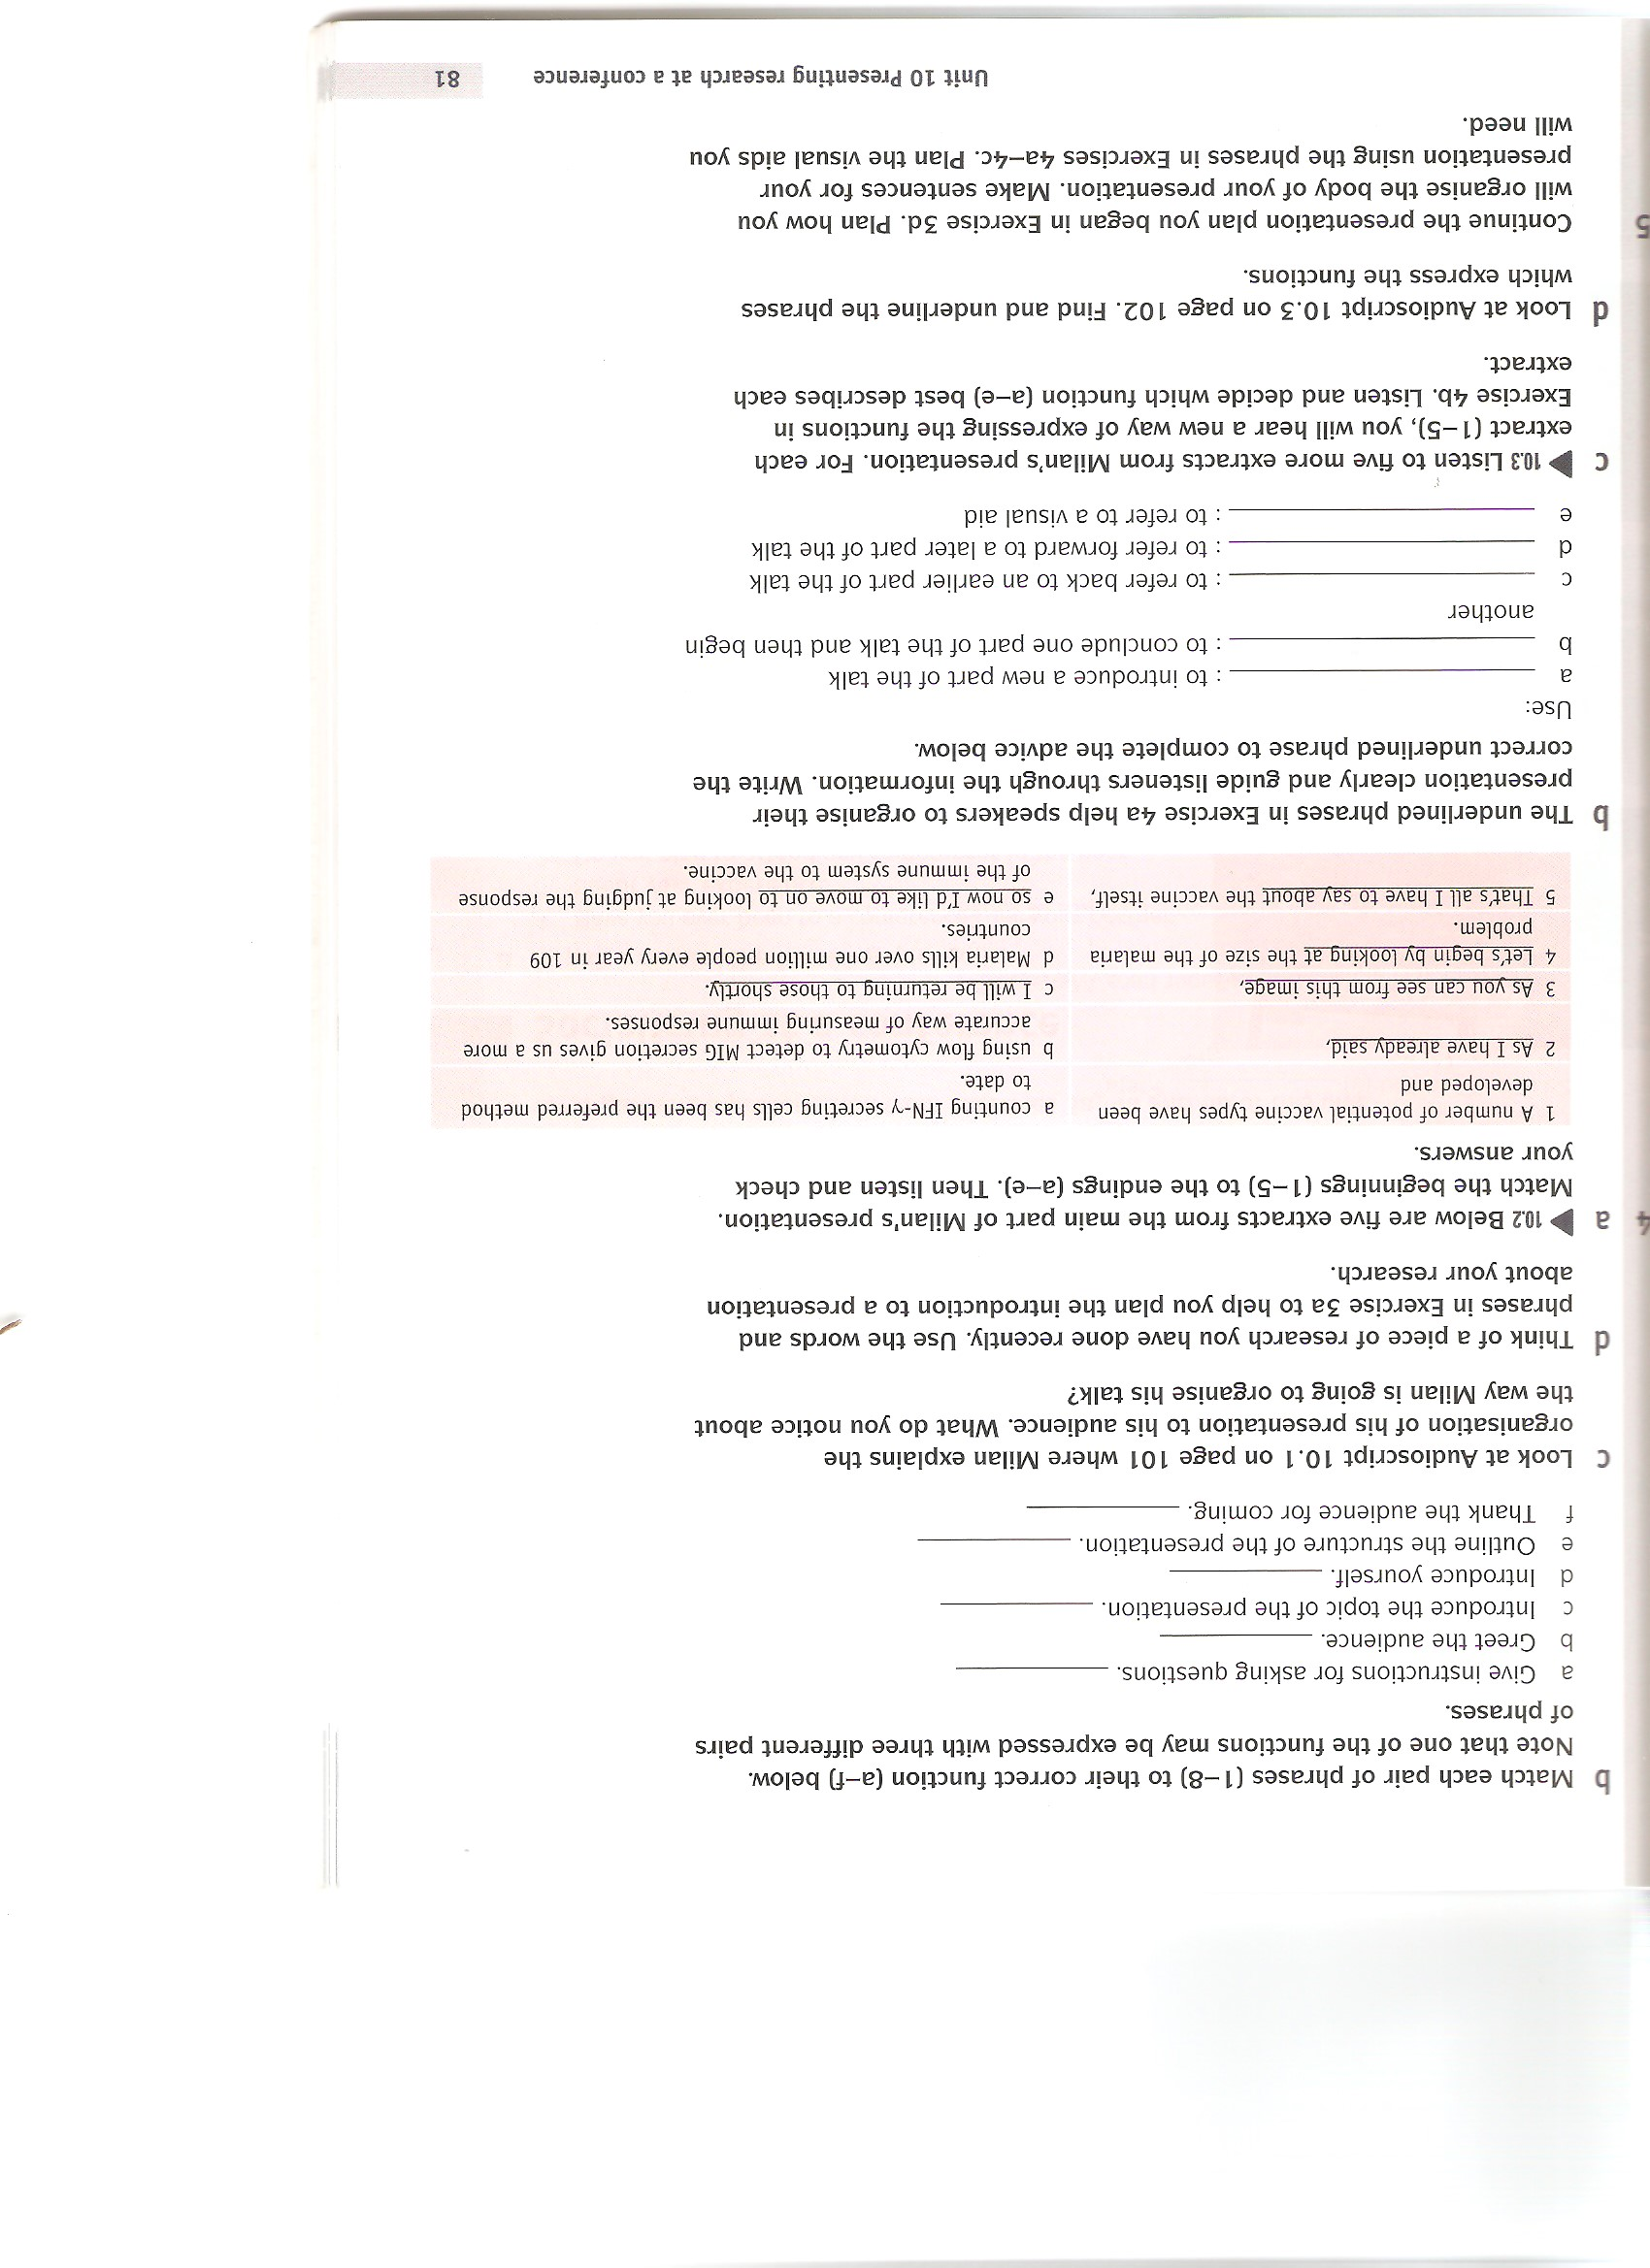

1. Summing up information from previous activities:
2. **what makes a good poster?**

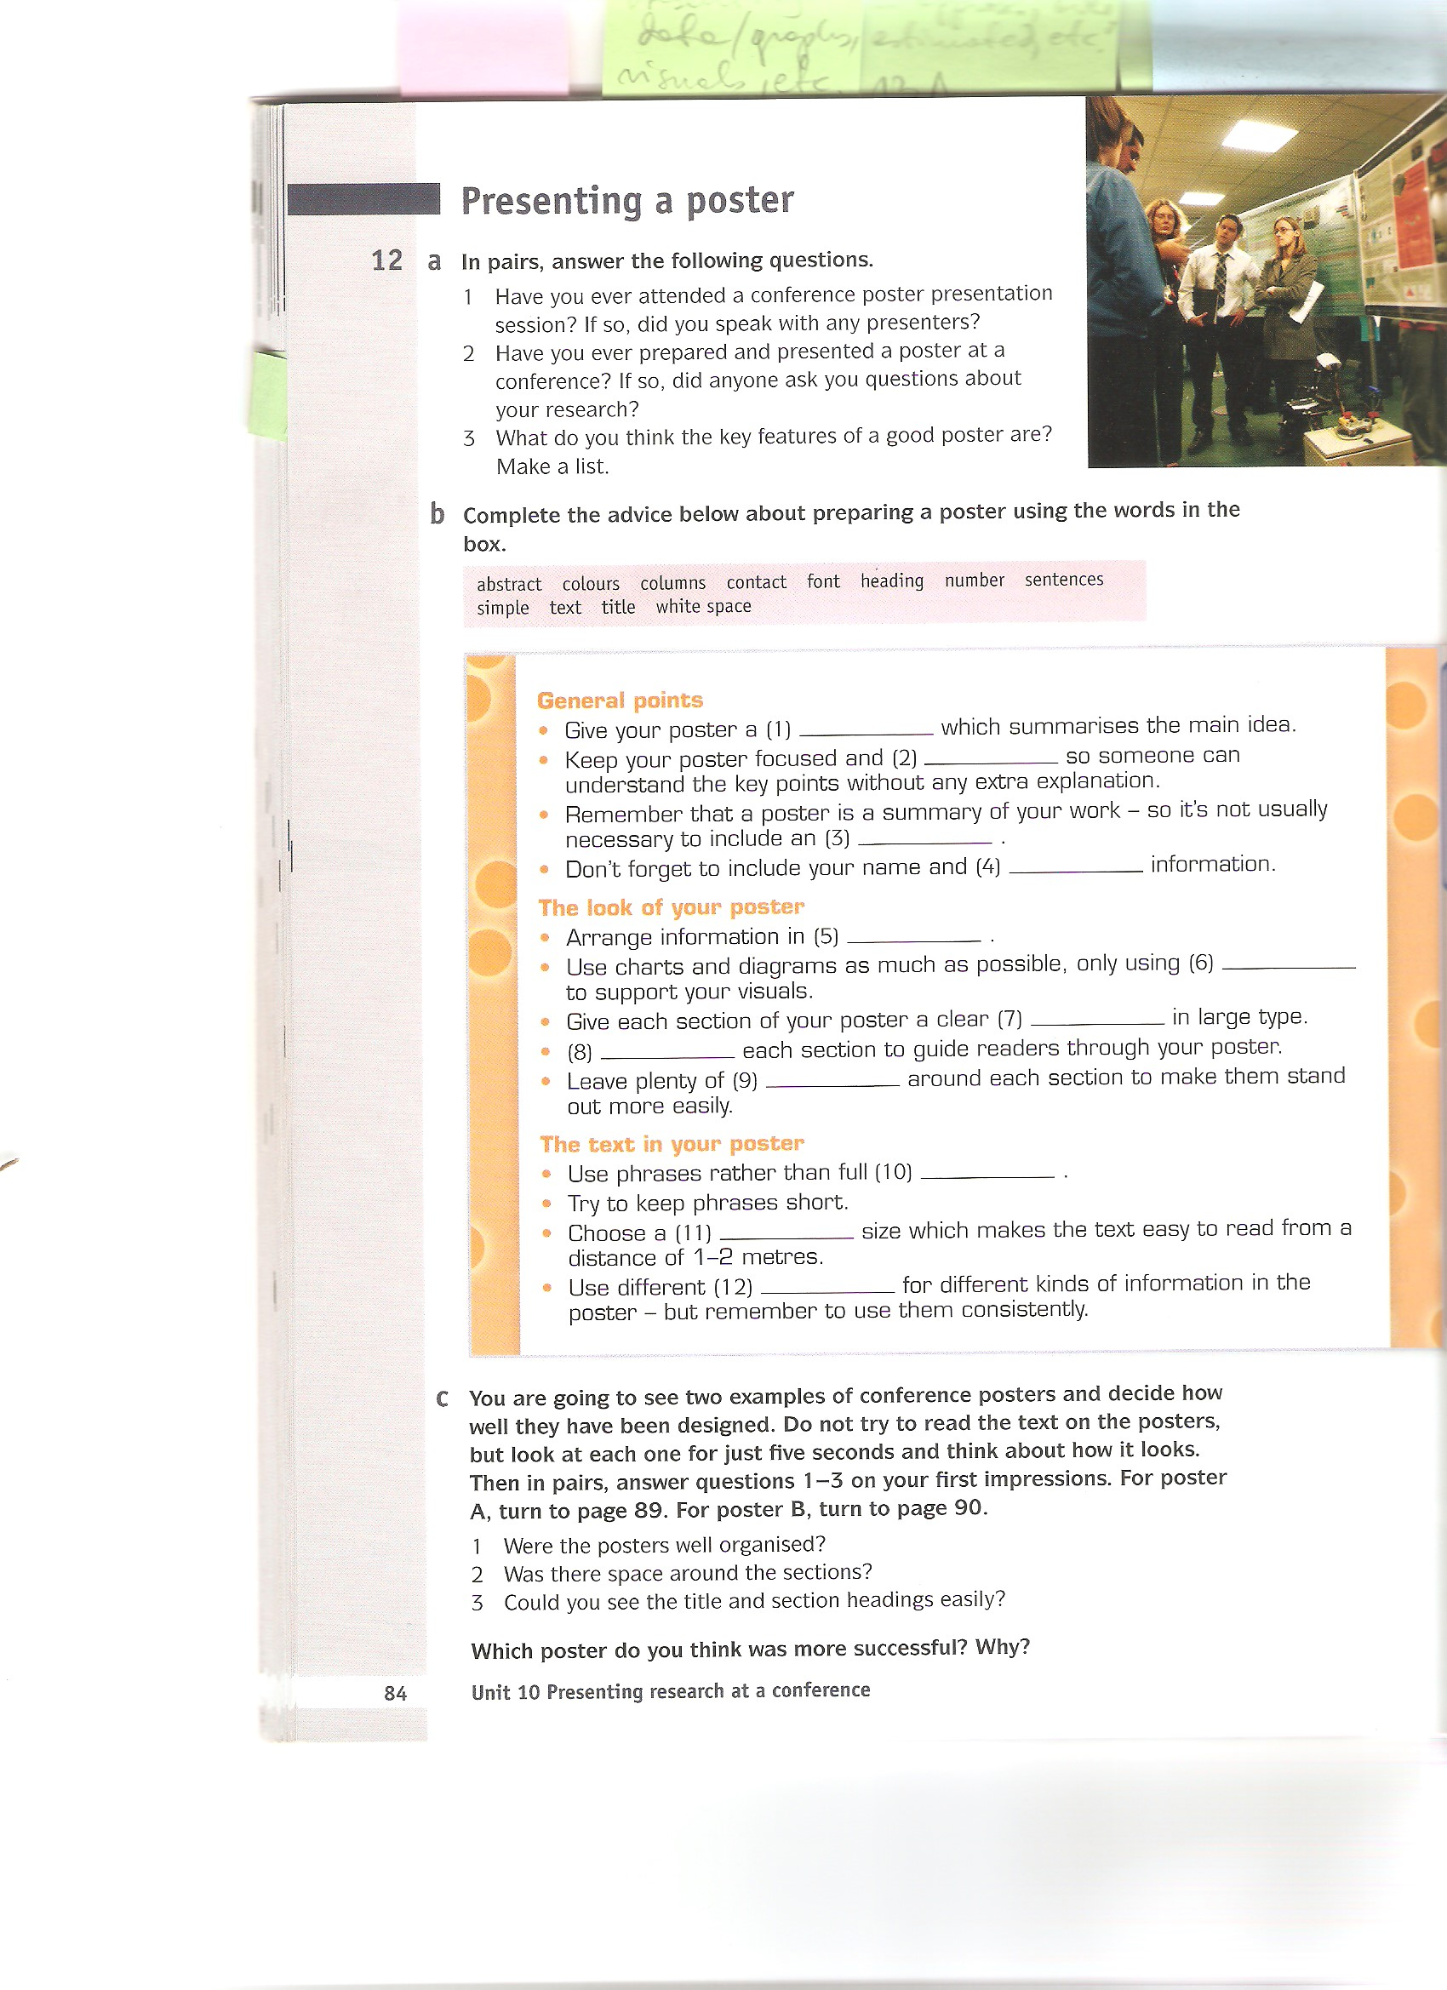

1. Imagine you will have to present a poster at a student conference. What topic will you choose? Look at the visuals below and decide which ones would be most useful for your topic.

[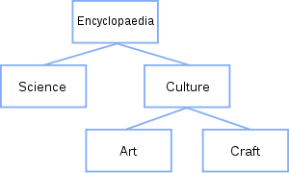](https://en.wikipedia.org/wiki/File:Binary_tree_structure.svg) [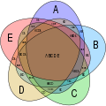](https://en.wikipedia.org/wiki/File:Symmetrical_5-set_Venn_diagram.svg)

tree diagram [Venn diagram](https://en.wikipedia.org/wiki/Venn_diagram)

[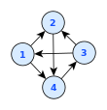](https://en.wikipedia.org/wiki/File:4node-digraph-natural.svg) [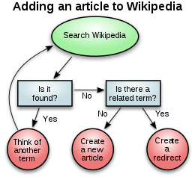](https://en.wikipedia.org/wiki/File:Wikipedia_article-creation-2.svg)

network diagram flowchart

[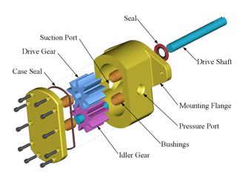](https://en.wikipedia.org/wiki/File:Gear_pump_exploded.png) [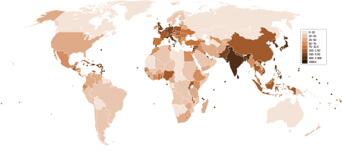](https://en.wikipedia.org/wiki/File:Countries_by_population_density.svg)

exploded view density map

[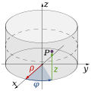](https://en.wikipedia.org/wiki/File:Cylindrical_Coordinates.svg) three-dimensional diagram

1. Think about a design of a poster to present your topic. There is a new conference rule: your poster cannot include text except for five sentences (max of 15 words each) but it can include as many illustrations as you wish. Which statements would optimally tell about the topic to your audience?
2. Use an affinity map or a fishbone diagram to help you realize the most important aspects of the chosen topic. Describe it to your partner.

[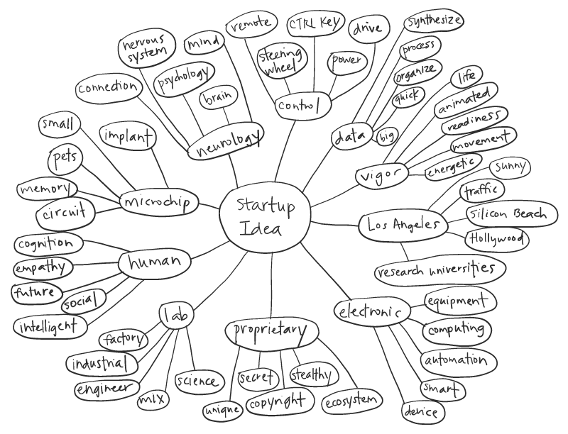](https://www.google.cz/url?sa=i&rct=j&q=&esrc=s&source=images&cd=&cad=rja&uact=8&ved=0ahUKEwiSn_iRwN7VAhWFfxoKHeACDCEQjRwIBw&url=http://jadeshyu.com/projects/psynapse/&psig=AFQjCNHJfKmuVPVOO_g0w7PRavZjAuVfdg&ust=1503067017970788)[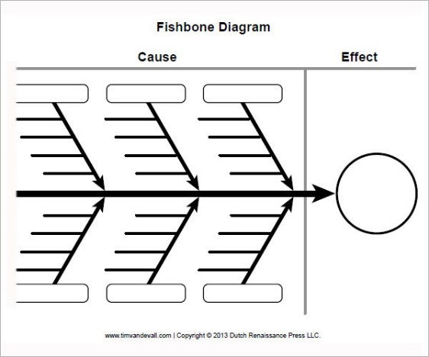](https://www.google.cz/url?sa=i&rct=j&q=&esrc=s&source=images&cd=&cad=rja&uact=8&ved=0ahUKEwiUjLatld7VAhXHthoKHeh1BRQQjRwIBw&url=http://resumesepti45.limdns.org/fishbone-diagram-template.html&psig=AFQjCNF-CkZ02xxnbkVI8nU3BzALoYbFBA&ust=1503055783534748)

<http://jadeshyu.com/projects/psynapse/> <https://www.template.net/business/word-templates/fishbone-diagram-template/>

1. Summarizing your presentation

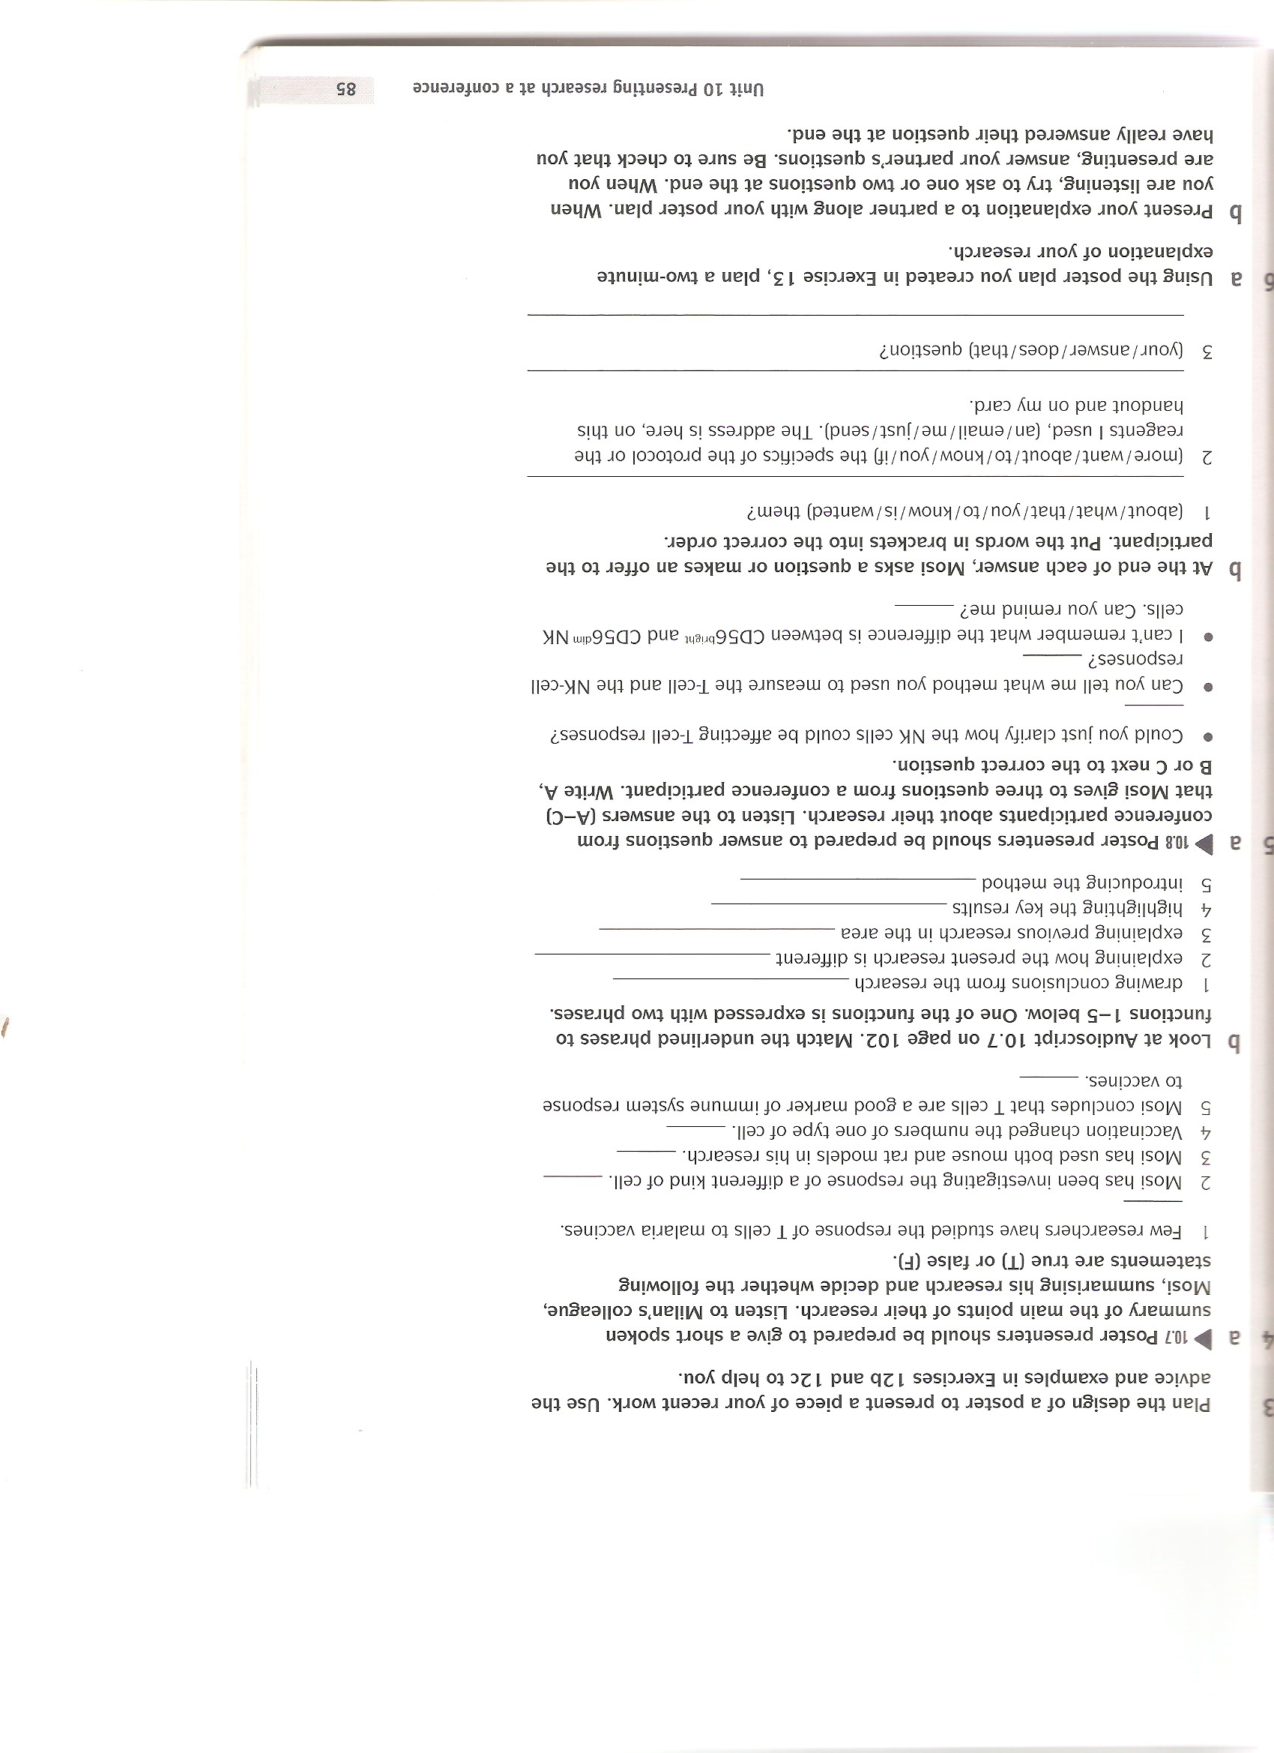

1. Reacting to questions from the audience. 

HOMEWORK: Now design your poster. Keep to the rule of presenting info top-down, left-right. Print it on A4 paper, in colour and bring it with you to the next class.

Source:

Armer, T. (2011) ***Cambridge English for Scientists*** CUP, apart from:

Ex.6 images: [www.wikipedia.org](http://www.wikipedia.org)

Ex.7, 8 tasks: Daniela Dlabolová (Poster Presentation)