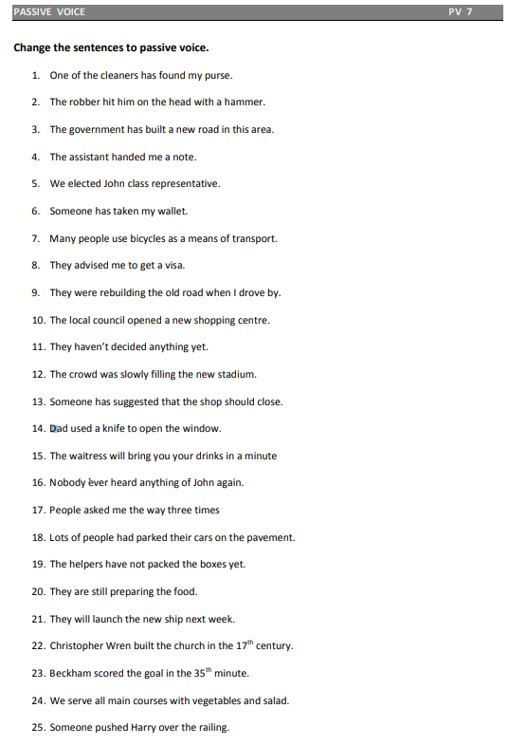

source https://www.english-grammar.at/worksheets/passive_voice/pv7.pdf