**5 GM TECHNOLOGY - EVALUATION**

**1. Read the definition and discuss what you know about GM food or technology.**

**Genetically modified** (of a plant, etc.) - having had its genetic structure changed artificially, so that it will produce more fruit or not be affected by disease

**Genetically modified foods** – foods made from plants that have been changed in this way

**2. Definitions and relative clauses – complete:**

1. GMO is an organism ………………… has been altered by genetic engineering.
2. Transgenic organism is an organism ………………… genetic makeup has been altered by the addition of genes from an unrelated organism
3. A situation may occur …………….. pollen from corn modified to kill corn pests might sometimes land on neighbouring plants.
4. A gene from one organism is transferred to cells of another organism, …………………. it is incorporated into the recipient’s chromosomes and expressed.

**3. Decide whether the publications A - D might offer neutral, positive, or negative evaluation of GM technology. Give reasons.**

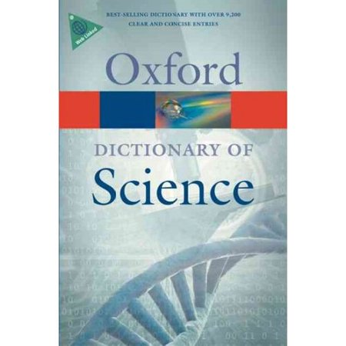 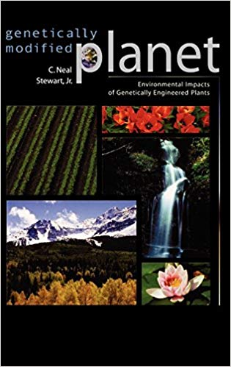 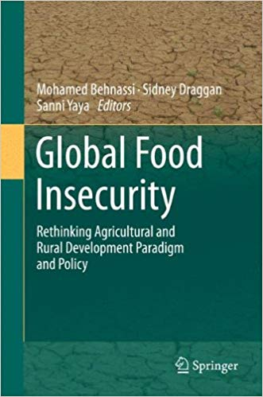 

A B C D

**The following extracts are texts from the books above. Decide whether they contain any evaluation.**

1. Genes for herbicide or insect resistance may spread from crop plants to wild plants, with possible serious consequences for both agriculture and natural ecosystems.

2. After growing trillions of transgenic plants in the US during the past 14 years, there have been no ecological disasters, no injuries or deaths, no GM crops invading natural ecosystems, no negative measurable effects whatsoever; yet, surprisingly, GM plants have not been universally accepted in agricultural systems on the global level.

3. The GM crops of tomorrow will continue this trend, but, on occasion, there may be significant environmental risks that need to be assessed.

**Which publications do you think the extracts are from?**

**4. Genetically modified organisms**

**a) The text is divided into four parts. Decide which part(s) contain:**

Evaluation - technical overview - positive points - negative points -

1 Since the early 1980s developments in genetic engineering made it possible to produce genetically modified organisms. A gene from one organism is isolated and transferred to cells of another organism, where it is incorporated into the recipient’s chromosomes and expressed. Such transgenic organisms can exhibit quite novel characteristics. During the 1990s there was a dramatic growth in the commercial applications of this new technology, ranging from the production of human hormones in bacteria and vaccines in yeasts to the development of genetically modified (GM) crop plants.

2 **Techniques**

Various methods are used to introduce novel genes, depending on the nature of the recipient organism […] Genetic modification has been used successfully as a vector with certain flowering plants, including tobacco, tomato, potato, soya been, and cotton. It works much less well with grasses, cereals, and other monocots. In these plants, various other techniques are available, including:

* Electroporation – treatment of cells by exposure to an electric field that renders them transiently permeable to DNA fragments;
* Microinjection – injection of DNA directly in to the cell nucleus;
* Biolistic – ‘shooting’ a cell with a DNA-coated tungsten microprojectile.

3 **Applications**

Plants: tolerance to herbicides

Improved insect resistance

‘vaccination’ against specific diseases

longer ‘shelf life’ for fruit

Animals: production of therapeutic proteins in milk

Potential for improved growth rates and milk yields

Potential for production of organs for human transplants

4 **Risks**

The use of GM organisms in the environment poses certain potential problems. For example, genes for herbicide or insect resistance may spread from crop plants to wild plants, with possible serious consequences for both agriculture and natural ecosystems. Farmers may be faced with new ‘super weeds’, while insect populations could decline. Moreover, the products of GM crops have to be fully evaluated to ensure that they are safe to eat. Genetic modification of animals often has unforeseen side-effects and raises ethical issues about such treatments

Source: Daintith, J.: Oxford Dictionary of Science (6th ed.). OUP

**b) Identify the neutral, positive and negative language in the text.** (nouns, adjectives, verbs + their phrases)

**c) Find examples of tentative (less strong, uncertain) language in section 4. Why does the author use such language?**

**5. Expressing degrees of evaluation**

In the previous two questions you have identified evaluation language (4b) and the expressions of the degree of evaluation (4c). The technique of expressing evaluation in a tentative way is called *hedging*.

**Grammar & vocabulary for hedging:**

**VERBS**: appear, seem, look, tend, contribute

*There appears to be a connection between …*

*Supporters of the technology tend to claim that …*

**MODALS:** can, may, might, could, should

*There can be a number of reasons why …*

*We might see a significant rise in the activities against …*

**ADJECTIVES**: likely, unlikely, probable

*People who take no exercise are likely to become obese.*

**ADVERBS**: apparently, relatively, typically, slightly

*Consumption of GM foods is considered relatively safe.*

**HEDGING PHRASES**:

*It is possible to argue that … , It is generally accepted that …, It seems fair to say that …*

*The evidence suggests that … , The latest research appears to show that …*

*Most economists claim that …, Most people agree that …*

**For the sentences below, decide whether there is hedging or not (in the evaluation parts in bold):**

1. *GM plants* ***do not add to any*** *of these existing risks or* ***pose any*** *new compelling risks* ***of any magnitude.***
2. *The GM crops of tomorrow will continue this trend, but,* ***on occasion, there may be significant environmental risks*** *that need to be assessed.*
3. ***It has worked so far.***
4. *After growing trillions of transgenic plants in the US during the past 14 years,* ***there have been no ecological disasters,******no*** *injuries or deaths,* ***no*** *GM crops invading natural ecosystems,* ***no negative*** *measurable* ***effects whatsoever****;* ***yet, surprisingly****, GM plants have not been universally accepted in agricultural systems on the global level.*

**Reformulate each sentence a) – e) to give the opposite degree of evaluation.**

*Example*

*a) GM plants* ***do not appear to add to any*** *of these existing risks or* ***pose any******obvious*** *new compelling risks* ***of any magnitude.***

*b)*

*c)*

*d)*

**Discuss which versions of the sentences you prefer.**

**6. Risks and benefits of GM technology**

**Watch the two extracts and decide if the speaker presents the risks or the benefits of GM technology. Specify in which areas it is beneficial /risky.**

|  |  |
| --- | --- |
| **Nobel Prize in Chemistry 2008** – Martin Chalfie – green fluorescent protein (GFP),  <https://www.youtube.com/watch?v=YCY0Inhb4oI>  28 – 30.45 | **What if my neighbor's kid was genetically modified?**  <https://www.youtube.com/watch?v=y7LXwGfvxwo>  4- 10.16, 15.12 -17.59 |
|  |  |

**7. Discussion**

**HOMEWORK: Connectors**

**Which pairs / groups of connectors have similar meaning?**

with respect to nonetheless with regard to therefore as opposed to nevertheless unlike regarding contrary to thus

**Complete the sentences with a suitable word / phrase:**

1. There is controversy over GMOs, especially …………………..their use in producing food.
2. There is a [scientific consensus](https://en.wikipedia.org/wiki/Scientific_consensus) that currently available food derived from GM crops poses no greater risk to human health than conventional food. …………………., members of the public are much less likely than scientists to perceive GM foods as safe.
3. Some health groups say there are unanswered questions …………………….the potential long-term impact on human health from food derived from GMOs
4. While GMOs have benefited human society in many ways, some disadvantages exist; ………………….. the production of GMOs remains a highly controversial topic in many parts of the world.
5. The main proponents of GM foods are Americans, …………………Europeans, who are the main sceptics.

Lesson based on de Chazal, E.: Oxford EAP B2, U 11 Technology, OUP