**Unit 2 Learning autonomy**

**Task 1** **The perfect learner**

**Study the diagram below. To what extent are you “The perfect Learner”?**

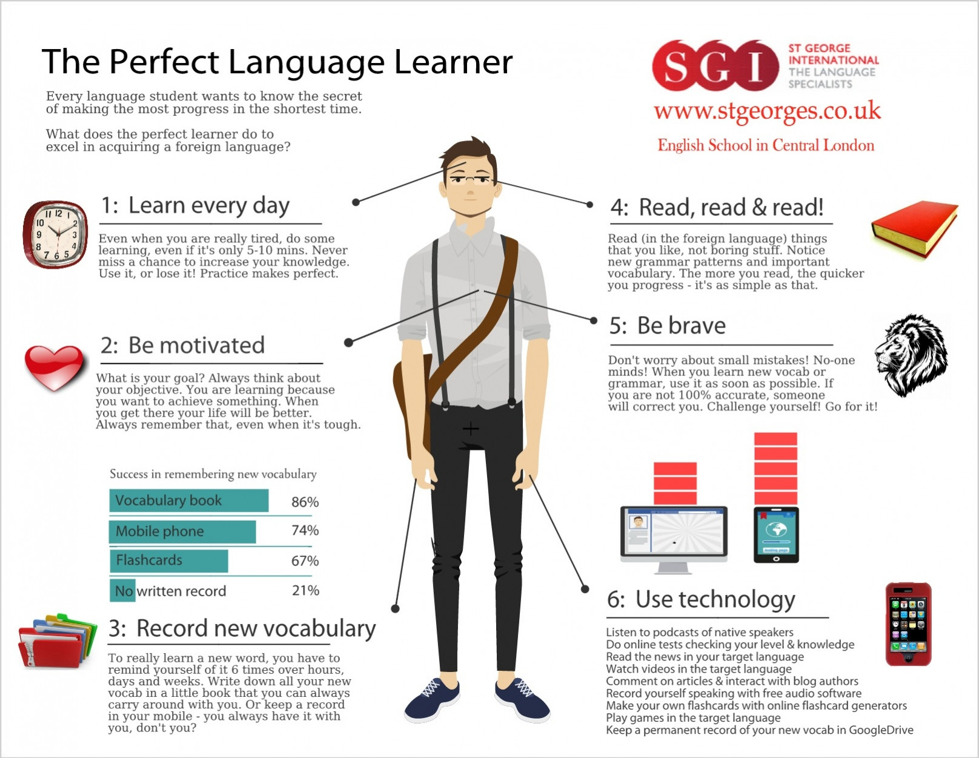

**Task 2 Strategy Inventory for Language Learning (R.L. Oxford, 1989)**

**Answer the following questions. Use this scale for every answer:**

1. **Never or almost never true of me.**
2. **Usually not true of me.**
3. **Somewhat true of me.**
4. **Usually true of me.**
5. **Always or almost always true of me.**

PART A

1. I use new English words in a sentence so I can remember them.
2. I remember a new English word by making a mental picture of a situation in which the word might be used.
3. I physically act out new English words.
4. I review English lessons often.
5. I remember new English words by remembering their location on the page, or on the board.
6. I think of relationships between what I already know and new things I learn in English.

PART B

1. I say or write new English words several times.
2. I read in English and/or watch English movies and TV shows.
3. I use the English words I know in different ways.
4. I start conversations in English.
5. I try to find patterns in English.
6. I try not to translate word-for-word.

PART C

1. To understand unfamiliar English words, I make guesses.

2. When I can´t think of a word during a conversation in English, I use gestures.

3. I make up new words if I don´t know the right ones in English.

4. I read English without looking up every new word.

5. I try to guess what the other person will say next in English.

6. If I can´t think of an English word, I use a word or phrase that means the same thing.

PART D

1. I try to find as many ways as I can to use my English.
2. I notice my English mistakes and use that information to help me do better.
3. I pay attention when someone is speaking English.
4. I look for people I can talk to in English.
5. I have clear goals for improving my English skills.
6. I look for opportunities to read as much as possible in English.

PART E

1. I try to relax whenever I feel afraid of using English.
2. I encourage myself to speak English when I am afraid of making mistakes.
3. I give myself a reward or treat when I do well in English.
4. I notice if I am tense or nervous when I am studying or using English.
5. I write down my feelings in a learning diary.
6. I talk to someone else about how I feel when I am learning English.

**Task 3 Word formation**

**How to learn vocabulary**

Students are under enormous …………………….. (PRESS) to learn huge amounts of vocabulary but they are rarely given ……………………. (GUIDE) as how to go about it. They have a ……………………….. (TEND) to try and learn long lists by heart, but this is hardly the most …………………………. (EFFICIENCY) approach to the problem. The golden rule is to do lots of ……………………….. (REVISE) at regular intervals. Secondly, students should concentrate on words with the highest ………………… (FREQUENT), particularly everyday words which also improve students´ spoken …………………… (FLUENT). They should also take every opportunity to use the words in ………………………… (COMMUNICATE) – there is considerable …………………………. (PSYCHOLOGY) evidence that learners who like using the foreign language improve their oral ………………………. (PERFORM) and their overall ………………… (ACQUIRE) of the language much more rapidly than students who are ……………………. (RELUCTANCE) to practise the language in real situations.

**Task 4 Listening – The Bilingual Brain**

(<https://www.ted.com/talks/mia_nacamulli_the_benefits_of_a_bilingual_brain#t-180929>)

1. **Use the following verbs in sentences:**

Involve Process Measure Split

1. **Can you guess the meaning of the expressions in italics?**

People know and use their languages *in varying proportions*.

She is learning two languages *simultaneously*.

Everyone can learn a foreign language, *regardless of age*.

The child is *likely* to learn the language faster.

The difference between the speakers is not *apparent*.

Unconscious *bias* can influence your attitude towards a language.

1. **Watch and answer the questions:**
2. What are the different types of bilinguals?
3. What does the critical period hypothesis say about learning languages?
4. What advantages do bilinguals enjoy?

# Task 5 Reading

# Autonomous Learning is the Future of Education

([Dr. L. Robert Furman](https://www.huffingtonpost.com/author/rob-364), 10/18/2017)

1. **Autonomous learning - innovation in education?**

We live in an exciting age of innovation. Technology plays an enormous role in that innovative spirit of change and discovery. Probably one of the most talked about technologies in today’s world is the self-driving car. Just think of the possibilities a driverless car presents: reading the newspaper on the way to work, getting your workout on the exercise machine installed in the car, watching the news on TV, and the list goes on and on. Could this be our future? Some say, “Why do we need a self-driving car? My car gets me where I want to go.” Future-ready thinkers say, “Why not?”

We are presented with the same kind of thinking when it comes to education. Let’s think about the self-driving student, also known as the self-directed learner or the autonomous learner. What do we mean by autonomous learning?  Betts and Knapp (1981) define autonomous learning as “one that solves problems or develops new ideas through a combination of divergent and convergent thinking and functions with minimal external guidance in selected areas of endeavour.”  Kember (1997) refers to autonomous learning as student-centered learning, shifting the focus of education from teaching to learning.

I like to think of it as the ability of the student to work independently and being given the freedom to do so. Autonomous learning would allow the learner to personalize his/her learning agenda based on his/her academic strengths and personal interests, and self-monitor his/her achievements. These are not unique ideas. Educators have been talking about independent learning, personalized learning, and student-centered learning for a very long time. The difference today is that new technologies have given us the unique abilities to accomplish this task with greater success.

1. **Role of the teacher**

I can hear the sceptics as we speak. What about the teacher? Are we doing away with teachers? Regardless of the teaching/learning philosophy, the teacher remains an integral part of the learning process.  Just like an autonomous car, there needs to be some guidance and direction in order for that vehicle or in this case that student to arrive at its destination. Consider the teacher the GPS of the autonomous learner. The teacher will offer up a variety of paths to students’ destinations and also suggest best routes. The teacher will be the director of the system, helping students decide on their destinations and helping them get there by passing through various necessary skills and standards that the students will need once they reach that point.

The teaching curriculum might look a bit different in the autonomous classroom. The teacher will be responsible for sharing self-monitoring strategies. Students might use learning logs or charts and tables to follow their progress. Teachers will teach error analysis and help students use their mistakes as learning opportunities to accommodate their learning goals. Teachers must provide the necessary guidance to help students choose their personal learning goals. Teachers must provide feedback as student pursue their own questions and solve their own problems. Teachers remain the most important part of the autonomous classroom.

1. **Example of autonomous learning**

Let’s take a look at autonomous learning: The student is working on his science objective in the field of chemistry. The student goes into his virtual science laboratory. Here he experiments using chemicals that might be considered dangerous in the traditional classroom. In his virtual lab, the student witnesses the chemical reactions and must determine why the chemical reacted in that manner. While in that virtual world, the student finds an artificially intelligent computer that moves the student through a lesson on chemical reactions. The student then logs his work and determines his ability to meet his goal(s). That same student then meets in a small discussion group with his teacher and others to solve real world problems using necessary math skills. After making a determination and deriving at a solution, the teachers uses augmented reality to determine if their solution actually solved the problem. The student will continue his learning at home as he uses his foreign language application to practice his chosen foreign language as he prepares to meet his “Family Abroad”.

Autonomous learning is the future of education. We must now think that instead of having a classroom of twenty students, we now have “twenty classrooms” of one student, each with their own agenda.

(<https://www.huffingtonpost.com/entry/autonomous-learning-is-the-future-of-education_us_59e77f81e4b0153c4c3ec479?guccounter=1>)