**The urease biosensor based on Eu(III) ternary complex of DO3A ligand**

Filip Smrčka,a) Přemysl Lubal,a,b)

1. *Department of Chemistry, Faculty of Science, Masaryk University, Kotlářská 2, CZ–611 37 Brno, Czech Republic*
2. *Central European Institute of Technology (CEITEC), Masaryk University, Kamenice 5, CZ–625 00 Brno, Czech Republic*

Specific spectroscopic, electrochemical and magnetic properties of Ln(III) ions make them perfect candidates for use in many chemical, biological and environmental systems. Ln(III) complexes with macrocyclic ligands (mainly DOTA derivatives) are commonly utilized in medicinal chemistry as radiopharmaceuticals (90Y, 153Sm, 166Ho, 177Lu) [1,2] and contrast agents for MRI (Gd) [3].

The 1,4,7,10-tetraazacyclododecane-1,4,7-triacetic acid (H3DO3A) as heptadentate ligand forms a stable complex with europium(III)/terbium(III) aqua ion. The ternary [Ln(DO3A)L] complex exhibits a high luminescence due to antenna effect leading to sensitization of Eu(III)/Tb(III) luminescence by a fluorophore (*e.g.* picolinic or isoquinolic acid) via efficient energy transfer from ligand to Ln(III) ion. The utilization of those ternary Eu(III) and Tb(III) complexes as selective dual luminescence/electrochemical sensors for determination of carbonate/oxalate using substitution reaction was reported [4, 5]. This was also employed for indirect determination of carbonate formed in the course of urea hydrolysis catalyzed by the urease enzyme (see Scheme). This new analytical procedure was proposed for the determination of both analytes (urea, urease) and the luminescence-based biosensor can be used in both kinetic time-dependent as well as equilibrium end-point modes [6].

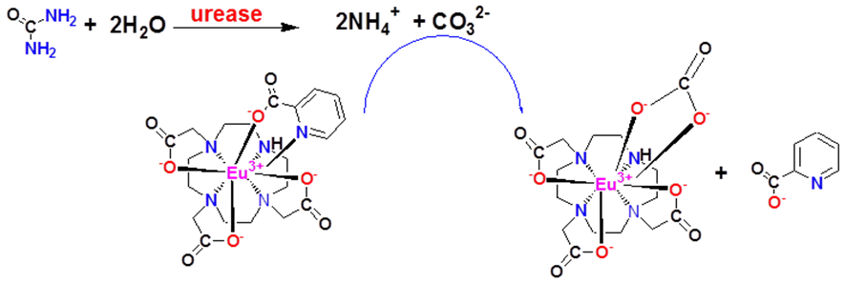

Scheme: The cascade reaction of the ternary [Eu(DO3A)(Pic)]- complex employed for enzymatic determination of urea.

The inhibition effect of some metal ions (*e.g.* Ag+, Pb2+, Zn2+, Cd2+) on enzymatic reaction can be employed for their analytical determination [6]. The proposed analytical procedure is fast, selective and sensitive with metrological parameters comparable for other urea biosensors. As it is known to authors, this new biosensor is the first example of biosensor using the bicarbonate detection as the product of urea hydrolytic reaction catalyzed by urease.

**References:**

1. Wadas TJ, Wong EH, Weisman GR, Anderson CJ (2010) Chem Rev 110:2858
2. Försterová M, Jandurová Z, Marques F, Gano L, Lubal P, Vaněk J, Hermann P, Santos I (2008) J Inorg Biochem 102:1531
3. Hermann P, Kotek J, Kubíček V, Lukeš I (2008) Dalton Trans 23:3027.
4. Vaněk J., Lubal P., Hermann P., Anzenbacher P., Jr. (2013) J. Fluorescence 23:57.
5. Vaněk J., Smrčka F., Lubal P., Třísková I., Trnková L. (2016) Monatsh. Chem. 147:925.
6. Smrčka F., Lubal P., Šídlo M. (2017) Monatsh. Chem. 148:1945.