Climate Plot 32 by S. Riediger, Department of Biology, University of Osnabrück

Manual
1. Program description
Climate Plot 32 has been developed in order to view and plot monthly climatic averages into climate diagrams in the WALTER and LIETH 1960 ff. convention of climate stations from all over the world. The program uses a database provided by Oak Ridge laboratory to the public domain. This database is stored on the program CD ROM. Additional data may be entered by the user and saved in user defined files.
Diagrams and tables may be pasted in existing documents (e.g. in Microsoft Word TM documents) or touched up with graphic programs (e.g. Corel Draw TM)
Climate Plot 32 has been written and tested for the following Microsoft Windows TM 32 bit operating systems:
• Windows 95 TM
• Windows 98 TM
• Windows NT 3.51 TM
• Windows NT 4.0 TM
• Windows NT Server 4.0 Terminal Server Edition TM
• Windows 2000 TM

All systems meeting the hardware requirements for the upper list of operating systems are able to run Climate Plot 32. Nevertheless a screen resolution of 800 x 600 or higher is strongly recommended to run the program in an appropriate way.
2. Installation
There are two ways of installation:
1.Standard installation (running the program without the CD ROM):
- 1. Insert the CD ROM
- 2. Copy the complete program directory \c_plot to a location on your harddisk or network drive
- Create a shortcut for “CPlot32.exe” on your desktop
This is the recommended installation method. The software with the data files needs about 9 MB of diskspace.
2. Custom installation (running the program from the CD ROM):
- 1. Insert the CD ROM
- 2. Create a shortcut for “CPlot32.exe” on your desktop
Use this installation method only when you are low on disk space. Reading data from the CD ROM drive is much slower than from the CD ROM.

Remark: When creating shortcuts for “CPlot32.exe”, always be sure that the ‘Start in:’ directory of the shortcuts is set to the directory containing the three data files TEMP.DAT, PRECIP.DAT and COUNTRY.DAT. Otherwise the program will not work.

3. Using Climate Plot 32
In Climate Plot 32 all program functions can be reached through the menu located on top of the program-window (fig. 1).
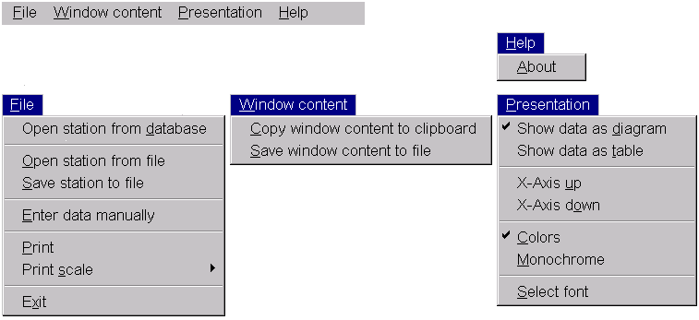
fig.1 Functions available in the menu of Climate Plot 32

In addition to the program menu a toolbar gives direct access to frequently used functions (fig. 2).

fig.2 The toolbar of Climate Plot 32
Each button represents a function from the menu. Resting the mouse cursor for more than a second over a button pops up a small help-window that informs about the associated function.
A double-click on the gray space between the buttons opens a dialog that allows the user to configure the toolbar individually (fig.3). Seldom used buttons can be removed and the left to right order can be changed at will.

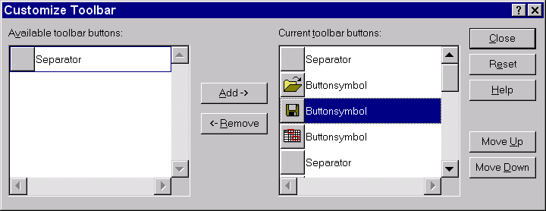
fig.3 The ‘Customize Toolbar’ dialog.

3.1 The menu
The menu item 'File'
The menu item ‘File’ contains all functions to handle the climate database and printing routines (fig.4).
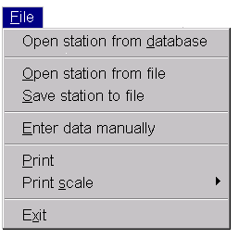
fig. 4 The menu item ‘File’

The 'Open station from (CD) database' menu selection
When selecting 'Open Station from database' a dialog-window with two listboxes appears (fig. 5). The left listbox contains the country names, the right listbox shows the names of the stations available in the selected country. A country can be chosen by mouse-click to show it’s stations. The data are loaded after double-clicking on the desired station name or by pressing the OK-button when the desired station is marked.
Tip: The keyboard can be used instead of the mouse to select countries or stations. When a listbox owns the input focus (e.g. by making a single-click on it), typing the first characters of a county or a station switches the listbox-mark to the desired element. It is also possible to use the cursor keys to move the listbox-mark up and down.
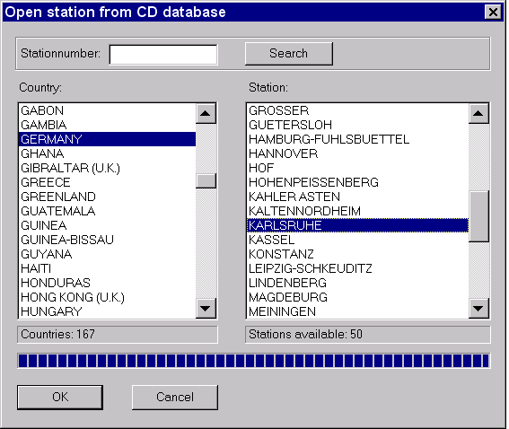
fig. 5 The ‘Open Station from CD database’ dialog
The field ‘Stationnumber’ in combination with the ‘Search’ button allows to search a station by it’s unique WMO-stationnumber. The field is blank by default.

The 'Open station from file' menu selection
This menu selection opens the 'Open station from file' dialog (fig.6). This windows allows to open climate station data generated individually from a previously saved file that is in the *.cli format. In contrast to the ‘Open station from CD database’ dialog the data are obtained from user created files and not from the default database on the CD ROM.

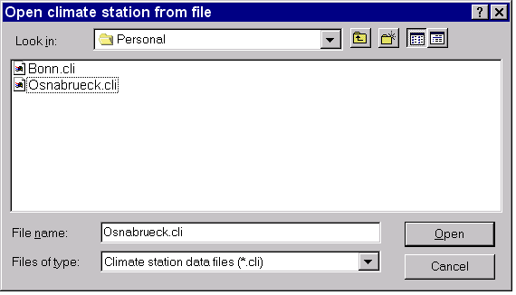
fig. 6 The ‘Open station from file’ dialog

The 'Save station to file' menu selection
This menu selection opens the 'Save station to file' dialog (fig. 7). Here the user can save own or modified data from the CD ROM database to a file. The dialog allows the user to choose an individual file name and directory location.
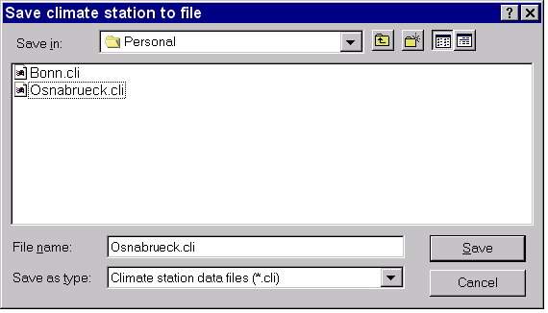
fig. 7 The ‘Save station to file’ dialog

The 'Enter data manually' menu selection
This selection opens the 'Enter data manually' dialog (fig.8) that allows the user to modify existing climate station data or to enter new data by himself. In the dialog-window values can be modified and additional information can be added. This new data can be saved with the ‘Save station to file’ function. Fields for which no data are available may be left blank.

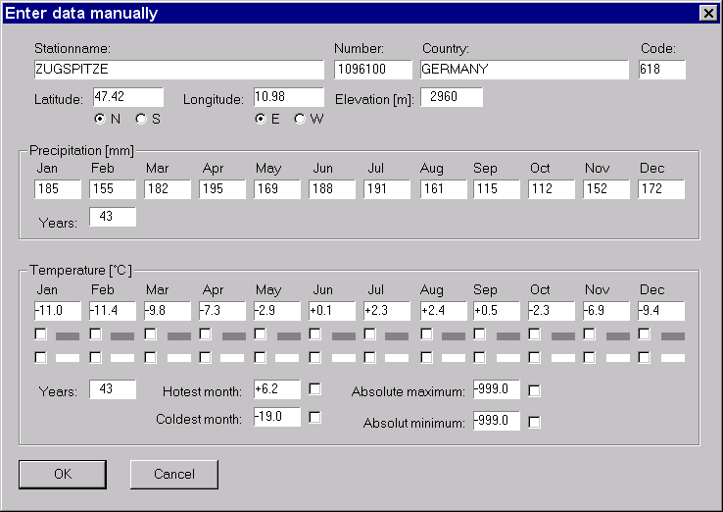
fig. 8 The ‘Enter data manually’ dialog. Fields for which no data are available may be left blank.

When entering or correcting data, the ‘Latitude’ checkmarks (fig. 9) have a special function: Because data of stations located in the southern hemisphere is shifted by six months for better comparison with stations of the north hemisphere, changing the ‘N’ and ‘S’ flags changes the months-label of each data-input-box by six months. The order of data is left unchanged and is not affected by the latitude. The order of data are displayed in the climate diagram corresponds to the left right order of the climate data input boxes .
In praxis this means when entering climate data of the southern hemisphere the user has to begin with July as the first month at the left side of the input boxes.
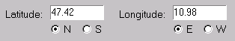
fig. 9 The latitude (‘N’ and ’S’) and longitude (‘E’ and ’W’) checkmarks

In the temperature area of the dialog, checkboxes are available for some additional data climate data to be shown in the diagram (fig.10 and fig.11). The checkboxes are unmarked by default, because the database on the program CD ROM does not contain the relevant data.

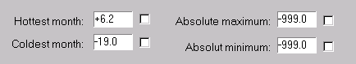
fig. 10 Checkmarks in the temperature area of the dialog
Information on ecological important frost periods can be manually entered by checking flags for any month (fig. 11):
Upper line: Months with a daily average temperature minimum below zero can be shown by black boxes under the baseline in the diagram.
Lower line: Months where the absolute temperature has fallen below zero during the entire observation period can be shown by white boxes under the baseline in the diagram.
Note: The database on the CD ROM does not contain any data about frost periods. Therefore all checkmark fields are blank by default.

fig. 11 Flags for ecological important frost periods
The 'Print scale’ menu selection
The ‘Print scale’ menu selection (fig. 12) controls the size of the printer output.
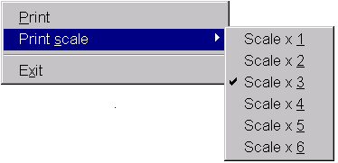
fig. 12 Available print scales
The size of the printed document depends on the used printer resolution. This means in practice, that under an 120 dpi (dots per inch) resolution each scale-selection causes a five times bigger output than under a 600 dpi resolution of the printer. Therefore the user has to find a suitable scale in combination with the printer resolution by himself. The print scale is set to 3x by default, which should be optimal for 600 dpi.

The menu item 'Window content'
The menu item ‘Window content’ (fig. 13) contains functions intended to transfer the graphical output of Climate Plot 32 (either the climate diagram or the data table) to other applications in two ways.
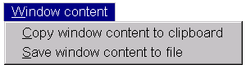
fig. 13 The menu item ‘Window content’

The 'Copy window content to clipboard’ menu selection
The 'Copy window content to clipboard’ menu selection allows to make use of the windows clipboard to transfer diagrams or data tables of Climate Plot 32 to documents of other windows applications. (e.g. word processors like Microsoft Word TM or graphic applications like Corel Draw TM).

The 'Save window content to file’ menu selection
This selection opens the ‘Save window content to file’ dialog (fig. 14).
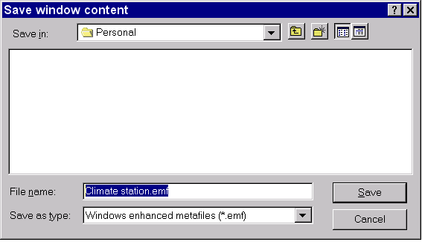
Fig. 14 The ‘Save window content to file’ dialog

This dialog allows the user to save the graphical windows content to an image file. This file is in the enhanced metafile format (*.EMF), so that it can be imported by windows and non-windows applications able to handle it.

The menu item 'Presentation'
The menu item ‘Presentation’ (fig. 15) contains functions to control the appearance of the climate diagram and climate data table.
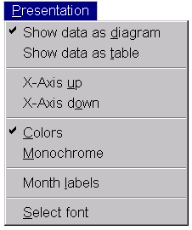
fig. 15 The menu item ‘Presentation’

The 'Show data as diagram' and 'Show data as table' menu selections
The two 'Show data as ...' menu flags allow the user to switch between the climate diagram and the climate data table. A typical switch between diagram and table output for a sample station is shown in fig. 16 and fig. 17.
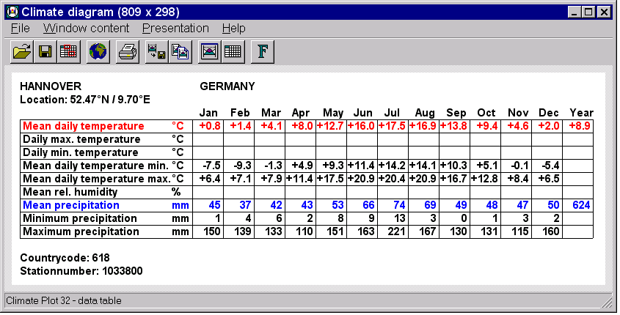
fig. 16 Climate Plot 32: A sample output of data as table.

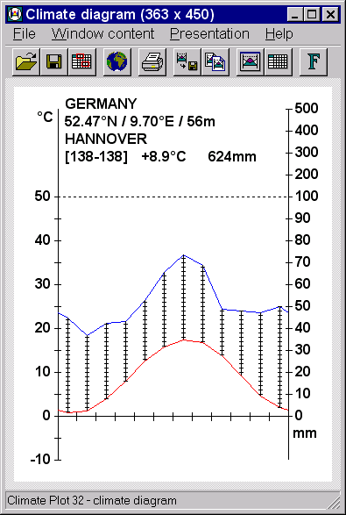
fig. 17 Climate Plot 32: A sample output of data as climate diagram.

The 'Color' and 'Monochrome' menu selections
The 'Color' and 'Monochrome' menu selections allow to switch between the use of colors and no colors when drawing the diagram. Some people may prefer the monochrome output, but the color output is selected by default: Blue lines for precipitation, red lines for temperature and black for all other elements.
The 'Month labels' menu selection
This selection allows to activate and deactivate the use of month labels underneath the base lines in the climate diagram. The use of month labels is deactivated by default.

The 'Select Font' menu selection
Choosing the 'Select Font' menu entry opens a windows standard dialog (fig 18.) that allows to alter the font to be used.

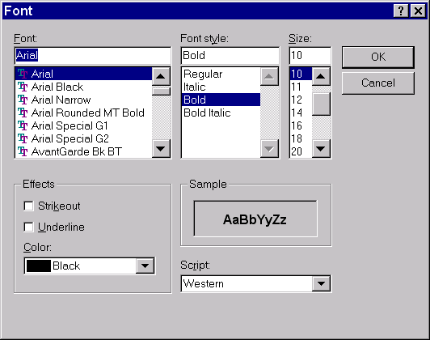

fig. 18 Climate Plot 32. The user dialog for font selection. The dialog may slightly differ from the figure, because as a standard Windows-dialog it differs with the actually used Windows language and/or version.

The menu item 'Help'
The menu item ‘Help’ (fig. 19) contains only one selection. An online help for Climate Plot 32 is not implemented yet.
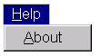
fig. 19 The menu item ‘Help’

The 'About' menu selection
The ‘About’ menu selection opens a window providing information about the version, compilation date and author of the program (fig. 20).
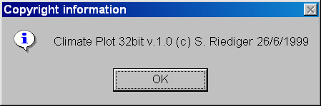
fig. 20

3.2 Mouse controls of Climate Plot 32
The diagram position and the size can be modified by mouse control. Changing the window size is possible with the standard windows mouse functionality. Height and width of the diagram can be customized for publications in this way. In addition, clicking inside the window below or above the x-axis of the diagrams allows the x-axis to be moved up and down as shown in the random examples in fig. 20. This may be particularly important for climate diagrams in areas with a higher precipitation or very deep temperatures.

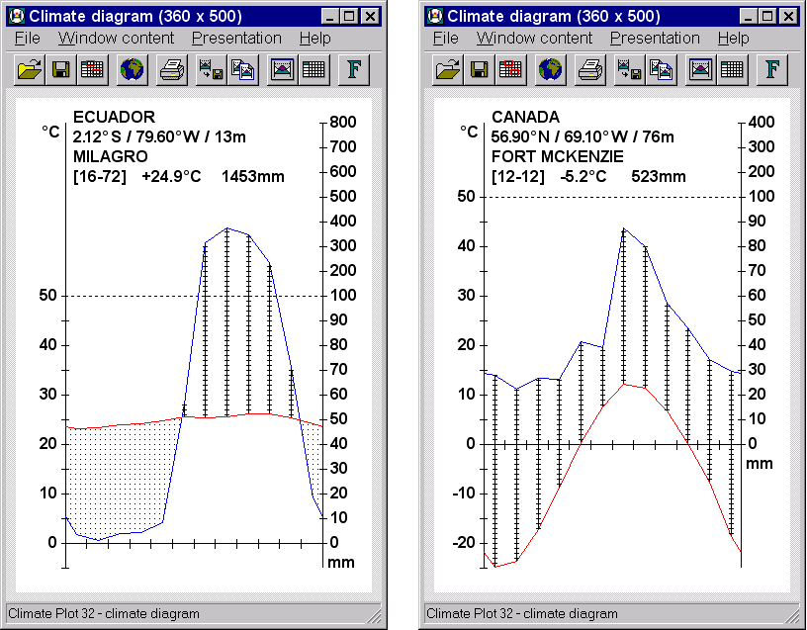
fig. 20 Variable positions of the x-axis, adjusted to extremely different climatic conditions of two stations.

Copyright © 1999 Backhuys Publishers, Leiden / Netherlands
Climate Plot 32 (software and manual) copyright © 1997-1999 by Stephan Riediger. All rights reserved.

