**C9550 Quantum Chemistry and Molecular Spectroscopy**

[**Syllabus - Fall 2019**](https://www.math.rutgers.edu/academics/undergraduate/courses/course-materials/135/1475-syllabus-4)

1. **Electromagnetic radiation and its interaction with atoms and molecules** 
   1. Electromagnetic radiation. Hollas 2.1
   2. Absorption and emission of radiation, line intensity. Hollas 2.2
   3. Line width. Hollas 2.3
   4. The electromagnetic spectrum and types of molecular excitations. Hollas 3.1
2. **Quantum chemical foundations of molecular spectroscopy** 
   1. Principles of quantum mechanics Atkins-EN 7.3-7.7, Atkins-CZ 7.2+7.3
   2. Selection rules for spectroscopy transitions Atkins-EN 9.3+12.2, Atkins-CZ 9.1.3+12.1.2
3. **Rotational spectra**

3.1 Rotation in two dimensions: a particle on a ring Atkins-EN 8.6, Atkins-CZ 8.3.1

3.2 Rotation in three dimensions: the particle on a sphere Atkins-EN 8.7, Atkins-CZ 8.3.2

3.3 Moments of inertia Atkins-EN 12.3, Atkins-CZ 12.2.1

* 1. The rotational energy levels Atkins-EN 12.4, Atkins-CZ 12.2.2

3.5 Rotational transitions Atkins-EN 12.5, Atkins-CZ 12.2.3

1. **Vibrational spectra**

4.1 Harmonic oscillator: the energy levels Atkins-EN 8.4, Atkins-CZ 8.2.1

4.2 Harmonic oscillator: the wavefunctions Atkins-EN 8.5, Atkins-CZ 8.2.2

4.3 Diatomic molecule vibrations Atkins-EN 12.8, Atkins-CZ 12.3.1

4.4 Selection rules Atkins-EN 12.9, Atkins-CZ 12.3.2

4.5 Anharmonicity Atkins-EN 12.10, Atkins-CZ 12.3.3

4.6 Vibration-rotation spectra Atkins-EN 12.11, Atkins-CZ 12.3.4

4.7 Vibration of polyatomic molecules: Normal modes Atkins-EN 12.13, Atkins-CZ 12.4.1

1. **Electronic spectra**
   1. The electronic spectra of diatomic molecules Atkins-EN 13.2, Atkins-CZ 13.1.2
   2. The electronic spectra of polyatomic molecules Atkins-EN 13.3, Atkins-CZ 13.1.3
2. **The effect of magnetic fields on electrons and nuclei**
   1. Angluar momentum and spin Atkins-EN 8.8, Atkins-CZ 8.3.3
   2. The spin-orbit coupling Atkins-EN 9.9, Atkins-CZ 9.3.4
   3. The energies of electrons in magnetic fields Atkins-EN 14.1, Atkins-CZ 14.1.1
   4. The energies of nuclei in magnetic fields Atkins-EN 14.2, Atkins-CZ 14.1.2
   5. Magnetic resonance spectroscopy Atkins-EN 14.3, Atkins-CZ 14.1.3
3. **Electron paramagnetic resonance (EPR) and nuclear magnetic resonance (NMR)**
   1. EPR g-value and g-tensor Atkins-EN 14.15, Atkins-CZ 14.4.2
   2. EPR Hyperfine structure Atkins-EN 14.16, Atkins-CZ 14.4.3
   3. Hyperfine structure – MO relationships for organic radicals Separate study materials
   4. NMR chemical shift Atkins-EN 14.5, Atkins-CZ 14.2.2
   5. NMR fine structure Atkins-EN 14.6, Atkins-CZ 14.2.3

**Literature**

and its availibility in University Kampus Library (on August 23rd, 2019)

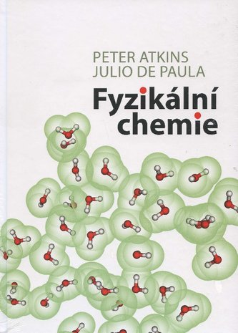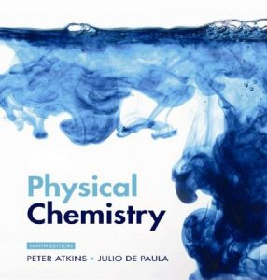

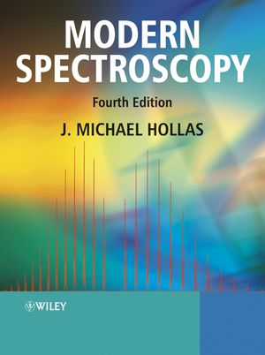

[Atkins’ physical chemistry](https://aleph.muni.cz/F/96Y7A6P5A8V9D8S9ACYBPHSSGIB9R72NDC5VVPJNGKXSH7ILLX-00599?func=full-set-set&set_number=002726&set_entry=000006&format=999), 9th edition, 2010

Peter Atkins, Julio de Paula

**16 items / 2 loans**

Modern Spectroscopy, 4th edition, 2004

J. Michael Hollas

**13 items / 2 loans**

[Fyzikální](https://aleph.muni.cz/F/96Y7A6P5A8V9D8S9ACYBPHSSGIB9R72NDC5VVPJNGKXSH7ILLX-00599?func=full-set-set&set_number=002726&set_entry=000006&format=999) chemie, překlad 9. vydání, 2013

Peter Atkins, Julio de Paula

**98 items / 22 loans**

**Class format**

Lectures (100 minutes a week, 10 minutes break) and homeworks.

Voluntary assignments will be given to students every week, can be handed in for correction at next lecture**.**

**Exam**

1. Written test in Czech or English (on choice). A sample test will be put in IS in the mid-semester at latest. The percent composition: ca 50% of lecture’s content and 50% of homework content.

6 pages, maximum 10 points for each. A: 60-54 points, B: 53-48 points, etc.

1. Oral part in Czech or English (on choice). 2 pages of the test with the lowest scores will be discussed. Maximum influence of the oral part result on the final grade: Written A or F: no influence. Written B or E: one grade up or down. Written C or D: two grades up or down.