**JAG01 Unit 2**  **The Earth**

**Task 1 Speaking: In pairs discuss what makes the planet Earth unique.**

**Task 2 Read the text and label the diagram with the correct information.**

The Earth is the fifth largest planet in our solar system and the third planet from the Sun. The Earth is made up of three main layers. There is the crust which is the outer layer and is very thin, between 5 and 67 km thick. The crust consists of the land and sea. The land is mainly made up of two types of rock: granite and basalt. Then there is the mantle. This is a thick layer which is about 3000 km thick that lies directly below the crust. It consists of hot dense rocks and compounds of magnesium, iron and silicon. The rocks of the mantle are much heavier than those in the crust. Lastly, there is the core. This is the centre of the Earth which consists of heavy metals. It has an inner and an outer layer. The outer core consists of molten rocks, iron and nickel, and it is about 2000 km thick. The inner core is about 1500 km thick and is a solid structure containing nickel and iron. The temperature and pressure of the inner core of the Earth is so great that the metals are squeezed together making it difficult for them to move about like a liquid, instead they are forced to vibrate in one place like a solid.

1) 1500 km thick 2) 2000 km thick 3) 3000 km thick 4) directly below the crust

5) granite and basalt 6) hot dense rock 7) inner core 8) land and sea

9) liquid, molten rock, iron, nickel 10) metals vibrate like solid 11) outer core

12) outer layer of the crust 13) solid structure, nickel and iron 14) the crust 15) the mantle

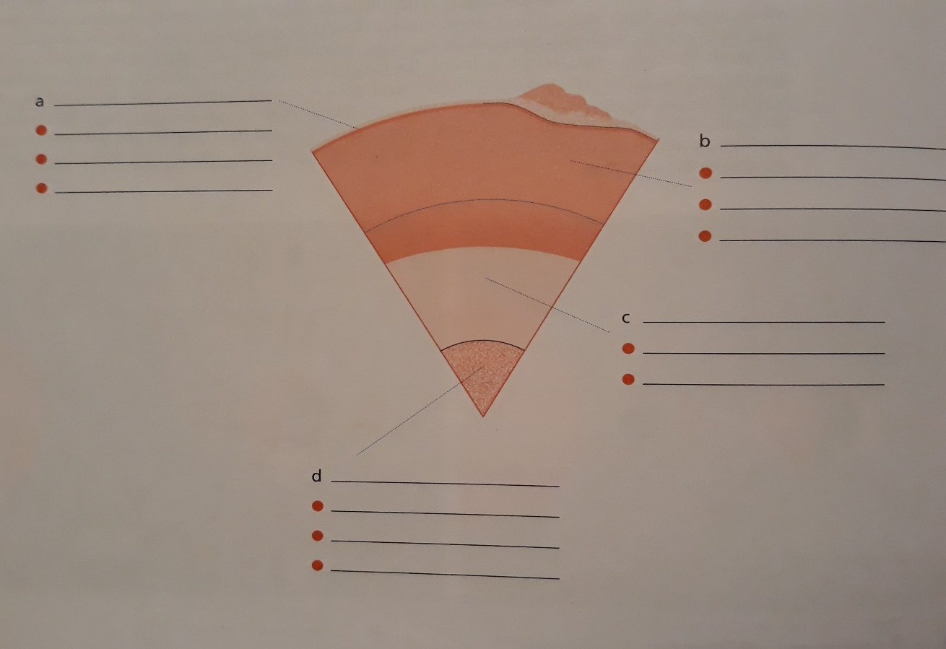

(adapted from Kelly, K. *Science.* Macmillan Education, 2008.)

**Task 3 Video: The Earth´s age**

**How old is the Earth? Watch the video and note down some of the analogies they present.**

<https://ed.ted.com/lessons/the-earth-s-age-in-measurements-you-can-understand-joshua-m-sneideman>

**After you watch:**

**How do geologists determine the age of planets? Why is understanding geological time significant?**

**Task 4 Predictions**

1. **Discuss in pairs:** What do you think your life will be like in 10, 25, 50 years? What do you think will be the main events in science in 10, 25 or 50 years?
2. **Predicting probability**: **Match the adverbs on the left with their equivalents:**

*Usually may/will possibly*

*Often certainly will not*

*Sometimes might*

*Occasionally may well*

*Rarely/ seldom probably will not*

*Never will probably*

**Alternative ways of predicting possibility:**

|  |  |  |  |
| --- | --- | --- | --- |
| It is  extremely/  fairly | certain | that X will occur. | 100% |
| probable |
| 50% |
| likely |
| possible |
| that X will occur.  that X will not occur. |
| improbable |
| unlikely |
| 0% |
| certain |

There is a/an extremely strong possibility that X will happen.

fairly high

weak

low

remote

no

The possibility that X will happen is extremely high/strong.

probability fairly low/ weak.

likelihood

1. **Using the structures for predicting probability, talk about a student of geology/**

**mathematics / literature / medicine / law.**

*E.g. A student of geology might have a microscope in his/her bedroom.*

1. **Reading – Read this passage and find predictions.**

**The World Turns**

The Earth is round; the fifteenth- and sixteenth-century explorers like Columbus and Magellan proved it. But there were ancient Greeks who had known this two thousand years earlier. They saw ships descend over the horizon and observed the curved shadow of the earth on the moon during a lunar eclipse. Then, in 200 B.C., the Greek astronomer Eratosthenes noted that at noon on the first day of summer, when the sun was at its highest, its rays shone to the bottom of a vertical well in Seyne, Egypt. Yet, on the same day in Alexandria, five hundred miles to the north, it was reported that a vertical post cast a shadow. If the earth had been flat, the post could not have cast a shadow at noon.

The earth spins, or rotates on its axis, once every twenty-four hours, causing us to have day and night. At any given time, the side of the earth facing the sun will have daylight, and the side turned away from the sun will have night. Although the earth is spinning at a speed of over one thousand miles an hour, we do not feel the movement or wind because everything around us, including the atmosphere, is moving at the same speed. The effect is similar to riding in an airplane. The air moves with you. If you light a match on an airplane, no wind will blow it out.

The earth also revolves around the sun once every year. This yearly revolution, plus the tilting of the earth on its axis, causes the seasons. When the sun´s rays are nearly overhead (*not* when the earth is closest to the sun) and the days are long, great amounts of the sun´s radiation are absorbed and the weather is hot. For example, from April through September, the North Pole tilts towards the sun and the northern hemisphere experiences summer while the southern hemisphere has winter. Then the North Pole tilts away from the sun and the seasons are reversed. On March 23 and September 21, the North Pole is not leaning toward or away from the sun. If you travelled around the earth on these two dates, you would find the days and nights equal every place you went.

(adapted from Bates, M.; Dudley-Evans, T. *Nucleus English for Science and Technology.* Longman, 1990)

**Which of the predictions you have found is probable, hypothetical and impossible?**

1. **A probable prediction:** This prediction will come true if certain conditions are met.
2. **A hypothetical prediction:** This prediction will also come true if certain conditions are met, but it may or may not come true.
3. **An impossible prediction:** Here, the prediction cannot be fulfilled because the condition is impossible, i.e. it is based on a past action.

**Now, formulate the sentence patterns for predictions below.**

1. **A probable prediction:***If + present tense, ……*
2. **A hypothetical prediction:**
3. **An impossible prediction:**

**Write all three types of predictions for the following:**

1. **active voice: s**tudy hard – pass the exam
2. **passive voice:** eclipse hidden – photos ruined

**Task 5 Grammar practice**

1. **Complete the sentences by filling in the proper form of the verb in parentheses:**
2. Plants will not grow if they _________ (be) deficient in nitrogen.
3. Many lives would have been saved if scientists ___________ (predict) the tornado.
4. A satellite will go into orbit when it _________ (reach) a speed of 18,000 miles per hour.
5. The calcium would melt if you _________ (heat) it to 845°C.
6. When winter comes, the bears __________ (hibernate).
7. If the iron bar was exposed to air, it ____________(rust).
8. If the compound had been acid, it ______________(turn) the litmus paper red.
9. It ____________ (be surprising) if the oil prices continued to rise.

(Zimmerman, F. *English for Science.* Prentice Hall Regents, 1989)

1. **Create predictions in any logical or imaginative way:**
2. After I graduate, ____________________
3. If I didn´t use English grammar correctly, _________________________ .
4. If I could go anywhere in the world, _______________________ .
5. My life would be easier if ___________________________ .
6. Had I known what my studies at university would involve, _______________ .
7. If I could change one thing in the world, ________________ .