**JAG03 Unit 1**

**Task 1** **The perfect learner**

**Study the diagram below. To what extent are you “The perfect Learner”?**

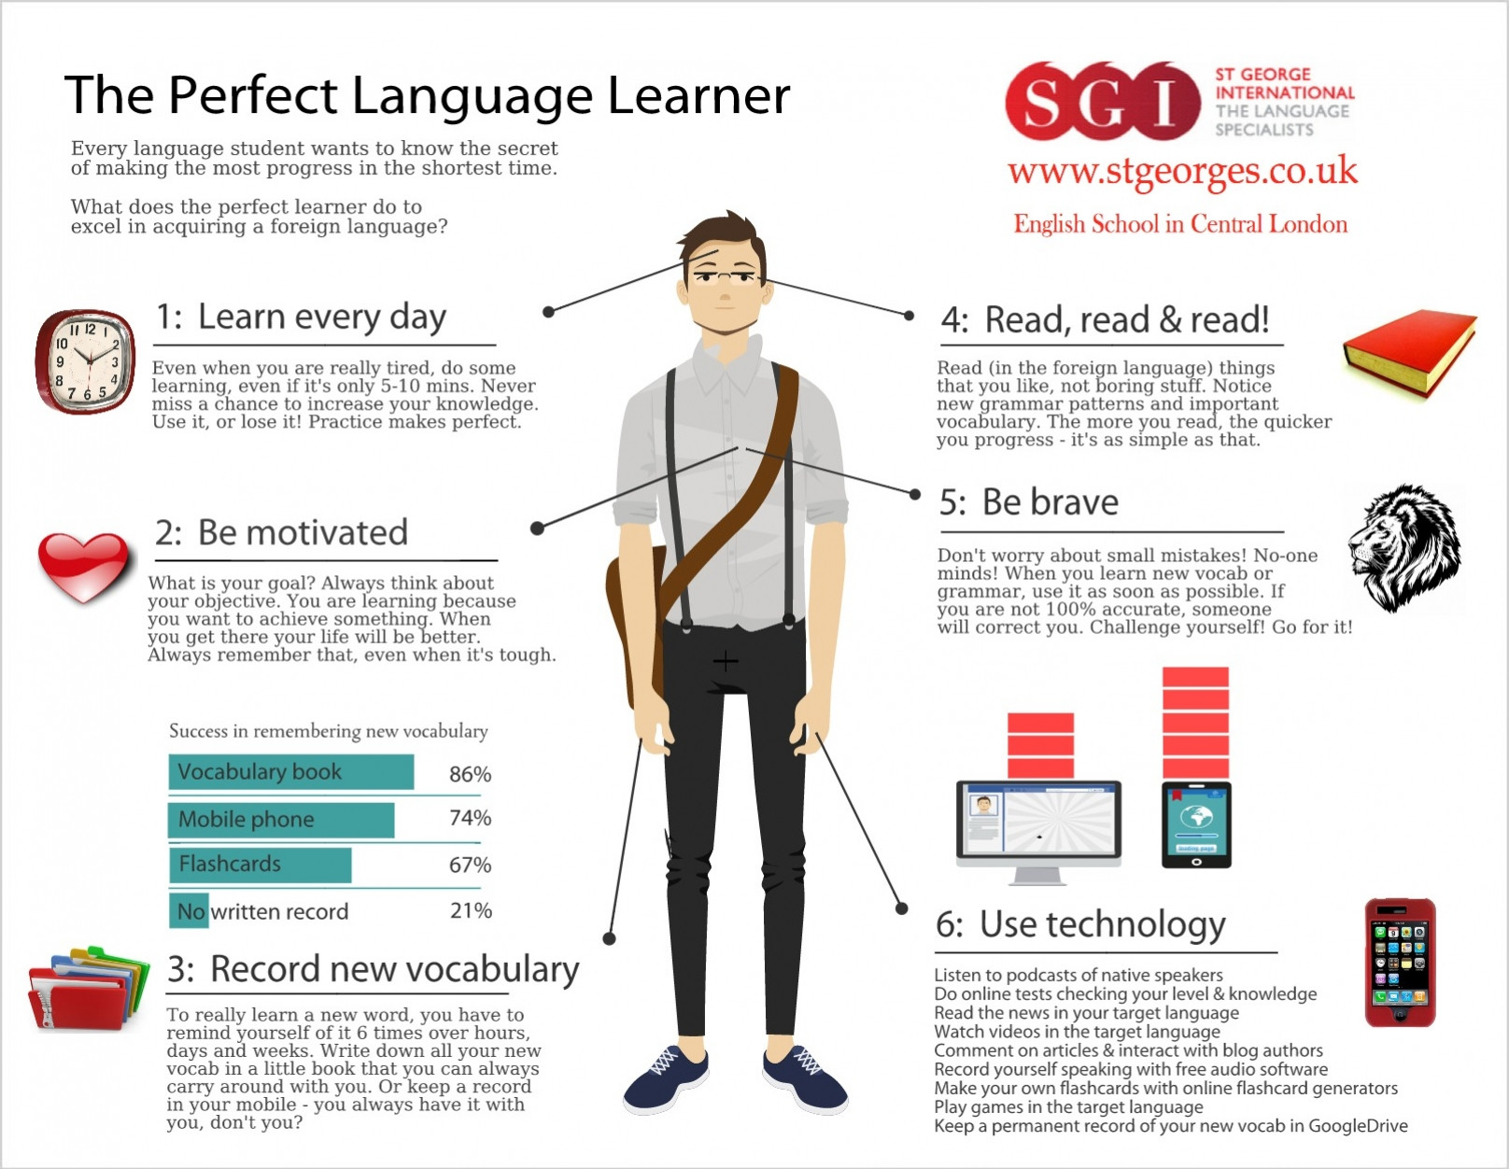

**Task 2 Word formation**

**Complete the gaps with the correct forms of the words in brackets.**

**How to learn vocabulary**

Students are under enormous …………………….. (PRESS) to learn huge amounts of vocabulary but they are rarely given ……………………. (GUIDE) as how to go about it. They have a ……………………….. (TEND) to try and learn long lists by heart, but this is hardly the most …………………………. (EFFICIENCY) approach to the problem. The golden rule is to do lots of ……………………….. (REVISE) at regular intervals. Secondly, students should concentrate on words with the highest ………………… (FREQUENT), particularly everyday words which also improve students´ spoken …………………… (FLUENT). They should also take every opportunity to use the words in ……………… (COMMUNICATE) – there is ………………. (CONSIDER) …………………………. (PSYCHOLOGY) evidence that learners who like using the foreign language improve their oral ………………………. (PERFORM) and their overall ………………… (ACQUIRE) of the language much more …………………… (RAPID) than students who are ……………………. (RELUCTANCE) to practise the language in real situations.

**Task 3 Listening – Being a non-native speaker of English**

**Glossary**

**Geordie** – a way of speaking in the area around Newcastle, in the north-east of England

**RP** – Received Pronunciation - the [standard](https://dictionary.cambridge.org/dictionary/english/standard) way in which [middle-class](https://dictionary.cambridge.org/dictionary/english/middle-class) [speakers](https://dictionary.cambridge.org/dictionary/english/speaker) of [southern](https://dictionary.cambridge.org/dictionary/english/south) British [English](https://dictionary.cambridge.org/dictionary/english/english) [pronounce](https://dictionary.cambridge.org/dictionary/english/pronounce) words

**You´re going to listen to two people talking about their experience of being non-native speakers of English.**

**What four questions do they answer?**

1. __________________________________ ?
2. __________________________________ ?
3. __________________________________ ?
4. __________________________________ ?

**Listen again and mark the sentences below W (woman), M (man) or B (both).**

1. They find some native speakers easier to understand than others. ___
2. They feel comfortable about being corrected. ___
3. They usually get what non-native speakers say because there is no hidden meaning. ___
4. They think that native speakers don´t spell as well as some non-native speakers. ___
5. They could have had an awkward conversation but, thankfully, it never occurred. ___
6. They notice a gap in their knowledge of English. ___

**Can you guess the meaning of these expressions/ phrases from the listening?**

*As far as* content *is concerned*…

Some dialects are harder to *decipher…*

They don´t use *obscure* cultural references…

It never *occurred to me* that she may be talking about…

I´m annoyed with myself when I make a *recurring* mistake…

He *insisted* that it was spelt with single ´m´.

I have to *switch back* to Hungarian.

It *would have been* very embarrassing for me…

**Task 4 Vocabulary – Collocations**

1. You have to *say / speak / talk* a number of languages to be a flight attendant.
2. The speaker went too fast, so it was impossible to *pass for / pick up / take in* all the information.
3. Bear in mind that children don´t always *say / talk / tell* the truth.
4. Did you manage to *brush up / get by / pick up* any Portuguese while you were in Lisbon?
5. Sorry, I didn´t get that. Can you *say / speak / tell* it again, please?
6. How will you *pick up / get by / pass for* in Kyoto if you don´t speak any Japanese?
7. He wants to have a few days off, so he needs to *say / talk / tell* to his boss.
8. She needs to *brush up / pick up / take in* her French before she takes up her new job in Paris.
9. The researchers found that 62% of those who learned Swedish between the ages of 1 and 11 *took in / picked up / passed for* native speakers with most of the judges.

(Tasks 3,4 adapted from Oxenden, C. (2010). *New English File Advanced Workbook*. OXU.)

**Task 5 Vocabulary – Idioms**

**Complete the idioms with a word denoting a part of the human body.**

I can´t remember the word but it´s on the tip of my ………………… .

I can´t give you the figures off the top of my ……………… but I´ll look them up and get back to you later.

It was a mistake to try to learn the whole presentation by ………………….. - at the crucial moment my mind went completely blank.

Hey, are you listening to me? - Yes, I´m all …………………… .

Tell me what happened. You´ll feel better when you get it off your ……………….. .