**Unit 2 Learning Autonomy**

**Task 1** **The perfect learner**

**Study the diagram below. To what extent are you “The perfect Learner”?**

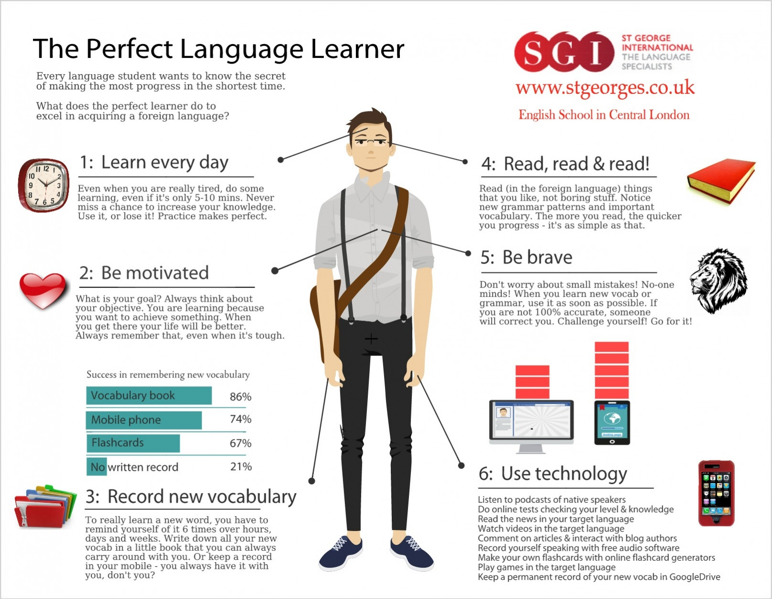

**Task 2 Word formation**

**How to learn vocabulary**

Students are under enormous …………………….. (PRESS) to learn huge amounts of vocabulary but they are rarely given ……………………. (GUIDE) as how to go about it. They have a ……………………….. (TEND) to try and learn long lists by heart, but this is hardly the most …………………………. (EFFICIENCY) approach to the problem. The golden rule is to do lots of ……………………….. (REVISE) at regular intervals. Secondly, students should concentrate on words with the highest ………………… (FREQUENT), particularly everyday words which also improve students´ spoken …………………… (FLUENT). They should also take every opportunity to use the words in ………………………… (COMMUNICATE) – there is …………………… (CONSIDER) …………………………. (PSYCHOLOGY) evidence that learners who like using the foreign language improve their oral ………………………. (PERFORM) and their overall ………………… (ACQUIRE) of the language much more rapidly than students who are ……………………. (RELUCTANCE) to practise the language in real situations.

**Task 3 Listening – The Bilingual Brain**

(<https://www.ted.com/talks/mia_nacamulli_the_benefits_of_a_bilingual_brain#t-180929>)

1. **Use the following verbs in sentences:**

involve process measure split

1. **Watch and answer the questions:**
2. What are the different types of bilinguals?
3. What are the functions of the left and right brain hemisphere?
4. What does the critical period hypothesis say about learning languages?
5. What advantages do bilinguals enjoy?
6. **Can you guess the meaning of the expressions in italics?**

People know and use their languages *in varying proportions*.

She is learning two languages *simultaneously*.

Everyone can learn a foreign language, *regardless of age*.

The child is *likely* to learn the language faster.

The difference between the speakers is not *apparent*.

Unconscious *bias* can influence your attitude towards a language.

# Task 4 Reading

# Read the text and summarise the main points of each section.

# Autonomous Learning is the Future of Education

* **Autonomous learning - innovation in education?**

We live in an exciting age of innovation. Technology plays an enormous role in that innovative spirit of change and discovery. Probably one of the most talked about technologies in today’s world is the self-driving car. Just think of the possibilities a driverless car presents: reading the newspaper on the way to work, getting your workout on the exercise machine installed in the car, watching the news on TV, and the list goes on and on. Could this be our future? Some say, “Why do we need a self-driving car? My car gets me where I want to go.” Future-ready thinkers say, “Why not?”

We are presented with the same kind of thinking when it comes to education. Let’s think about the self-driving student, also known as the self-directed learner or the autonomous learner. What do we mean by autonomous learning?  Betts and Knapp (1981) define autonomous learning as “one that solves problems or develops new ideas through a combination of *divergent and convergent thinking* and functions with minimal external guidance in selected areas of endeavour.”  Kember (1997) refers to autonomous learning as student-centered learning, shifting the focus of education from teaching to learning.

I like to think of it as the ability of the student to work independently and being given the freedom to do so. Autonomous learning would allow the learner to personalize his/her learning agenda based on his/her academic strengths and personal interests, and self-monitor his/her achievements. These are not unique ideas. Educators have been talking about independent learning, *personalized learning*, and *student-centered learning* for a very long time. The difference today is that new technologies have given us the unique abilities to accomplish this task with greater success.

* **Role of the teacher**

I can hear the sceptics as we speak. What about the teacher? Are we doing away with teachers? Regardless of the teaching/learning philosophy, the teacher remains an integral part of the learning process.  Just like an autonomous car, there needs to be some guidance and direction in order for that vehicle or in this case that student to arrive at its destination. Consider the teacher the GPS of the autonomous learner. The teacher will offer up a variety of paths to students’ destinations and also suggest best routes. The teacher will be the director of the system, helping students decide on their destinations and helping them get there by passing through various necessary skills and standards that the students will need once they reach that point.

The *teaching curriculum* might look a bit different in the autonomous classroom. The teacher will be responsible for sharing *self-monitoring strategies*. Students might use learning logs or charts and tables to follow their progress. Teachers will teach error analysis and help students use their mistakes as learning opportunities to accommodate their learning goals. Teachers must provide the necessary guidance to help students choose their personal learning goals. Teachers must provide feedback as student pursue their own questions and solve their own problems. Teachers remain the most important part of the autonomous classroom.

* **Example of autonomous learning**

Let’s take a look at autonomous learning: The student is working on her science objective in the field of chemistry. The student goes into her *virtual science laboratory*. Here she experiments using chemicals that might be considered dangerous in the traditional classroom. In the virtual lab, the student witnesses the chemical reactions and must determine why the chemical reacted in that manner. While in that virtual world, the student finds an artificially intelligent computer that moves the student through a lesson on chemical reactions. The student then logs her work and determines her ability to meet her goal(s).

That same student then meets in a small discussion group with her teacher and others to solve real world problems using necessary math skills. After drawing up a plan and arriving at a solution, the teacher uses *augmented reality* to determine if the solution actually solved the problem. The student will continue her learning at home as she uses her foreign language application to practice her language skills.

Autonomous learning is the future of education. We must now think that instead of having a classroom of twenty students, we now have “twenty classrooms” of one student, each with their own agenda.

(adapted from <https://www.huffingtonpost.com/entry/autonomous-learning-is-the-future-of-education_us_59e77f81e4b0153c4c3ec479?guccounter=1> by [Dr. L. Robert Furman](https://www.huffingtonpost.com/author/rob-364), 10/18/2017)

1. **Explain the meaning of the concepts in italics (use the Internet, if necessary).**
2. **Complete the gaps with prepositions:**
3. She referred ____ the subject of education of children with disabilities several times during her speech.
4. When it comes ____ education, whose interests do we really have at heart?
5. All the children are lumped together in one class, regardless ____ their ability.
6. We all argued about it for hours and eventually arrived ________ a decision.
7. The report is based _______ figures from six different countries we included in our research.