**Linking Spin-Orbit NMR Shielding at the Ligh Atom with Magnetically Induced Currents on Heavy-Atom–Light-Atom Bond**

Ben Joseph R. Cuyacot, Jan Novotný, and Radek Marek

*Department of Chemistry, Faculty of Science and CEITEC, Masaryk University,*

*Kamenice 5, CZ-62500, Brno, Czechia*

*benjoseph.cuyacot@mail.muni.cz*

The modulations of NMR shifts of Light Atoms (LA) by the relativistic spin-orbit (SO) coupling which originates from the neighboring Heavy Atom (HA) have been explored in numerous theoretical studies.1-3 This effect was also shown to be significantly influenced by the character of the HA–LA bond which could be modified by substituents oriented *trans* to the LA spectator atom.

In this study we explore the SO HALA effect further by examining the link between the SO effects on NMR shielding of the light atom (δSO) and molecular magnetically induced currents (SO-MICs).

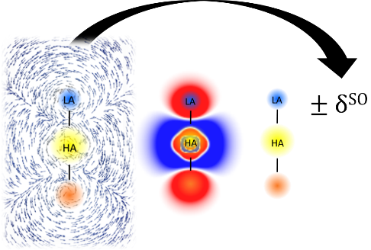

We used four-component approach employing Dirac–Kohn–Sham Hamiltonian to treat the SO effects, PBE0 functional, and simple HALA systems. We focused on the currents on HA–LA bonds and in the vicinity of light atom. The results revealed a clear link between the two properties and provide additional information about the HA–LA bonds.

**REFERENCES**

(1) Novotný, J.; Vícha, J.; Bora, P. L.; Repisky, M.; Straka, M.; Komorovsky, S.; Marek, R. *J. Chem. Theory Comput.* **2017**, *13* (8), 3586–3601. https://doi.org/10.1021/acs.jctc.7b00444.

(2) Vícha, J.; Straka, M.; Munzarová, M. L.; Marek, R.. *J. Chem. Theory Comput.* **2014**, *10* (4), 1489–1499.

(3) Vı́cha, J.; Novotný, J.; Komorovsky, S.; Straka, M.; Kaupp, M.; Marek, R. *Chem. Rev.* **2020**, *120* (15), 7065–7103.