Making Good's buffers good for freezing: The acidity changes and their elimination via mixing with sodium phosphate
Lukáš Veselý¹, Behera Susrisweta¹, Dominik Heger^{*1}
¹Department of Chemistry, Faculty of Science, Masaryk University, Kamenice 5, 625 00 Brno, Czech Republic
Solutions of three Good’s buffers (HEPES, MOPS, and MES), both pure and mixed with sodium phosphate buffers (Na-P), are investigated in terms of the freezing-induced acidity changes in their operational pH ranges. The Good’s buffers have the tendency to basify upon freezing and, more intensively, at lower pHs. The acidity varies most prominently in MES, where the change may reach the value of two. Importantly, the Good’s buffers are shown to mitigate the strong acidification in the Na-P buffer. Diverse concentrations of the Good’s buffers are added to cancel out the strong, freezing-induced acidity drop in 50 mM Na-P that markedly contributes to the solution’s acidity^{[1, 2]}; the relevant values are 3 mM HEPES, 10 mM MOPS, and 80 mM MES. These buffer blends are therefore proposed to be applied in maintaining approximately the acidity of solutions even after the freezing process and, as such, should limit the stresses for frozen chemicals and biochemicals.
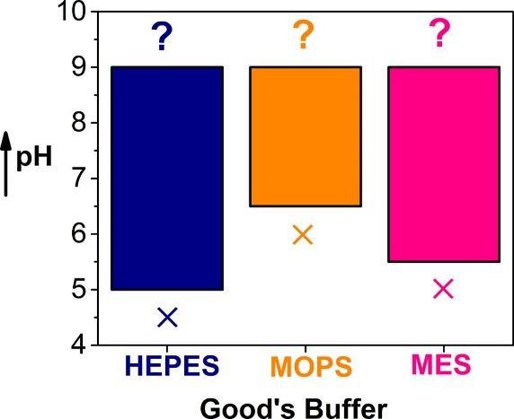
Graphical representation of the useful ranges (below one unit of acidity change) relating to the 50 mM Good’s buffers suitable for the freezing processes ^{[3]}.
1. Thorat, A.A. and R. Suryanarayanan, Characterization of Phosphate Buffered Saline (PBS) in Frozen State and after Freeze-Drying. Pharm Res, 2019. 36(7): p. 98.
2. Gomez, G., M.J. Pikal, and N. Rodriguez-Hornedo, Effect of initial buffer composition on pH changes during far-from-equilibrium freezing of sodium phosphate buffer solutions. Pharmaceutical Research, 2001. 18(1): p. 90-97.
3. Veselý, L., B. Susrisweta, and D. Heger, Making good's buffers good for freezing: The acidity changes and their elimination via mixing with sodium phosphate. Int J Pharm, 2021. 593: p. 120128.

