**Uncovering of the Structure and Reactivity Correlation of CO-photoreactions of 3-Hydroxyflavone-Based Acid-Base forms**

Marina Russo,† Peter Štacko, Lenka Karpíšková†, Petr Klán†,*

†Department of Chemistry and RECETOX, Masaryk University, Kamenice 5, 625 00, Brno, Czech Republic

The well-established toxicity of CO appears contradictory with its possible therapeutical function. Indeed, barely in the last century was discover that CO is produced endogenously.

Studies of the effects of CO have demonstrated its potential to produce a variety of beneficial health outcomes, including anti-inflammatory, anti-bacterial effects, and antiproliferative effects on cancer.[1] Therefore, carbon monoxide-releasing molecules (CORMs), biologically compatible agents allowing for defined administration of carbon monoxide into living organisms to circumvent its acute toxicity, are of special interest.[2] A precise spatial and temporal control over the CO release can be achieved via activation of the CORM by light (photoCORMs).

A good photoCORM should be stable under ambient conditions and soluble in aerobic aqueous environments. It should release CO using light at wavelengths that do not have the potential to impart cellular damage and may exhibit fluorescence to enable tracking in the cell.

Understanding the mechanism is a key step for designing new derivatives with improved properties for biological applications, such as water solubility, higher quantum yield and the absorption spectra in the visible light region.

The detailed mechanism of the photochemically induced CO release from 3-Hydroxy-2-phenyl-benzo[*g*]chromen-4-one has been studied in our group.[3]

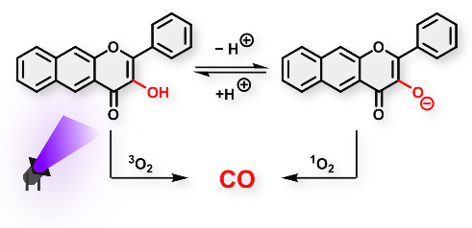

For a deeper comprehending, an uncovered study of the structure and reactivity correlation of CO-photoreactions of such class of compound will be presented in this station.

1. L. Vítek, H. Gbelcová, L. Muchová, R. Koníčková, J. Šuk, M. Zadinova, Z. Knejzlík, S. Ahmad, T. Fujisawa, A. Ahmed, T. Ruml, *Digestive and Liver Disease* **2014**, 46 369-375.
2. C. C. Romao, W. A. Blatter, J. D. Seixas, G. J. L. Bernades, *Chem. Soc. Rev*. **2012**, *41*, 3571-3583
3. Russo M., Štacko P., Nachtigallová D., Klán P J. Org. Chem. 2020, 85, 3527-3537.