**Protocol: Preparation of hemolymph smear**

**Theory:** Observation of hemocyte cells, hemolymph in invertebrates

**Objective:** to prepare a smear from one insect representative (Waxwing or Silkworm) to monitor hemocytes in insects.

**Material:**

Silkworm or weevil larvae, staining cuvettes, Leukodif staining kit (Biolatest) or Pappenheim staining solutions (May - Grünwald solution 1: 1 with water, Giemsa dye 1: 9 with distilled water, methyl alcohol), underlay glasses, gloves, glass cleaning alcohol, adjustable micropipettes, tips, eye scissors, thermal water bath

**Workflow:**

We cut 1 leg of the larva and catch the escaping hemolymph with a drop on a slide and rub the drop and heat the coated glass, eg for heating. The cells adhere better to the glass.

**Spread:**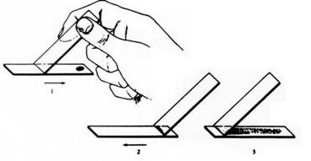

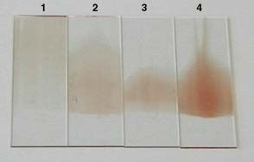

1. Too thin and long

2. good

3. Too short, the drop of blood was too small

4. Too strong, a drop of blood was too big

Retrieved from http://www.aum.iawf.unibe.ch/hemosurf/Demo_E/Lab/smears_quality.htm

**Pappenheim staining in cuvettes:**

3 min. fixation in a cuvette with methyl alcohol

3 min. May - Grunwald 1: 1 with water (preferably 2 min.)

15 min. Giemsa - Romanowski 1: 9 with water

catch the mfu with a drop on the slide and spread the drop and heat the coated glass, eg for heating. The cells adhere better to the glass.opláchnout ve vodě, nechat schnout

Note: slides slide backwards into 1 groove

another coloring variant

Leukodif 200 staining

immerse 5x1s in fixing solution No. 1 (methanol), wipe the drops against the wall of the container

immerse 3x1s in reagent No. 2 (Eosin dye), wipe the drops against the wall of the container

immerse 5x1s in reagent No. 3 (Azur dye), wipe the drops against the wall of the container

rinse in dest.H2O and allow to air dry

We will make simpler staining using Leukodif red

**Evaluation:** in the smear from hemolymph we observe hemocytes and draw

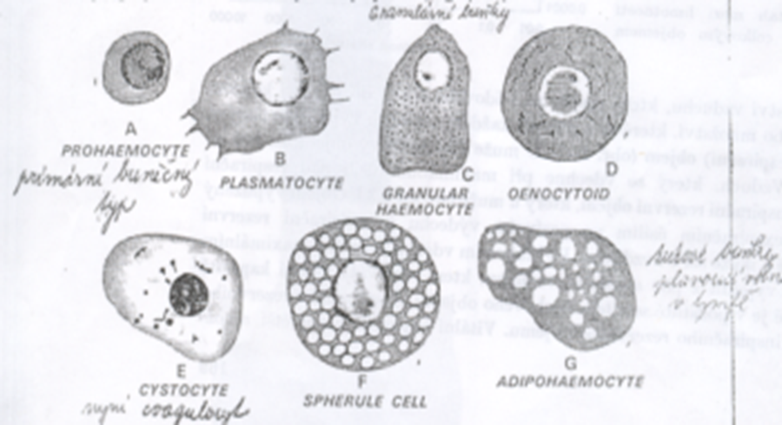

**Protocol**

**Monitoring of phagocytic abilities of hemocytes in silkworm larvae or wax moths.**

**Theory:** The following types of hemocytes are found in hemolymph: prohemocyte, plasma cell, granulocyte, eonocytoid, coagulocyte, spherulocyte, adipohemocyte. In Zavíječ they phagocytose plasma and granulocyte, in Bource only granulocyte. The aim will be to learn to recognize hemocytes and observe their phagocytic activity.

**Aim:** Monitoring of phagocytic activity of hemocytes, calculation of phagocytic index and% phagocytosis

Material:Larvae of Silkworm or Waxworm, starch grain solution, starch dilution: 15ml physiol. solution plus 0.25g starch, phenylthiourea, syringe - insulin, scissors, slides, staining solutions, eppendorfs, tips, adjustable micropipettes, microscope

**Method:**

1.Cut 1 leg of the larva and catch the escaping hemolymph with a drop on the slide and rub the drop and heat the coated glass (for heating)

2nd additional drop - transfer 15 μl to an eppendorf tube containing phenylthiourea so that the hemolymph does not clot, add 7 μl of starch particle solution and let it cultivate for 20 minutes

3.after culturing, drop a drop of hemolymph on the slide in the same way and grind and heat the coated slide (in vivo method)

4. we inject 20 μl of a solution of inert particles into the next larvae, let the larvae cultivate in the heat for 20 min (do not stretch the larvae during the injection), (in vitro zp.)

5. After culturing the particles (starch) in the larva, cut off 1 leg of the larva and catch the flowing hemolymph with a drop on the slide and rub the drop and heat the coated glass.

6.coat stains with Leukodif staining system or according to Pappenheim.

Result and evaluation: 1. We observe hemocytes (we draw and photograph at least three species) without phagocytosis and the same with phagocytosis. 2. Calculate the ratio of the amount of phagocytosed particles and the number of phagocytes and calculate the phagocytic index (FI) and the% of phagocytosis separately for phagocytosis with starch particles (in vitro method).

FI = (number of phagocytosed particles) / (number of phagocytic cells)

% phagocytosis = (number of phagocytic cells) / (total number of cells capable of phagocytosis in a given area) x 100

1. Smears are evaluated using the differential number of hemocytes, in which we denote as phagocytic only those particles that have absorbed 3 or more particles.

2. Calculate the phagocytic index FI by dividing the number of phagocytosed particles by the number of phagocytic cells.

3. Calculate the% phagocytosis by dividing the number of phagocytic cells in a given space by the number of all cells capable of phagocytosis and multiplying by 100.

**Evaluation example:**

|  |  |  |  |
| --- | --- | --- | --- |
| **plasmatocyte** | **granulocyte** | **unknown** | **summa** |
| 3 |  |  | 3 |
| 13, 12 | 1 |  | 3 |
| 3 |  |  | 3 |
|  |  |  |  |

**Table: numbers of phagocytic hemocytes in insect hemolymph smears**

**FI = number of phagocytosed particles / number of phagocytic cells = X**

**% F = number of phagocytic cells / number of cells capable of phagocytosis = x%**

**Experiment scheme**

|  |  |  |  |
| --- | --- | --- | --- |
| **METODA** | | **Without phagoc. (control)** | **Phagocytosis in vivo, in vitro** |
| each of  larva pair | larva  glass | drop →  → Spread, staining | 15 μl hemol with phenylthio + 5 μl (starch) → cultivation →  → Spread, staining , |
|  |  |  | larva + 20 μl (starch) →  → cultivation →  → Spread, staining |

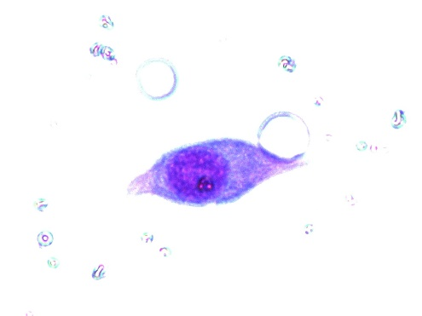 plasmocyte

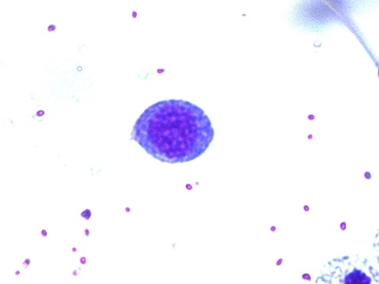 granulocyte

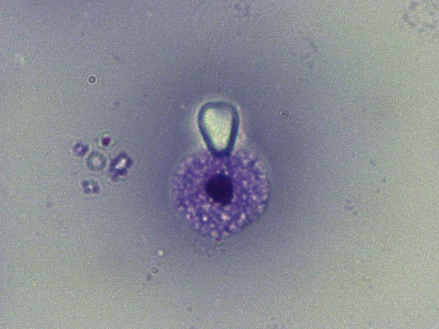 phagocytosis in vitro

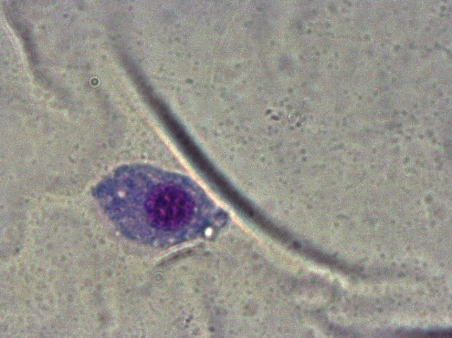 phagocytosis in vivo

Phagocytosis in vitro

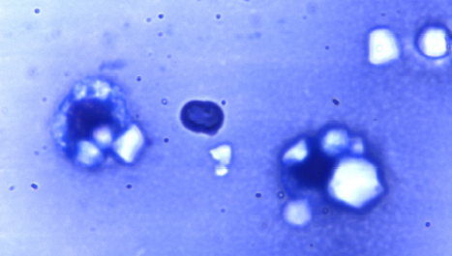

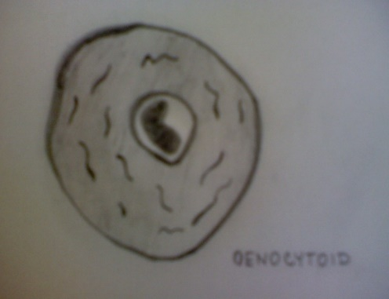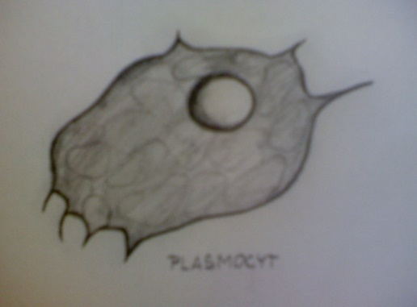

plasmocyt

oenocytoid