**Lymphocyte activity and cytotoxicity test**

**Theory:** Proliferation is one of the physiological phenomena of cell activation. There are several ways to detect lymphocyte activity. One of the best known is the use of radiolabeled thymidine (3H-thymidine), where we are able to quantitatively examine lymphocyte proliferation in the laboratory, because thymidine is incorporated into the DNA of dividing cells and labeled in this way. The formation of new DNA is proportional to the amount of cell division. Another option for rapidly determining the proliferation and cytotoxicity of mammalian cells is to determine the amount of cellular ATP (adenosine triphosphate). This assay replaces the incorporation of 3H thymidine.

For division, lymphocytes can be stimulated in vitro polyclonally or specifically. Lectins, plant proteins that bind to cell membrane glycoproteins, act as polyclonal mitogens. They activate the lymphocyte regardless of its antigenic specificity. Phytohemagglutinin (PHA) and concavalin A (Con A) are used to stimulate T cells, and pokeweed mitogen (PWM) is used to activate B cells. Monoclonal antibodies can also be used, for example an anti-CD3 antibody. We use tetanus toxoid (antigen) for specific stimulation, as well as E. coli or tuberculin. The presence of antigen-presenting cells, such as monocytes, is essential here. In our exercise, we will not stimulate lymphocytes, but only measure their activity without the addition of stimulants.

**Technical overview**

This kit (BioThema) can be used to detect the bioluminescence of adenosine 5´-triphosphate (ATP) released from a suspension of living somatic cells. The cell concentration can be calculated provided that the amount of ATP per cell does not change much. The number of living somatic cells is counted selectively because when a cell dies, its ATP is significantly reduced.

Generally, a live somatic cell contains 1 picogram (10-12 grams) or 2 femtomoles (2 x 10-15 moles) of ATP. More accurate data for a particular cell line and growth medium can be obtained from the literature or by staining and counting living cells. Live somatic cell ATP can be defined as:

**ATP + D-luciferin + O2 Oxyluciferin + AMP + CO2 + PPi + light**Když je ATP limiting factor, the light emitted is proportional to the amount of ATP present, which is progressively proportional to the number of somatic cells in the sample.

Due to the different properties of the cells (it is not a 100% homogeneous culture), not exactly determined cell concentration by counting in the Bürker chamber (human error), possible inaccuracies in dilution, etc., the calculated amount of ATP may serve as a guide only.

Aim: Tests of lymphocyte activity and cytotoxicity

In our exercise we will not stimulate lymphocytes, but A) we will only measure the activity without the addition of stimulants - control

B) we measure the cytotoxicity of lymphocytes by adding a determined concentration of colloidal silver

Material: centrifuge, cell counting chambers, eppendorf tubes, test tubes, adjustable micropipettes and tips, 0.87% NH4Cl, PBS lymphocyte storage solution, mouse spleen

Workflow:

Isolation of lymphocytes from mouse spleen

1. Bleed the mouse carotid artery and remove the spleen.

2. Homogenize the spleen in PBS.

3. Carefully pour the cell suspension with the spleen residue over the gauze and centrifuge for 10 minutes at 1000 rpm.

4. Resuspend the pellet in about 300 l NH 4 Cl and centrifuge for 10 min at 1500 rpm.

5. Resuspend the pellet in about 300 PBSl PBS (3x).

6. Resuspend cells in about 1-1.5 ml PBS (depending on the number of cells) and count. In addition to lymphocytes, monocytes and granulocytes are also present in the solution.

Counting in Bűrker's chamber: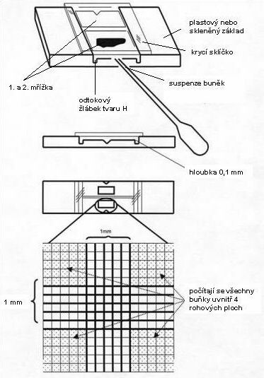

literature[**http://www.who.int/vaccines/en/poliolab/webhelp/Figure_4.2.htm**](http://www.who.int/vaccines/en/poliolab/webhelp/Figure_4.2.htm)

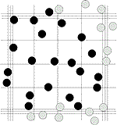 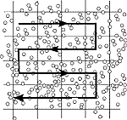

(<http://www.superior.de/pgr06_info_e.htm>)

**To calculate the amount of cells in 1 ml of suspension, it is necessary to know the thickness of the sample above the grid. Each of the 25 squares typically measures 0.2 x 0.2 x 0.1 mm and thus has a volume of 0.004 mm 3. So 25 squares has a volume of 0.1 mm3. Multiplying the number of cells in 25 squares by 10,000 gives the number of cells in 1 ml of suspension.**

**Determination of the relative amount of ATP**

**ATP Reagent SL - lyophilisate containing D-luciferin, luciferase and stabilizers,**

**Lysing Diluent - Tris (hydroxymethyl) aminomethane solution, EDTA, lysing agent, ATPase inhibitor. It is used to dissolve ATP Reagent SL**

**Work-kit procedure:**

**Dissolve the entire contents of the ATP Reagent SL vial by adding the entire volume of another vial of Lysing Diluent. Note The result will be a 12 ml solution that needs to be drained or then frozen when left, but an accurate result after thawing is not guaranteed.**

**Sample preparation:**

**Pipette 50 μl of extractant into the strips, then add:**

**1. Use 3 different dilutions of the cell solution in duplicate - for each dilution, the control must be silver-free, concentrated, 2x diluted and 4x diluted, all in an amount of 50 μl.**

**Edit 3x Blank: blank without cells and without silver, without cells with silver, with cells and with silver. Add 50 μl of nanosilver solution at a concentration of 50 ppm (50 mg / l) to each diluted sample, allow to cultivate at 37 ° C for 15 minutes.**

**2. Pipette cells in PBS in which the amount of ATP is determined in a volume of 100ul in triplicate (or duplicate) into the wells in the strip.**

**3. Add 50 μl of reconstituted ATP Reagent SL to each well and mix.**

**4. Measure the luminescence (RLU) corresponding to the amount of ATP**

|  |  |  |  |  |
| --- | --- | --- | --- | --- |
| The solution with cells in ul | Solution with Ag | reagent | PBS | value luminiscence |
| Concentrated 50 | 50 | 50 |  |  |
| 2x diluted 50 | 50 | 50 |  |  |
| 4x diluted 50 | 50 | 50 |  |  |
| Blank 50 |  | 50 | 50 |  |
| Blank 50 | 50 | 50 |  |  |
|  | 50 | 50 | 50 |  |

**Evaluation:**

After subtracting the average luminescence value of the blank, plot the average luminescence values against the appropriate concentration / amount of cells in 50 l pipetted into the well in the strip and evaluate the extent to which the luminescence value changed.

Evaluation example:

Number of cells before adding silver = lymphocytes / ml

Number of cells after addition of silver = X lymphocytes / ml

→ loss of about X lymphocytes

Initial silver concentration: 50 mg / l

**Evaluation example:**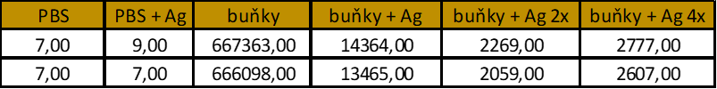

Graph of luminescence dependence on lymphocyte concentration in individual variants and dilutions: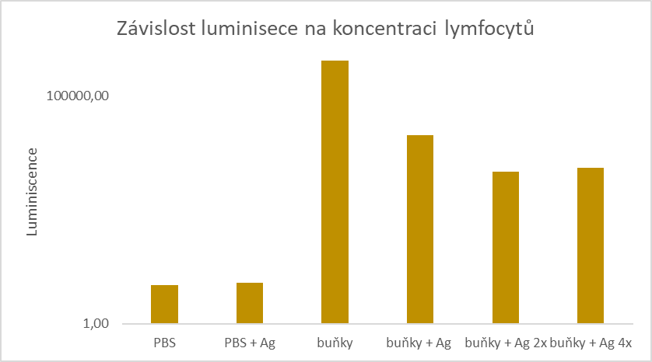

**Conclusion:**