Isolation of salivary glands from ticks Ixodes ricinus
The procedure is based on an article by L. Paulin Maldonado-Ruiz and his team (1996). The salivary glands were prepared from 14 females into 2 test tubes. The selected individuals were females, due to better handling compared to small nymphs.
Reagents
• 0.5% NaClO
• 70% Ethanol
• PBS (phosphate buffer) pH 7.4
• dH2O
Instruments and laboratory equipment
• Binocular microscope (brand)
• Scalpel, tweezers, needle
• Common laboratory equipment: Eppendorf test tubes, automatic pipettes, tips, petri dishes, parafilm,
Method
Subjects were placed one at a time on a petri dish, where they were sterilized with 0.5% sodium hypochlorite. Subsequently, wash with 70% ethanol and wash with dH2O before the preparation itself. The subject was placed on a piece of parafilm, which was spread on the surface of a petri dish, and then the tick was dripped with PBS buffer. The preparation was performed under a binocular microscope, where it was performed from the front part, in order to avoid as much as possible contamination with intestinal components. The dorsal integument was first dissected and removed, and then the salivary glands (anatomy see Figure 5) were transferred to a tube with PBS buffer. Thus, the samples were stored at -20 ° C.
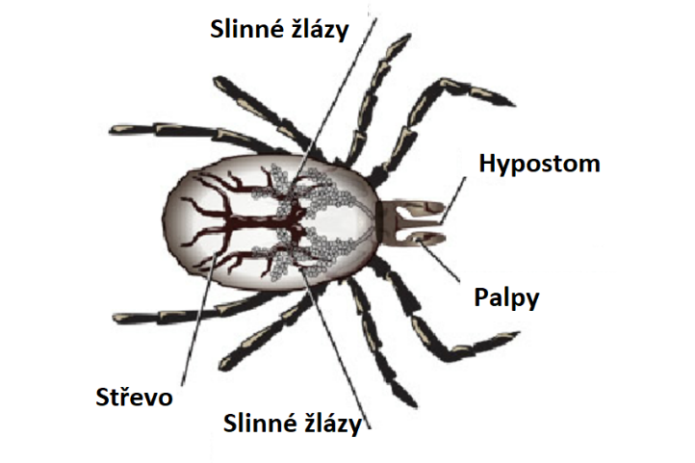
Location of salivary glands in the tick Ixodes ricinus (URL5), modified

