Immunochromatographic determination of the absence of antibodies against HIV

Theory: In vitro test, visual reading, qualitative immunoassay for the detection of antibodies to HIV-1 and HIV-2 in human serum, plasma or whole blood. Detection of antibodies in infected individuals.
Acquired Immunodeficiency Syndrome (AIDS) is characterized by changes in the T cell population. In an infected individual, the virus causes depletion of Th lymphocytes, which leads to a lower immune system. The virus exists in two related types, HIV-1 and HIV-2. The presence of HIV causes the production of specific antibodies against both types.

Objective: To confirm the absence of antibodies to the HIV virus
Method: immunochromatographic method in the form of a cassette test (precipitation)
Material: cassette TEST, sample from the individual's serum
Procedure: Sampling:
1. from a finger into EDTA tubes or into eppendorf tubes by a standard method to obtain blood, serum or plasma
2. from a vein in order to obtain blood
Store samples in the refrigerator for a maximum of 7 days
Apply 50μl from all sources (blood, serum, plasma) to the site in the cartridge marked with an arrow and wait 15-60min and read the result. If blood is used, 1 drop of Chase buffer is added to the same site as the sample 1 minute after sample application.

The sample is applied to the plate. As it migrates through the conjugate plate, it is diluted and mixed with the selenium antigen that is bound to the plate by the colloidal conjugate. This solution migrates through the solid phase to the patient part (panel) where the recombinant antigens and synthetic peptides are immobilized. If there are antibodies in the sample, they bind to the antigen-selenium colloid and to the antigen in the patient's window. If there are no antibodies in the sample, the antigen-selenium colloid passes through the patient window and no red line is formed. A control panel is included for quality control.
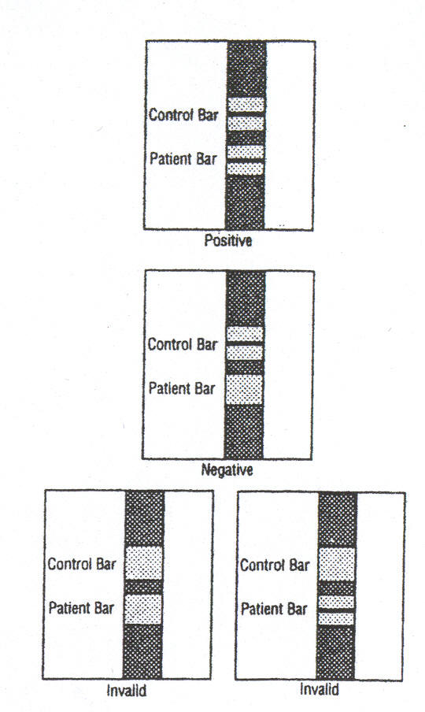

A Interpretation of results:
- positive: a red bar appears on both the control panel and the patient panel

- negative: the red bar appears only in the control section

- invalid: no red stripe appears anywhere

Results: A blood sample diluted by adding a drop of Chase buffer will pass through all parts of the cassette test during incubation. After about 15 minutes, a clear band will form in the control part of the test.

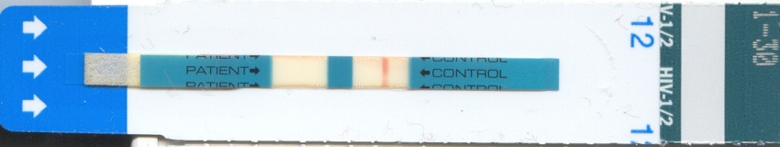

Cassette test for the detection of anti-HIV antibodies with a visible red stripe in the control section. The patient portion is empty because the test sample did not contain anti-HIV antibodies that could bind to the antigen immobilized therein.

Comment:
- the test is positive, even if the strip in the patient part is thicker or weaker than in the control part
- the strength of the strip in the patient's part does not correlate with the titer of antibodies in his blood
- a negative result does not rule out the possibility of HIV infection. A false negative result may occur if:
- amount of antibodies lower than the lower limit of the test
- infection with a virus variant for which the test is not intended
- The patient's HIV antibodies do not bind to specific antigens in the test
- poor sample handling is reflected in poor antibody binding
- positive specimens should be retested by another method and compared with the overall clinical condition
There are validation tests of this set when verifying positivity or negativity in patients and negative individuals. All tests were 100% to verify the accuracy of these defectstových testů.

