**Immunochromatographic determination of the presence of Helicobacter pylori in stool**

**Characteristics:** Helicobacter pylori is a bacterium that lives in the epithelium of the duodenum and stomach. It is transmitted from person to person through contact with the stomach contents. Vomiting or stool infected people. They also survive on dental plaque, also on a poorly washed cup. It has also been shown in saliva, it can be transmitted by kissing. Only a person with insufficient resistance to this microorganism can become infected. The immun is responsible for that. body system. It causes inflammation of the lining of the stomach and duodenum and subsequently develops ulcers in these organs, which can also turn into cancer. The Helicobacter pylori test is intended for rapid qualitative immunochromatographic determination of H. pylori infection in faeces and also for checking the success of treatment of the infection and as a control 6 weeks after the end of treatment.

**Procedure:** Collect stool samples on toilet paper or in a suitable container. It is best to perform the examination immediately after sampling.

Open the colored top of the tube and immerse the probe tip (full thread) in the stool sample at various locations, max as much stool as the thread can hold. Place the probe in a test tube, screw in well and shake. Remove the test plate from the aluminum foil. Break off the tip of the top, resp. release the tip at the top of the closed tube and squeeze three drops from the window marked with an arrow, resp. the letter S on a test plate. After 10 minutes, one or 2 bars appear on the plate. Do not count the results after the 15th minute

**Evaluation:**

Positive result - The sample is positive for H. pylori: Two pink dashes appear on the test plate. The colored bars in the positive reaction zone T and the control zone C may differ in color intensity. However, this does not affect the interpretation of the results.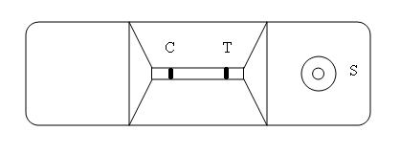

Negative result - One colored dash is formed on the test plate in control zone C - there is no H. pylori in the stool.

The test was not performed correctly if no comma appears on the plate in control area C, in which case add a few more drops of extract. If it still does not appear, repeat the test with a new test plate.

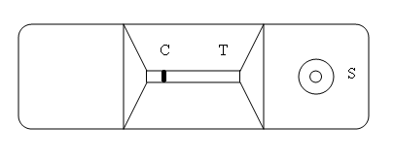

**Reaction:** there is an antibody against H. pylori in the T zone in the plate and it is absorbed on the nitrocellulose membrane in the sample line. The control antibody is absorbed into zone C, which turns pink after use of the assay (see Figure). Both antibodies are conjugated and dried on an inert fibrous support. This, together with the membrane, forms a test strip. The test strip is located on the right side of the test cartridge.

