**Immunochromatographic determination of the presence of hemoglobin in stool**

**Objective:** Rapid test for qualitative detection of the presence of hemoglobin in stool

**Characteristics:** Colorectal cancer is one of the most common types of cancer. Its incidence is constantly increasing and most often affects people over the age of 45.

**Manifestations:** Polypeptic growths occur in 10% of the population in the intestinal and rectal mucosa. As many as 1% of them are malignant and polyps larger than 0.5 cm are constantly bleeding through constant irritation. The warning signal for detecting the disease is blood in the stool, which is in the initial stage invisible to the eye.

Determination of human hemoglobin in this occult stool bleeding using this test is a simple and reliable immunochromatographic examination of colorectal cancers and colon and rectum.

Another possible damage to the intestinal mucosa may be the presence of parasites. It is also manifested by bleeding into the stool.

**SAMPLE COLLECTION AND PREPARATION**

1. This test is only for stool samples that have been obtained and prepared using the included sampling aids. The stool sample must not be contaminated with toilet water.

2. Because this test only detects human hemoglobin, no special diet is required in advance. However, the subject should discontinue alcohol, aspirin, and drugs that irritate the GIT 48 hours prior to the test.

3. The test is not performed if the patient has hemorrhoids, or blood in the urine, during menses and 3 days before and after due to possible false positives.

4.Use the enclosed paper, which you attach to the edge of the toilet bowl (according to the drawing) with stickers. Unscrew the top of the sample container and use the stick to obtain the sample by inserting it into 3 places in the stool. Make sure you have actually taken a sample. Too small a quantity can cause false negatives.

5. Insert the sample rod back into the container and close tightly. Mix thoroughly with the liquid in the container. The collected sample can be stored at room temperature for up to 14 days (cold 4-8 ° C) for up to a month.

TEST PERFORMANCE

1. The stool sample solution must be allowed to reach room temperature if stored cold. Stir thoroughly before use! The white cap must be tightly closed.

2. Do not remove the test cartridge from the envelope until just before use and place it on a flat, dry surface.

3. Grasp the sample solution container with the top facing up, then break off the tip of the blue cap

Apply 3 drops of sample solution to the well of the cassette marked S (sample)

4. You can observe how the pinkish antibody proceeds with the sample through the chromatographic membrane

the result window. Read the result after 5 to 10 minutes (within 15 minutes at the latest).

Note This procedure applies to work at room temperature (15-30 ° C). At significantly lower temperatures, the reading time increases.

**INTERPRETATION OF THE RESULT**

A control line C must appear at the top of the results window to confirm that the test was performed correctly and that a sufficient amount of sample was applied. The actual test result appears as a reddish line next to the T (test) mark at the bottom of the window.

**Positive result:** 2 colored lines in the result window, one at T (test), the other control (C)

**Negative result:** 1 colored line, control only, marked C. No coloration is visible on the T (test) mark

If the control line does not appear at mark C, there is an error in the test procedure and the result cannot be evaluated!

Note A positive result does not appear immediately, you have to wait 10 minutes to create a colored line. The color shade of the lines may vary

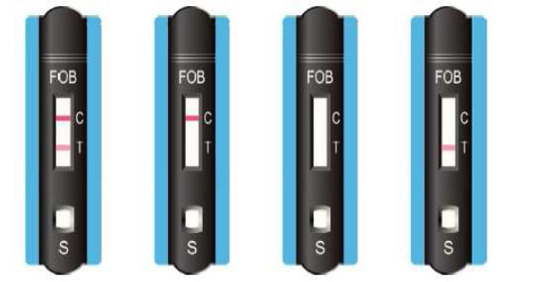

Sensitivity: The sensitivity of the test is 40 ng / ml.

Reaction: there is an antibody against one of the components of the hemoglobin protein in zone T and it is absorbed on the nitrocellulose membrane in the sample line. The control antibody is absorbed into zone C, which turns red after use of the assay (see figure). Both antibodies are conjugated and dried on an inert fibrous support. This, together with the membrane, forms a test strip. The test strip is located on the right side of the test cartridge.