 | www.qiagen.com

Quantitation Report

Experiment Information
Run Name | Run 2021-12-15-sk3
Run Start | 15.12.2021 10:53:27
Run Finish | 15.12.2021 12:30:12
Operator | MP
Notes
Run On Software Version | Rotor-Gene Q Software 2.0.2.4
Run Signature | The Run Signature is valid.
Gain Green | 10,
Machine Serial No. | 0911113

Quantitation Information
Threshold | 0,030
Left Threshold | 5,000
Standard Curve Imported | No
Standard Curve (1) | conc= 10^(-0,360*CT + 10,759)
Standard Curve (2) | CT = -2,779*log(conc) + 29,898
Reaction efficiency (*) | (* = 10^(-1/m) - 1) 1,29001
M | -2,77904
B | 29,89843
R Value | 0,99501
R^2 Value | 0,99004
Start normalising from cycle | 1
Noise Slope Correction | Yes
No Template Control Threshold | % 0
Reaction Efficiency Threshold | Disabled
Normalisation Method | Dynamic Tube Normalisation
Digital Filter | Light
Sample Page | Page 2
Imported Analysis Settings

Profile
Cycle | Cycle Point
Hold 1 | Hold @ 95°C, 10min 0s
Cycling (35 repeats) | Step 1: Hold @ 95°C, 15s
Cycling (35 repeats) | Step 2: Hold @ 60°C, 30s, acquiring to Cycling A([Green][1][1])
Cycling (35 repeats) | Step 3: Hold @ 72°C, 20s
Hold 2 | Hold @ 72°C, 1min 0s
Melt | Ramp from 55°C to 90°C
Melt | Hold for 90s on the 1st step
Melt | Hold for 5s on next steps,Melt A([Green][1][1])

Raw Data For Cycling A.Green
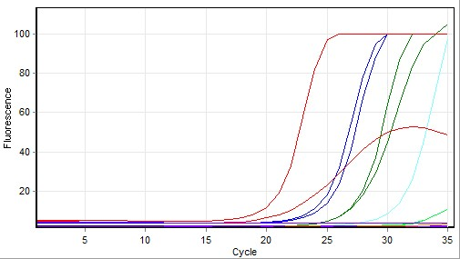

Quantitation data for Cycling A.Green
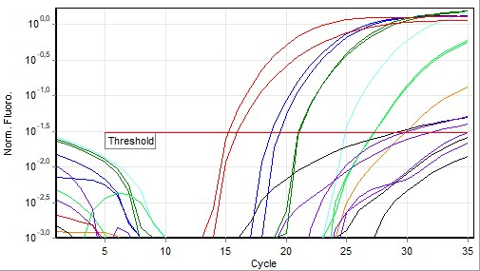

Standard Curve
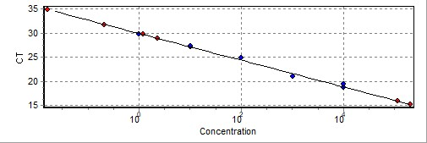
No. | Color | Name | Type | Ct | Ct Comment | Given Conc (IU/ml) | Calc Conc (IU/ml)
41 |  | T6 3 1X | Standard | 18,71 |  | 10 000 | 10 593
42 |  | T6 3 1X | Standard | 19,37 |  | 10 000 | 6 147
43 |  | T6 3 10x | Standard | 20,99 |  | 1 000 | 1 603
44 |  | T6 3 10x | Standard | 21,05 |  | 1 000 | 1 525
45 |  | T6 3 100x | Standard | 24,83 |  | 100 | 67
47 |  | T6 3 1000x | Standard | 27,20 |  | 10 | 9
48 |  | T6 3 1000x | Standard | 27,22 |  | 10 | 9
49 |  | T6 3 10000x | Standard | 29,79 |  | 1 | 1
51 |  | 3 NK | Unknown | 31,76
52 |  | 3 NK | Unknown
53 |  | D6 3 ACO4 | Unknown
54 |  | D6 3 ACO4 | Unknown
55 |  | D6 3 ACO4 | Unknown | 28,89 |  |  | 2
56 |  | 3 NK | Unknown | 34,85
58 |  | B6 3 ACO4 | Unknown | 15,87 |  |  | 111 541
59 |  | B6 3 ACO4 | Unknown | 15,17 |  |  | 199 580
60 |  | 3 NK | Unknown | 29,68 |  |  | 1
-
Warning: The following samples were not analysed :
1T6 1 1X- 2T6 1 1X- 3T6 1 10x- 4T6 1 10x- 5T6 1 100x- 6T6 1 100x- 7T6 1 1000x- 8T6 1 1000x- 9T6 1 10000x- 10T6 1 10000x- 111 NK- 121 NK- 13D6 1 ACO3- 14D6 1 ACO3- 15D6 1 ACO3- 16B6 1 ACO3- 17B6 1 ACO3- 18B6 1 ACO3- 191 NK- 201 NK- 21T6 2 10X- 22T6 2 10X- 23T6 2 1x- 24T6 2 1x- 25T6 2 100x- 26T6 2 100x- 27T6 2 1000x- 28T6 2 1000x- 29T6 2 10000x- 30T6 2 10000x- 312 NK- 322 NK- 33D6 2 ACO2- 34D6 2 ACO2- 35D6 2 ACO2- 362 NK- 37B6 2 ACO2- 38B6 2 ACO2- 39B6 2 ACO2- 402 NK- 46T6 3 100x- 50T6 3 10000x- 57B6 3 ACO4
Legend:
NEG (NTC) - Sample cancelled due to NTC Threshold.
NEG (R. Eff) - Sample cancelled as efficiency less than reaction efficiency threshold.
This report was generated by Rotor-Gene Q Series Software 2.3.1 (Build 49)
Copyright 2013 QIAGEN GmbH. All Rights Reserved.

