 | www.qiagen.com

Quantitation Report

Experiment Information
Run Name | Run 2021-12-15-sk4
Run Start | 15.12.2021 13:53:27
Run Finish | 15.12.2021 15:40:16
Operator | MP
Notes
Run On Software Version | Rotor-Gene Q Software 2.0.2.4
Run Signature | The Run Signature is valid.
Gain Green | 10,
Machine Serial No. | 0911113

Quantitation Information
Threshold | 0,030
Left Threshold | 5,000
Standard Curve Imported | No
Standard Curve (1) | conc= 10^(-0,462*CT + 13,104)
Standard Curve (2) | CT = -2,165*log(conc) + 28,364
Reaction efficiency (*) | (* = 10^(-1/m) - 1) 1,89724
M | -2,16458
B | 28,36425
R Value | 0,94975
R^2 Value | 0,90203
Start normalising from cycle | 1
Noise Slope Correction | Yes
No Template Control Threshold | % 0
Reaction Efficiency Threshold | Disabled
Normalisation Method | Dynamic Tube Normalisation
Digital Filter | Light
Sample Page | Page 2
Imported Analysis Settings

Profile
Cycle | Cycle Point
Hold 1 | Hold @ 95°C, 10min 0s
Cycling (40 repeats) | Step 1: Hold @ 95°C, 15s
Cycling (40 repeats) | Step 2: Hold @ 60°C, 30s, acquiring to Cycling A([Green][1][1])
Cycling (40 repeats) | Step 3: Hold @ 72°C, 20s
Hold 2 | Hold @ 72°C, 1min 0s
Melt | Ramp from 55°C to 90°C
Melt | Hold for 90s on the 1st step
Melt | Hold for 5s on next steps,Melt A([Green][1][1])

Raw Data For Cycling A.Green
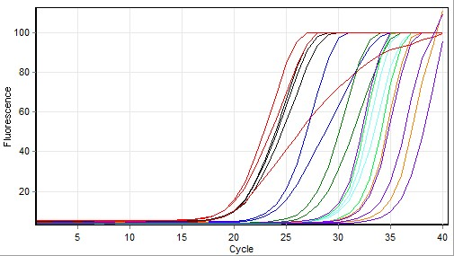

Quantitation data for Cycling A.Green
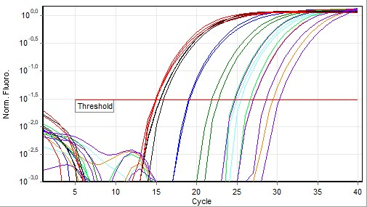

Standard Curve
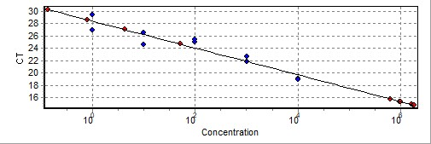
No. | Color | Name | Type | Ct | Ct Comment | Given Conc (IU/ml) | Calc Conc (IU/ml)
1 |  | T6 1X | Standard | 19,08 |  | 10 000 | 19 419
2 |  | T6 1X | Standard | 18,96 |  | 10 000 | 22 162
3 |  | T6 10x | Standard | 21,86 |  | 1 000 | 1 014
4 |  | T6 10x | Standard | 22,61 |  | 1 000 | 458
5 |  | T6 100x | Standard | 24,96 |  | 100 | 37
6 |  | T6 100x | Standard | 25,42 |  | 100 | 23
7 |  | T6 1000x | Standard | 24,55 |  | 10 | 58
8 |  | T6 1000x | Standard | 26,55 |  | 10 | 7
9 |  | T6 10000x | Standard | 29,41 |  | 1
10 |  | T6 10000x | Standard | 26,96 |  | 1 | 4
11 |  | NK | Unknown | 26,99 |  |  | 4
12 |  | NK | Unknown | 24,67 |  |  | 51
13 |  | D6 ACO1 | Unknown | 15,83 |  |  | 614 583
14 |  | D6 ACO1 | Unknown | 15,39 |  |  | 988 758
15 |  | D6 ACO1 | Unknown | 15,43 |  |  | 949 130
16 |  | B6 ACO1 | Unknown | 14,86 |  |  | 1 734 706
17 |  | B6 ACO1 | Unknown | 14,91 |  |  | 1 637 042
18 |  | B6 ACO1 | Unknown | 14,82 |  |  | 1 810 215
19 |  | NK | Unknown | 28,58 |  |  | 1
20 |  | NK | Unknown | 30,22
-
Warning: The following samples were not analysed :
21T6 1X- 22T6 1X- 23T6 10x- 24T6 10x- 25T6 100x- 26T6 100x- 27T6 1000x- 28T6 1000x- 29T6 10000x- 30T6 10000x- 31NK- 32NK- 33D6 ACO5- 34D6 ACO5- 35D6 ACO5- 36B6 ACO5- 37B6 ACO5- 38B6 ACO5- 39NK- 40NK- 41T6 1X- 42T6 1X- 43T6 10x- 44T6 10x- 45T6 100x- 46T6 100x- 47T6 1000x- 48T6 1000x- 49T6 10000x- 50T6 10000x- 51NK- 52NK- 53D6 UBC10- 54D6 UBC10- 55D6 UBC10- 56B6 UBC10- 57B6 UBC10- 58B6 UBC10- 59NK- 60NK
Legend:
NEG (NTC) - Sample cancelled due to NTC Threshold.
NEG (R. Eff) - Sample cancelled as efficiency less than reaction efficiency threshold.
This report was generated by Rotor-Gene Q Series Software 2.3.1 (Build 49)
Copyright 2013 QIAGEN GmbH. All Rights Reserved.

