 | www.qiagen.com

Quantitation Report

Experiment Information
Run Name | Run 2021-12-15-sk5
Run Start | 15.12.2021 13:53:27
Run Finish | 15.12.2021 15:40:16
Operator | MP
Notes
Run On Software Version | Rotor-Gene Q Software 2.0.2.4
Run Signature | The Run Signature is valid.
Gain Green | 10,
Machine Serial No. | 0911113

Quantitation Information
Threshold | 0,030
Left Threshold | 5,000
Standard Curve Imported | No
Standard Curve (1) | conc= 10^(-0,353*CT + 9,871)
Standard Curve (2) | CT = -2,835*log(conc) + 27,982
Reaction efficiency (*) | (* = 10^(-1/m) - 1) 1,25309
M | -2,83464
B | 27,98183
R Value | 0,98111
R^2 Value | 0,96257
Start normalising from cycle | 1
Noise Slope Correction | Yes
No Template Control Threshold | % 0
Reaction Efficiency Threshold | Disabled
Normalisation Method | Dynamic Tube Normalisation
Digital Filter | Light
Sample Page | Page 2
Imported Analysis Settings

Profile
Cycle | Cycle Point
Hold 1 | Hold @ 95°C, 10min 0s
Cycling (40 repeats) | Step 1: Hold @ 95°C, 15s
Cycling (40 repeats) | Step 2: Hold @ 60°C, 30s, acquiring to Cycling A([Green][1][1])
Cycling (40 repeats) | Step 3: Hold @ 72°C, 20s
Hold 2 | Hold @ 72°C, 1min 0s
Melt | Ramp from 55°C to 90°C
Melt | Hold for 90s on the 1st step
Melt | Hold for 5s on next steps,Melt A([Green][1][1])

Raw Data For Cycling A.Green
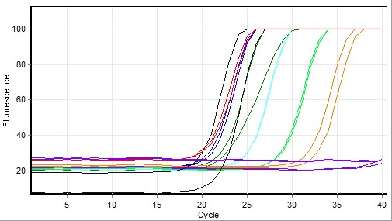

Quantitation data for Cycling A.Green
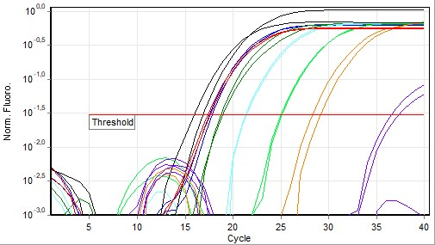

Standard Curve
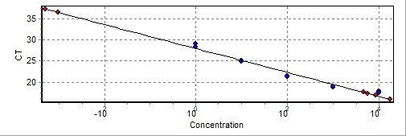
No. | Color | Name | Type | Ct | Ct Comment | Given Conc (IU/ml) | Calc Conc (IU/ml)
21 |  | T6 1X | Standard | 17,79 |  | 10 000 | 3 926
22 |  | T6 1X | Standard | 17,50 |  | 10 000 | 4 966
23 |  | T6 10x | Standard | 18,72 |  | 1 000 | 1 852
24 |  | T6 10x | Standard | 18,90 |  | 1 000 | 1 601
25 |  | T6 100x | Standard | 21,33 |  | 100 | 221
26 |  | T6 100x | Standard | 21,41 |  | 100 | 208
27 |  | T6 1000x | Standard | 25,06 |  | 10 | 11
28 |  | T6 1000x | Standard | 24,96 |  | 10 | 12
29 |  | T6 10000x | Standard | 28,30 |  | 1 | 1
30 |  | T6 10000x | Standard | 29,14 |  | 1
31 |  | NK | Unknown | 37,32
32 |  | NK | Unknown | 36,51
34 |  | D6 ACO5 | Unknown | 16,83 |  |  | 8 608
35 |  | D6 ACO5 | Unknown | 15,93 |  |  | 17 872
37 |  | B6 ACO5 | Unknown | 17,34 |  |  | 5 676
38 |  | B6 ACO5 | Unknown | 17,60 |  |  | 4 615
39 |  | NK | Unknown
40 |  | NK | Unknown
-
Warning: The following samples were not analysed :
1T6 1X- 2T6 1X- 3T6 10x- 4T6 10x- 5T6 100x- 6T6 100x- 7T6 1000x- 8T6 1000x- 9T6 10000x- 10T6 10000x- 11NK- 12NK- 13D6 ACO1- 14D6 ACO1- 15D6 ACO1- 16B6 ACO1- 17B6 ACO1- 18B6 ACO1- 19NK- 20NK- 33D6 ACO5- 36B6 ACO5- 41T6 1X- 42T6 1X- 43T6 10x- 44T6 10x- 45T6 100x- 46T6 100x- 47T6 1000x- 48T6 1000x- 49T6 10000x- 50T6 10000x- 51NK- 52NK- 53D6 UBC10- 54D6 UBC10- 55D6 UBC10- 56B6 UBC10- 57B6 UBC10- 58B6 UBC10- 59NK- 60NK
Legend:
NEG (NTC) - Sample cancelled due to NTC Threshold.
NEG (R. Eff) - Sample cancelled as efficiency less than reaction efficiency threshold.
This report was generated by Rotor-Gene Q Series Software 2.3.1 (Build 49)
Copyright 2013 QIAGEN GmbH. All Rights Reserved.

