 | www.qiagen.com

Quantitation Report

Experiment Information
Run Name | Run 2021-12-15-sk6
Run Start | 15.12.2021 13:53:27
Run Finish | 15.12.2021 15:40:16
Operator | MP
Notes
Run On Software Version | Rotor-Gene Q Software 2.0.2.4
Run Signature | The Run Signature is valid.
Gain Green | 10,
Machine Serial No. | 0911113

Quantitation Information
Threshold | 0,030
Left Threshold | 5,000
Standard Curve Imported | No
Standard Curve (1) | conc= 10^(-0,329*CT + 8,561)
Standard Curve (2) | CT = -3,037*log(conc) + 25,997
Reaction efficiency (*) | (* = 10^(-1/m) - 1) 1,13449
M | -3,0368
B | 25,99718
R Value | 0,97869
R^2 Value | 0,95784
Start normalising from cycle | 1
Noise Slope Correction | Yes
No Template Control Threshold | % 0
Reaction Efficiency Threshold | Disabled
Normalisation Method | Dynamic Tube Normalisation
Digital Filter | Light
Sample Page | Page 2
Imported Analysis Settings

Profile
Cycle | Cycle Point
Hold 1 | Hold @ 95°C, 10min 0s
Cycling (40 repeats) | Step 1: Hold @ 95°C, 15s
Cycling (40 repeats) | Step 2: Hold @ 60°C, 30s, acquiring to Cycling A([Green][1][1])
Cycling (40 repeats) | Step 3: Hold @ 72°C, 20s
Hold 2 | Hold @ 72°C, 1min 0s
Melt | Ramp from 55°C to 90°C
Melt | Hold for 90s on the 1st step
Melt | Hold for 5s on next steps,Melt A([Green][1][1])

Raw Data For Cycling A.Green
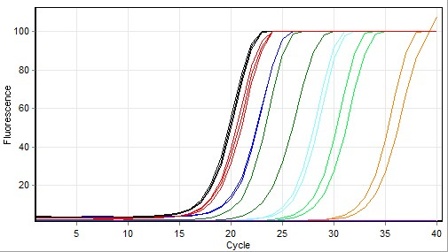

Quantitation data for Cycling A.Green
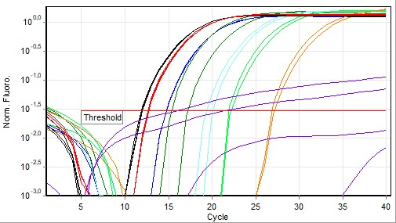

Standard Curve
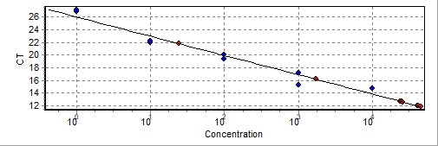
No. | Color | Name | Type | Ct | Ct Comment | Given Conc (IU/ml) | Calc Conc (IU/ml)
41 |  | T6 1X | Standard | 14,70 |  | 10 000 | 5 237
42 |  | T6 1X | Standard | 14,68 |  | 10 000 | 5 348
43 |  | T6 10x | Standard | 15,28 |  | 1 000 | 3 394
44 |  | T6 10x | Standard | 17,16 |  | 1 000 | 811
45 |  | T6 100x | Standard | 20,08 |  | 100 | 89
46 |  | T6 100x | Standard | 19,34 |  | 100 | 156
47 |  | T6 1000x | Standard | 21,90 |  | 10 | 22
48 |  | T6 1000x | Standard | 22,18 |  | 10 | 18
49 |  | T6 10000x | Standard | 26,80 |  | 1 | 1
50 |  | T6 10000x | Standard | 27,13 |  | 1
51 |  | NK | Unknown
52 |  | NK | Unknown
53 |  | D6 UBC10 | Unknown | 11,94 |  |  | 42 535
54 |  | D6 UBC10 | Unknown | 12,01 |  |  | 40 427
55 |  | D6 UBC10 | Unknown | 11,85 |  |  | 45 548
56 |  | B6 UBC10 | Unknown | 12,70 |  |  | 23 920
57 |  | B6 UBC10 | Unknown | 12,65 |  |  | 24 923
58 |  | B6 UBC10 | Unknown | 12,60 |  |  | 25 838
59 |  | NK | Unknown | 16,16 |  |  | 1 736
60 |  | NK | Unknown | 21,80 |  |  | 24
-
Warning: The following samples were not analysed :
1T6 1X- 2T6 1X- 3T6 10x- 4T6 10x- 5T6 100x- 6T6 100x- 7T6 1000x- 8T6 1000x- 9T6 10000x- 10T6 10000x- 11NK- 12NK- 13D6 ACO1- 14D6 ACO1- 15D6 ACO1- 16B6 ACO1- 17B6 ACO1- 18B6 ACO1- 19NK- 20NK- 21T6 1X- 22T6 1X- 23T6 10x- 24T6 10x- 25T6 100x- 26T6 100x- 27T6 1000x- 28T6 1000x- 29T6 10000x- 30T6 10000x- 31NK- 32NK- 33D6 ACO5- 34D6 ACO5- 35D6 ACO5- 36B6 ACO5- 37B6 ACO5- 38B6 ACO5- 39NK- 40NK
Legend:
NEG (NTC) - Sample cancelled due to NTC Threshold.
NEG (R. Eff) - Sample cancelled as efficiency less than reaction efficiency threshold.
This report was generated by Rotor-Gene Q Series Software 2.3.1 (Build 49)
Copyright 2013 QIAGEN GmbH. All Rights Reserved.

