**10 CHEMICAL EXPERIMENT**

**1. Complete the vocabulary for lab equipment in the pictures:**

|  |  |  |
| --- | --- | --- |
| C:\Users\Admin\AppData\Local\Microsoft\Windows\INetCache\Content.MSO\CBC0B2AF.tmp  1. F _ _ _ _ | Evaporating Dish, 75mL, porcelain – Home Educational Resources  2. EVAPORATING D _ _ _ | C:\Users\Admin\AppData\Local\Microsoft\Windows\INetCache\Content.MSO\81F2B1E7.tmp  3. B_ _ _ _ _ |
| C:\Users\Admin\AppData\Local\Microsoft\Windows\INetCache\Content.MSO\CA5B9892.tmp  4. BOTTLE | Duran Squat Glass Cylinder 25ml | School Science Equipment  5. CALIBRATED C _ _ _ _ _ _ _ | C:\Users\Admin\AppData\Local\Microsoft\Windows\INetCache\Content.MSO\C23943B1.tmp  6. TEST-T _ _ _ |
| C:\Users\Admin\AppData\Local\Microsoft\Windows\INetCache\Content.MSO\D865542A.tmp  7.MORTAR AND P _ _ _ _ _ | https://encrypted-tbn0.gstatic.com/images?q=tbn%3AANd9GcR-o8QqmlgVb0nSzK9wSnr3Ii_XVi7MGWkxTmwhCkrYTYS6q_BQLkoebfrf_SZwz_CGOC6Ahqk&usqp=CAc  8. THERMO _ _ _ _ _ | C:\Users\Admin\AppData\Local\Microsoft\Windows\INetCache\Content.MSO\B58F6329.tmp  9. F _ _ _ _ _ |
| 10. FORCEPS | C:\Users\Admin\AppData\Local\Microsoft\Windows\INetCache\Content.MSO\C35C981F.tmp  11. B _ _ _ _ _ | 12.CLAMP |
| C:\Users\Admin\AppData\Local\Microsoft\Windows\INetCache\Content.MSO\FB39CBB3.tmp  13. G _ _ _ _ _ _ | 14. STIRRING R _ _ | Melting crucible 79 C Tall, 15 ml, 0 | Melting crucible | Melting crucibles,  ignition dishes and laboratory porcelain | Laboratory Glass, Vessels,  Consumables | Labware | Carl Roth - Austria  15. C _ _ _ _ _ _ _ |

**2. Read about laboratory equipment and complete the gaps with the phrases below.**

A common laboratory is provided 1____. The usual equipment includes also desiccators, used for drying materials and a balance for 2____. Other necessities are sinks for 3____ and good ventilation.

An important [ventilation](http://en.wikipedia.org/wiki/Ventilation_%28architecture%29) device that is designed 4____ is called fume cupboard or fume hood.

The indispensable equipment comprises also glass and porcelain vessels. These are test-tubes, beakers, various flasks and cylinders. Glassware is made 5____, such as Pyrex glass because it has to resist sudden changes of temperatures.

Porcelain vessels include different kinds of dishes and 6____ . A grinding mortar with a pestle, desiccating dish and stirrers are generally made of porcelain.

At present, plastic materials are increasingly used in laboratories 7____, acid or alkali-proof and unbreakable.

Adapted from C. Doubravová, Angličtina pro posluchače VŠCHT

A pouring out waste water

B of a special kind of glass

C crucibles of different diameters   
D accurate weighing of samples

E with running water, gas and electricity  
F since many of them are chemically resistant  
G to limit exposure to toxic fumes and [vapours](http://en.wikipedia.org/wiki/Vapor)

**3. What are these things used for? Describe their purpose.**

**You can use one of these grammar structures:** *… is used for doing something*

*… is used to do something*

*Example*

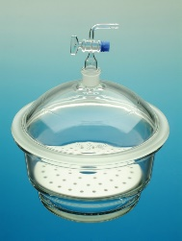

***Desiccator***  *is a container with a drying agent that is used for removing moisture from specimens and protecting them from water vapour in the air.*

*OR … to remove moisture from specimens and to protect them from water vapour in the air.*

1.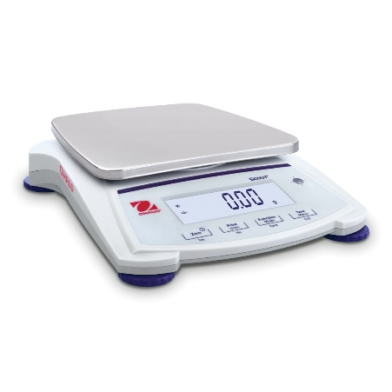 2. 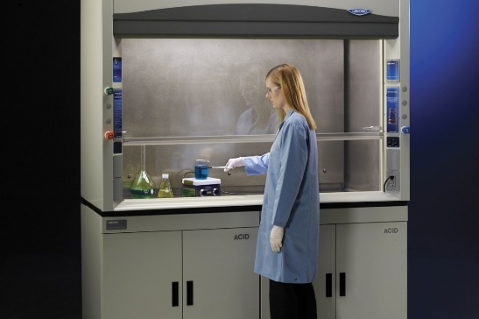 3.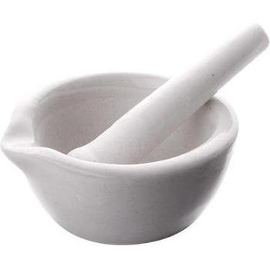

1. The scales are used …

2. The fume hood …

3. The…

**4. Read the lab memo below and identify in the picture the equipment written in bold.**

*Hi everyone,*

*Last week, I noticed some careless use of glassware. Remember our equipment safety practices:*

* *Some glassware cannot stand on its own. Keep* ***test tube****s and* ***buret****s on their* ***rack****s. Otherwise, they tip over or roll away.*
* ***Dropper****s and* ***pipette****s are for transferring substances. Do not store materials in these containers for long periods.*
* *Avoid spillage. Pour carefully into narrow containers like* ***graduated cylinder****s. Use a funnel when appropriate.*
* *Use equipment for its designated purpose. Only use a volumetric flask for particular volume and temperature precision. Otherwise, use a* ***beaker*** *or* ***Erlenmeyer flask*** *instead.*
* *Water is the only substance allowed in the wash bottles.*

*Tony*

(from: Evans, Dooley &Norton, 2015, ***Career Paths: Science)***

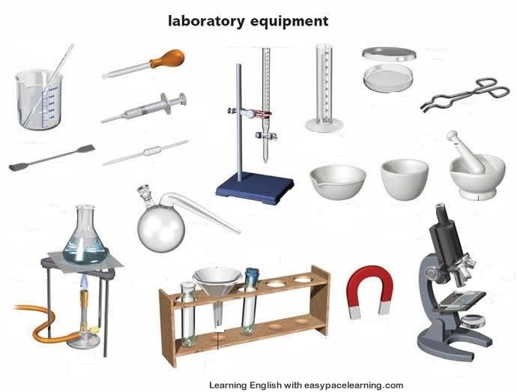

**5. SHAPES (word formation):**

1. **Match the parts of sentences to make true statements.**

|  |  |  |  |  |  |
| --- | --- | --- | --- | --- | --- |
| A coin  A ruler  A set square  A protractor  A chess-board | is  shaped  like a | square  rectangle.  semi-circle.  triangle.  circle. | It is | rectangular  circular  square  semi-circular  triangular | in shape. |

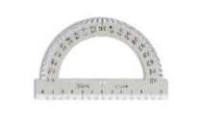 protractor 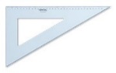set square 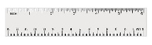 ruler

**b) Complete the last word – an adjective describing a shape.**

1. A volumetric flask is shaped like a sphere, it is …………
2. A test-tube is shaped like a cylinder, it is … ………
3. A funnel is shaped like a cone, it is …………..
4. A salt crystal is shaped like a cube, it is …………...

(from: Evans, Dooley &Norton, 2015, Career Paths: Science)

**6. CHEMICAL APPARATUS** [ˈæpəˌreɪtəs]

**Study the prepositions and phrases in the two boxes below and then use some of them to complete the text describing the picture of the distillation apparatus.**

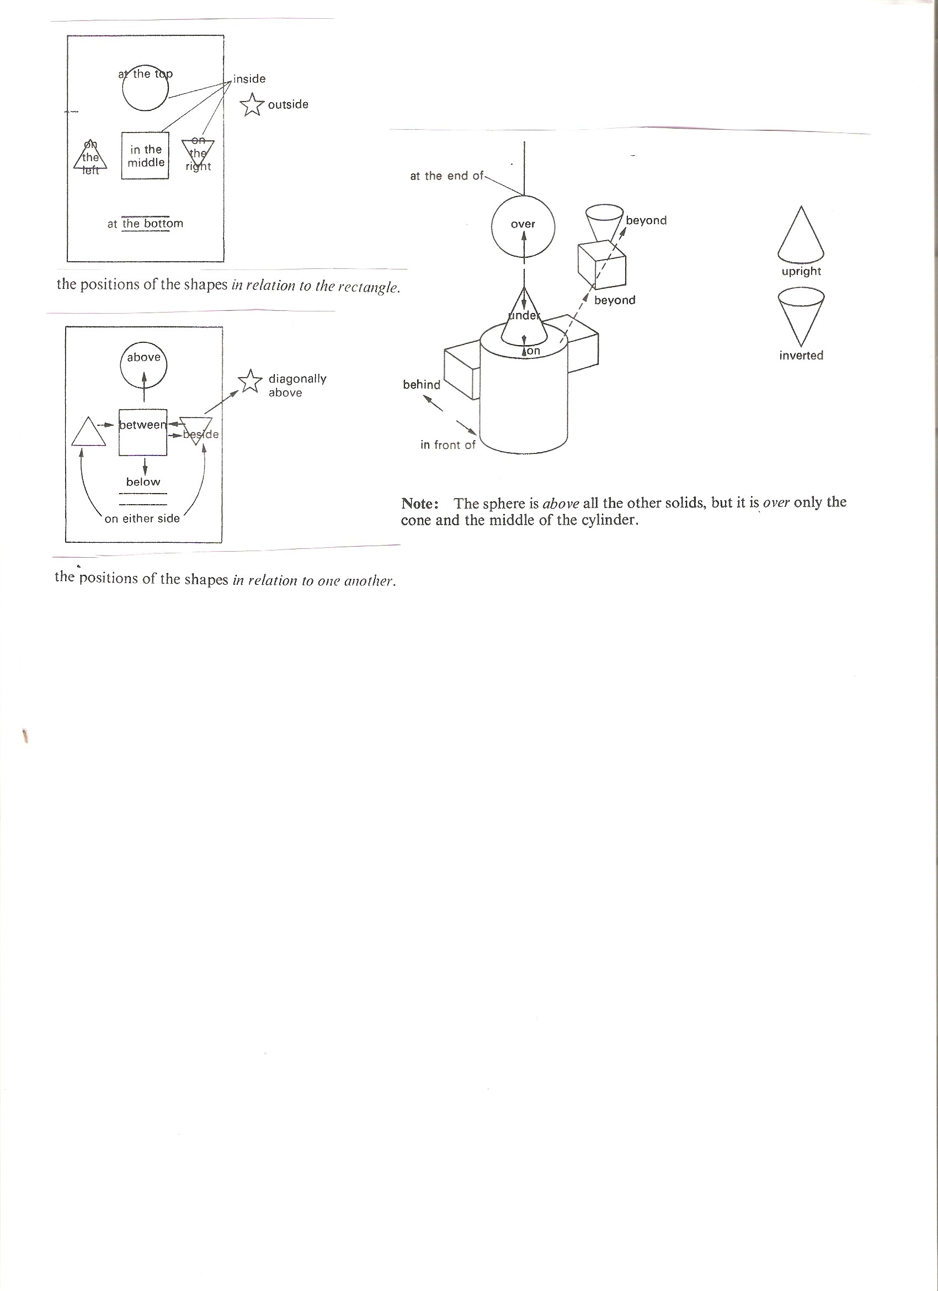



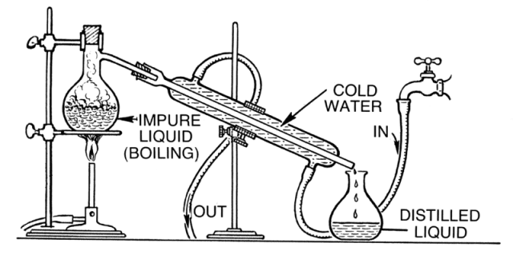

<https://www.thoughtco.com/how-to-set-up-distillation-apparatus-606046>

**1**……………………………….. there is a spherical flask placed on a gauze mat over the Bunsen burner. A condenser is placed diagonally **2**………….……………………….. of the apparatus. The flask for collecting the drops of the condensate is placed **3**……………….………………………. . The condenser is cooled by cold water from the tap. **4**……………………………..…… of the condenser there is an inlet of the cold water and **5**…………………………………. there is the outlet of the cold water. The collecting flask stands right **6**…………….…………. the bottom part of the condenser.

**7. DESCRIBING AN EXPERIMENT**

**A) You will watch an experiment. What parts do you expect in the commentary?**

**Complete the missing headings for the these parts:**

Purpose ?………. Result ?……………….

# <https://www.youtube.com/watch?v=bsshuMxcRuc> The reaction of aluminium and iodine 0.20 – 2.22

**B) Order the instructions correctly:**

A) ……… the reaction starts, clouds of purple iodine vapour are released as heat is generated.

B) Put one or two drops of warm water onto the top of the mound using the dropper.

C) ………. grind 0.4 g of iodine in the mortar.

D) The mixture ……… bursts into flame, producing a white smoke together with the iodine vapour, and leaving a glowing, white residue of aluminium iodide.

E) …… mix the iodine with 0.1 g of aluminium powder and place the mixture in a small mound on the tin lid.

F) …….. the fume cupboard should be switched on, as iodine vapour is toxic.

G) There can be an induction period ….… the reaction starts but if there appears to be nothing happening, add another one or two drops of water.

**Add the adverbs/ adverbial phrases into the text:**

*before at this point finely then carefully when*

**C) Use the headings to complete the gaps: *Result Purpose Steps Conclusion Materials***

**1………………………….**

To show how the properties of a mixture differ from the properties of a compound.

**2. ………………………….**  
0.4 g of iodine, 0.1 g of aluminium powder, warm water  
tin lid, dropper, mortar and pestle, eye protection, access to a fume cupboard

**3. ………………………….**Finely grind 0.4 g of iodine in the mortar.

Carefully mix the iodine with 0.1 g of aluminium powder and place the mixture in a small mound on the tin lid.

Put one or two drops of warm water onto the top of the mound. There can be an induction period before the reaction starts but if there appears to be nothing happening add another one or two drops of water. A little detergent in the water assists wetting.

When the reaction starts, clouds of purple iodine vapour are released as heat is generated. At this point the fume cupboard should be switched on, as iodine vapour is toxic.

**5. ………………………….**

The mixture then bursts into flame, producing a white smoke together with the iodine vapour, and leaving a glowing, white residue of aluminium iodide.

**6. ………………………….**

Oxidation of finely dispersed aluminium with iodine is initiated using drops of water. The reaction is strongly exothermic, producing the aluminium iodide. The excess iodine vaporises, forming a deep violet vapour. The reaction is 2Al(s) + 3I2(s) → Al2I6(s). It was demonstrated how the colour of the mixture of aluminium and iodine differs from the colour of the aluminium iodide compound.