11 CHEMICAL REACTIONS

1. Warm-up: Which of these processes are chemical reactions and which are not? Why?
rusting of iron
photo-synthesis
sharpening your knife
alcohol ferments

breathing
digestion of food

thawing of ice
burning of coal

dew condensing on a leaf
rotting of bananas

2. What triggers a chemical reaction http://ed.ted.com/lessons/what-triggers-a-chemical-reaction-kareem-jarrah
Describe what this picture means from a chemical point of view
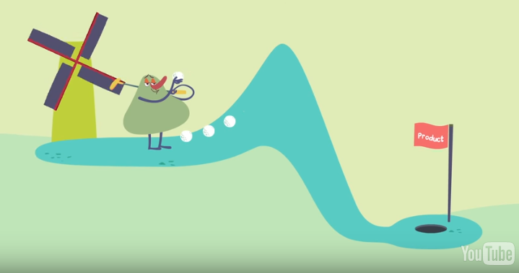

Make sure you understand the phrases below:
increase or decrease of energy structure of proteins
potential energy randomness, chaos
be likely to react shift to instability
combustion of hydrogen and oxygen transition from structure to disorder
release energy
activate a reaction

How does the video explain what is:
Enthalpy
Entropy
Exothermic reaction
Endothermic reaction
3. Grammar: Verb Patterns https://advice.writing.utoronto.ca/english-language/gerunds/
A. Some verbs have the structure verb + object + to…
tell, ask, want, would like, remind, invite, warn, advise, expect, encourage, enable, allow, cause …etc.

The professor encouraged me to do the experiment.
Intensive heating causes water to evaporate.
Our competitors did not expect us to win the match.
We invite you to attend the ceremony.
We could ask her to demonstrate the process.
They will require us to submit a summary.

B. Complete the sentences with suitable verb form with ‘to ‘ or without ‘to’. Check: 2.00 – 2.50
1. Exothermic reactions are more likely to happen than endothermic ones because they require less energy …………………….. (occur) .
2. There’s another independent factor that can make reactions …………………..… (happen) – entropy.
3. Shift to higher entropy can allow reactions ………………………… (happen) .
4. Transition from structure to disorder gets some reactants past the hump and lets them ……………………… (start) a reaction.

C. Practice:
Discuss several things that can cause/ let/ make/ allow some chemical reactions (to) proceed/ run faster.
Write several ideas in sentences with the infinitive structure ( with/ without ‘to’).

4. Complete the gaps and practise reading the equations.
decomposes into combine to produce to react with yield

2H₂O₂ O₂ + 2H₂O
Two molecules of hydrogen peroxide go to form one molecule of oxygen gas plus two molecules of water.

CH₄ + 2O₂ CO₂ + 2H₂O
Methane and oxygen …………………………. carbon dioxide and water.

2C + O₂ 2CO
Two atoms of carbon plus one molecule of oxygen …………………………. two molecules of carbon monoxide.

C + O₂ CO₂
Carbon reacts with oxygen to form carbon dioxide.

2 NaOH + H₂SO₄ Na₂SO₄+ 2 H₂O
It takes 2 molecules of sodium hydroxide …………… 1 molecule of sulphuric acid to produce 1 molecule of sodium sulphate and 2 molecules of water.

H₂O H⁺ + OH⁻
Water can break down into hydrogen and hydroxide ions, but hydrogen and hydroxide ions can also combine back together to form water.

2H₂O₂2H₂O + O₂(g)
2 molecules of H₂O₂ decompose to form 2 molecules of H₂O plus one molecule of oxygen gas
OR: Hydrogen peroxide …………………………. water and oxygen gas.
5. Types of reactions – suggest the words.
1. A complex molecule breaks down to form simpler ones.
D _ _ _ _ _ _ _ _ _ _ _ _
2. Reaction between an acid and base which yields a salt and water.
N _ _ _ _ _ _ _ _ _ _ _ _ _
3. One reactive element is replaced by another element in a compound formula.
D I S _ _ _ _ _ _ _ _ _
4. Molecules of two reactants exchange some atoms or groups of atoms and give two new compounds; rearrangement takes place.
C O N _ _ _ _ _ _ _
5. Two or more reactants combine to form one product.
S _ _ _ _ _ _ _ _
6. Reaction of a compound or element with oxygen to form an oxide and produce heat.
C O M _ _ _ _ _ _ _

6. Read these equations and identify the type of reaction according to ex.5.
A. The burning of naphthalene C₁₀H₈ + 12 O₂ ---> 10 CO₂ + 4 H₂O
B. The combination of iron and sulphur 8 Fe + S₈ ---> 8 FeS
C. The electrolysis of water 2 H₂O ---> 2 H₂ + O₂
D. Magnesium in water Mg + 2 H₂O ---> Mg(OH)₂ + H₂
E. The formation of an insoluble salt BaCl₂ + H₂SO₄ ---> 2 HCl + BaSO₄
F. The reaction of hydrobromic acid with sodium hydroxide HBr + NaOH ---> NaBr + H₂O

7. Forming questions
Look at the information from the textbook summary and write questions asking about the underlined parts.
Example
Chemical equations are used to describe reactions. Why are chemical equations used?
Reactants yield products. What yields products?

1. Equations must be balanced to be consistent with the law of conservation of matter.

2. Formula weights are determined by adding together the atomic weights of the atoms in the formula unit.

3. One mole of a substance contains 6.02 x 10²³ units of a substance.

4. The coefficients in an equation give the combining ratio of moles.

5. The coefficients in an equation give the combining ratio of moles.
D.M. Feigl: General, Organic, and Biological Chemistry, Ch.6, p. 183

