**Classifying matter**

1. How do the properties of substances in gaseous, liquid ans solid state differ?

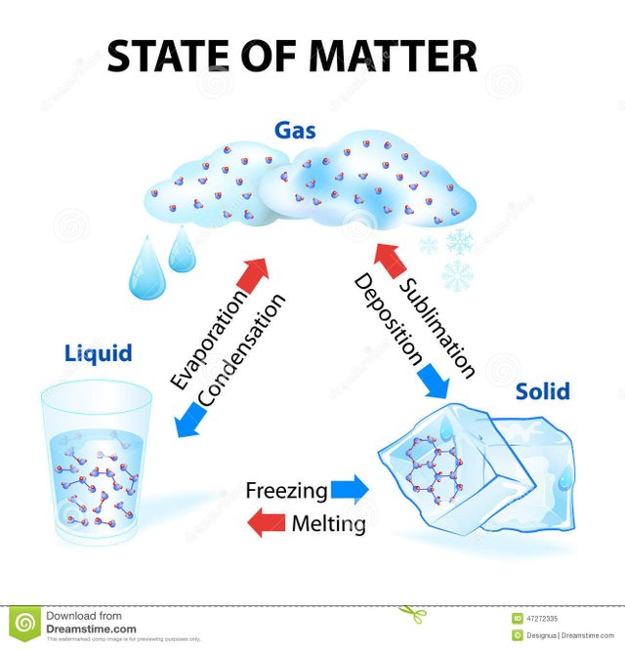

 

**2. Complete the words for changes in the state of matter:**

|  |  |  |
| --- | --- | --- |
| *Change* | *verb* | *noun/s* |
| Liquid to solid | *solidify* | *solidification* |
| Solid to liquid |  |  |
| Liquid to gas |  |  |
| Gas to liquid |  | *condenser* |
| Gas to solid | *deposit* |  |
| Solid to gas | *sublime* |  |

**3. Doing Solids: Crash Course Chemistry #33** <https://www.youtube.com/watch?v=bzr-byiSXlA> 0 – 1.50

**Listen to the following division of chemicals into classes. Complete each gap with one or two words.**

1. Liquid chemicals …………………….………………….. on crops.

2. …………………………..……. chemicals come out of exhaust pipes.

3. Vast majority of matter you interact with is in the form of ………………………………. .

4. Solids are a lot ………………………………………………… than we might think.

5. Many metals are …………………………………. under the right conditions.

6. Lack of flexibility causes rock ……………………..………………… under sufficient force.

7. There are two main classes of solids: ……………………………………. and …………………………………………

8. In amorphous substances atoms are ………………………………………………………. .

**4. You will get sentences that make up an article ‘The Nature of Matter’. Put them in the right order**

**5. Classification a) from general to specific**

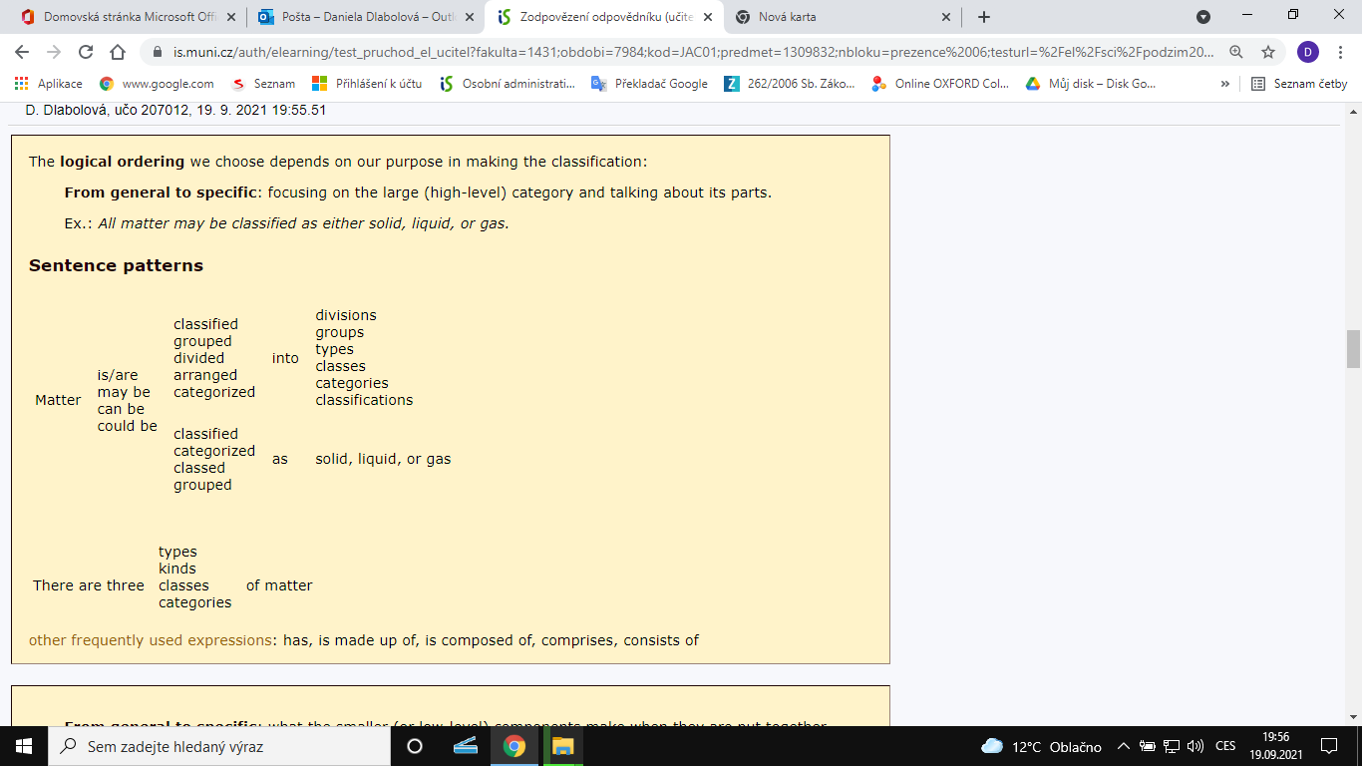

**b) from specific to general:** 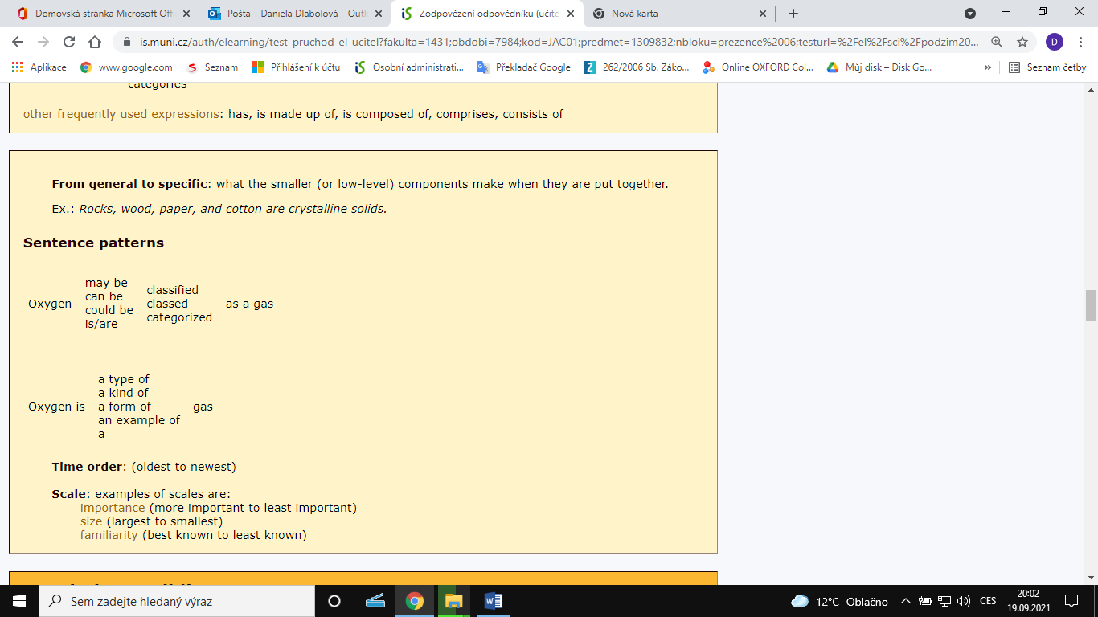

**6. Which of the examples go *from general to specific* and which *from specific to general*?**

X is classified as A and B.

X can be divided into A, B, and C.

X is composed of A, B, and C.

X is made up of A, B, and C. A, B, and C constitute X.

X consists of A, B, and C. A, B, and C make up X.

X comprises A, B, and C.

X includes A, B, and C.

**7. Listen to a one-minute extract and use the information to draw a diagram of the classification of matter:**

Types of matter <https://www.youtube.com/watch?v=dggHWvFJ8Xs> 1.44 – 2.54

**8. Mini-presentations**

Work in small groups. Each group will get a different text. Read it and underline all the things that are classified. Then draw a diagram. Prepare a 2-minute team presentation summarizing the ideas from your text with the help of the diagram. It will be shown to the class through the data projector.

You need to use phrases for organizing your presentation.

* *Good morning / afternoon / Hello, everyone.*
* *My name is ... and this is... We would like to show you... / to talk about … We will take a look at...*
* *First of all…*

*As you can see in the diagram / poster...*

* *And finally, …*
* *That’s all. Our presentation is over. Thank you for your attention.*

One speakers’ part needs to be connected to the other speaker’s part:

*And now I’ll* ***hand over to*** *Jane. Tedˇ předám slovo Janě.*

*And now Martin will tell you more. Více vám řekne Martin.*

*Martin,* ***the floor*** *is yours. Martine, máš slovo.*

### Points to be careful about:

* 1. Is the information presented clearly?
  2. Is the pace *(tempo)* of the speech just right, not too fast?
  3. Is the classifying vocabulary used in a correct way?
  4. Are the speakers’ parts well connected to each other?
  5. Is there good eye contact with the listeners?

**9. Check the order of sentences from task 4.**

Everything around us consists of matter: this paper, your body, the air you breathe, and the water you drink. All matter may be classified as either solid, liquid, or gas.

Solids are firm and have a definite form. A considerable force would be needed to change the shape or volume of an iron bar, for example, because the atoms or molecules of a solid are densely packed and have very little freedom of movement. Solids may be further divided into two classes: crystalline and amorphous. Crystalline solids are made up of atoms arranged in a definite pattern. When these solids are heated, they change to a liquid, known as melting, is sharp and clear. In amorphous substances, the pattern of atoms is not orderly, and when heated, they gradually soften.

Liquids, on the other hand, are not rigid. If a liquid is poured on a table, it will flow all over the surface. The atoms or molecules of liquids attract each other and thereby enable liquids to flow. But these atoms are loosely structured and do not keep their shape. Therefore, a liquid will take the shape of any container in which it is poured. However, liquids have a definite volume: a quart of milk cannot fit in a pint container.

Gases have no fixed shape or volume of their own. They diffuse or spread out to fill any container. The atoms or molecules of gases are widely spaced and move very rapidly. They either compress or expand to adapt to any area.

Everything we know is made of matter in solid, liquid or gaseous form.

Zimmerrman, Fran: *English for Science*. New Jersey

**10. Passive voice**

**Change these phrases from the active to the passive voice.**

*Present tense:* You heat the sample. *The sample is heated.*

*With a modal verb:* You can heat the sample. …

You need to heat the sample. …

*Past tense:* You heated the sample. …

*Present perfect:* You have heated the sample. …

*Future:* You will heat the sample. …

**Transformations: Change the sentences into passive voice.**

1. We can classify matter as solid, liquid and gas.

Matter ………………………….…….….. as solid, liquid and gas.

1. You would need a considerable force to change the shape of an iron bar.

A considerable force ……………………..………….………. to change the shape of an iron bar.

1. If we pour water on the table, it will flow all over the surface.

If …………………………………..…….… on the table, it will flow all over the surface.

1. When we heated the crystals, they melted.

When ……………………………….……………., they melted.

1. Now that you have heated the amorphous substance, you can see that it softens.

Now that …………………………………………., you can see that it softens.

1. If we pour water from one container to another, we will change the shape of the water mass.

If we pour water from one container to another, the shape ………………………………………………... .