6 PERIODIC TABLE OF THE ELEMENTS

1. Warm-up
Work in groups of three and find out who has got
- A coffee cup with the picture of the periodic table
- A T-shirt with the picture of the periodic table
- A portable periodic table in a plastic foil in the bag
- A periodic table on the bedroom wall

2. Put the number of the definition from the list below into the square with the appropriate term. Check your answers by adding the numbers to see if all the sums both across and down add up to the same number.

PERIODS | ATOMIC NUMBER | SYMBOL
FAMILIES | VALENCE | NEUTRON
ELECTRON | MASS NUMBER | ISOTOPE

- atoms of the same element that differ in mass numbers
- vertical columns on the periodic table
- number of protons in an element
- the electrons in the outermost energy level
- represents an element
- negative subatomic particle
- horizontal rows on the periodic table
- number of protons and neutrons
- subatomic particle without charge

3. Name groups of elements based on their properties. The first letter is given for you.

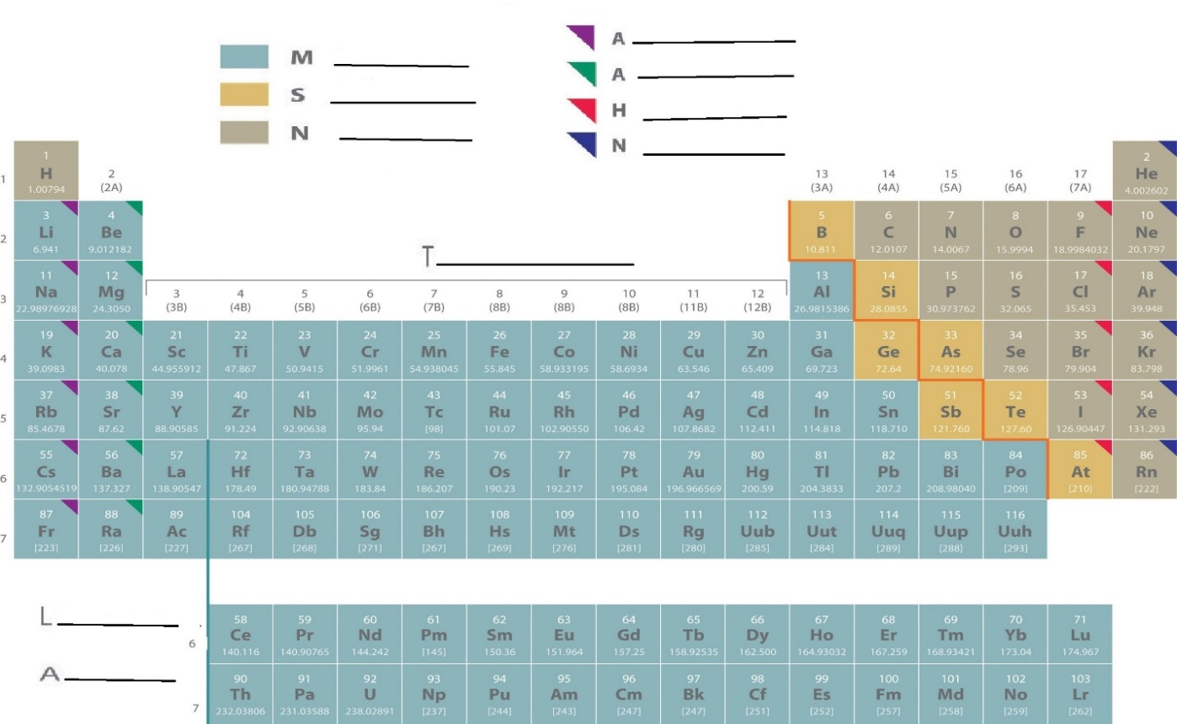

Watch the video and note down examples of elements’ properties in each category:
https://www.youtube.com/watch?v=0RRVV4Diomg 0.45 – 7.49
4. Read the text and put the missing phrases back in the right gaps
- good conductors of electricity and malleable
- combinations of elements can create the products
- semiconductor and computer chip
- classify elements by properties

How to read and interpret the periodic table
The periodic table helps chemists 1.…… and similarities. One way to sort the elements is to divide them into three categories – metals, nonmetals and metalloids.
Most of the elements on the periodic table are considered metals. They share similar characteristics – most are solid, shiny, 2……... Nonmetals have properties opposite of the metals – they are brittle, not flexible and not strong conductors of heat or electricity. Some nonmetals are liquids, some are gases. Metalloids, or semimetals, are considered a cross between metals and nonmetals. Metalloids have unique conductivity properties, which make them useful in the 3……. industries.
The periodic table can help us better understand chemical elements and their relationship to one another – how they react with each other, and how 4 ……, materials and technologies that shape our lives.
https://www.chemicalsafetyfacts.org/celebrating-150-years-of-the-periodic-table-of-elements/

5. Work in pairs. You will get short texts to read, A and B. Read your text and identify the key words or phrases.
- Student A uses these key words/phrases and summarizes the information for student B.
- Then student B will have to summarize the same information back, starting: If I understand you correctly, you’re saying that ….
- Student B uses key words for text B to summarize it and, again, student A reacts: If I understand you correctly, you’re saying that ….

6. Find the 15 chemical elements.
If you cross all of them, the remaining letters, if read from left to right, form a word. Which word is it?

 | A | B | C | D | E | F | G | H | I
1 | C | A | R | B | O | N | I | T | E
2 | A | L | U | M | I | N | I | U | M
3 | L | E | B | S | L | E | M | M | E
4 | C | K | I | N | O | E | N | N | T
5 | I | C | D | R | R | D | A | E | L
6 | U | I | I | C | O | Z | I | N | C
7 | M | N | U | R | A | N | I | U | M
8 | S | R | M | O | S | M | I | U | M
9 | Y | T | T | E | R | B | I | U | M

/´ælyə’mɪniəm/
/’ɒzmiəm/
/’mɜrkyəri/
/’kælsiəm/
/ru’bɪdiəm/
/’niɒn/
/’kɑrbən/
/’soʊdiəm/
/ɪ’tɜrbiəm/
/’aɪərn/
/tɪn/
/’nɪkəl/
/lɛd/
/yʊ’reɪniəm/
/zɪŋk/

http://dictionary.reference.com/help/luna/IPA_pron_key.html
7. Explore The Royal Society of Chemistry’s interactive periodic table: images, history, alchemy, podcasts, trends. Identify the elements described in 1 - 6 below. https://www.rsc.org/periodic-table/

- This metallic element is present in surprising amount in baked beans.
- This is a shiny grayish metal that rusts in damp air.
- This element’s name is derived from the Greek word for ‘sun’.
- This element represented the perfection of all matter at any level for the alchemists.
- This is the element with the highest density.
- This element has the highest melting point.

8. HOMEWORK: Circle the synonym a) or b) for the word in italics.

1. Chemists study the composition of natural substances.
a. materials b. phenomena

2. Plastic products are hard to dispose of because they are almost indestructible.
a. unable to be destroyed b. unable to be constructed

3. Silicon is a semi-metallic element that is inexpensive because it is so abundant in minerals and rocks.
a. rare b. plentiful

4. When exposed to air and moisture, iron will corrode.
a. rust b. shine

5. After the fire, the police investigated the cause of the combustion.
a. burning b. excitement

6. Gasoline should be stored carefully because it is flammable.
a. fireproof b. able to catch fire easily

7. Heat can convert a solid to a liquid.
a. condense b. change

8. The ammonia was diluted in water to make it weaker.
a. thinned b. thickened

9. A catalyst speeds up a chemical reaction.
a. chemical agent b. forest animal

10. To obtain aluminum, metallurgists must extract it from bauxite.
a. remove b. destroy

11. The temperature on a Fahrenheit fever thermometer ranges from 94° to 108°.
a. extends b. contracts

12. The volume of air in a room can be measured in cubic feet.
a. quality b. quantity

13. Newton computed the weights of the planets.
a. measured b. calculated

14. Water contains hydrogen and oxygen in a ratio of two to one.
a. proportion b. size

15. The price of gasoline was quadrupled, and there were fears it would go even higher.
a. multiplied by four b. divided by four

source: Zimmerrman, Fran. English for Science.New Jersey 1989.

