**CHEMICAL EXPERIMENT KEY**

**1. LABORATORY EQUIPMENT**

1 flask, 2 evaporating dish, 3 beaker, 4 bottle, 5 calibrated cylinder, 6 test tube, 7 mortar and pestle, 8 thermometer, 9 funnel, 10 forceps, 11 Bunsen burner, 12 clamp, 13 goggles, 14 stirring rod, 15 crucible

**2. Read about laboratory equipment and complete the gaps with the phrases below. Exam practice**

A common laboratory is provided 1__E__. The usual equipment includes also desiccators, used for drying materials and a balance for 2__D__. Other necessities are sinks for 3__A__ and good ventilation.

An important [ventilation](http://en.wikipedia.org/wiki/Ventilation_%28architecture%29) device that is designed 4__G__ is called fume cupboard or fume hood.

The indispensable equipment comprises also glass and porcelain vessels. These are test-tubes, beakers, various flasks and cylinders. Glassware is made 5__B__, such as Pyrex glass because it has to resist sudden changes of temperatures.

Porcelain vessels include different kinds of dishes and 6__C__ . A grinding mortar with a pestle, desiccating dish and stirrers are generally made of porcelain.

At present, plastic materials are increasingly used in laboratories 7__F__, acid or alkali-proof and unbreakable.

Adapted from C. Doubravová, Angličtina pro posluchače VŠCHT

A pouring out waste water

B of a special kind of glass

C crucibles of different diameters   
D accurate weighing of samples

E with running water, gas and electricity  
F since many of them are chemically resistant  
G to limit exposure to toxic fumes and [vapours](http://en.wikipedia.org/wiki/Vapor)

A common laboratory is provided with running water, gas and electricity. The usual equipment includes also desiccators, used for drying materials and a balance for accurate weighing of samples. Other necessities are sinks for pouring out waste water and good ventilation.

An important [ventilation](http://en.wikipedia.org/wiki/Ventilation_%28architecture%29) device that is designed to limit exposure to toxic fumes and [vapours](http://en.wikipedia.org/wiki/Vapor) is called fume cupboard or fume hood.

The indispensable equipment comprises also glass and porcelain vessels. These are test-tubes, beakers, various flasks and cylinders. Glassware is made of a special kind of glass, such as Pyrex glass because it has to resist sudden changes of temperatures.

Porcelain vessels include different kinds of dishes and crucibles of different diameters. A grinding mortar with a pestle, desiccating dish and stirrers are generally made of porcelain.

At present, plastic materials are increasingly used in laboratories since many of them are chemically resistant, acid or alkali-proof and unbreakable.

Adapted from C. Doubravová, Angličtina pro posluchače VŠCHT, p 24

**3. Describing purpose. Examples of answers:**

1. The scales are used for accurate weighing of samples.

2. The fume hood is used to lead away toxic vapours and fumes.

3. The mortar and pestle are used for crushing hard substances into powder.

**4.**

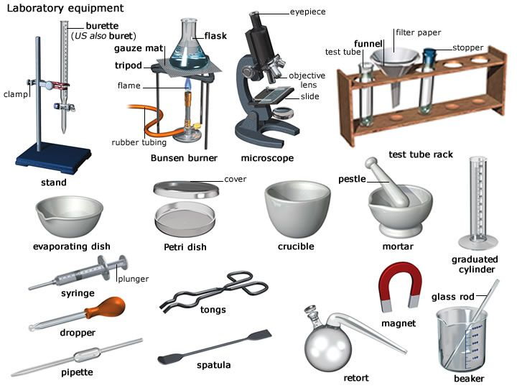

**5. SHAPES**

1. **Match the parts of sentences to make true statements.**

|  |  |  |  |  |  |
| --- | --- | --- | --- | --- | --- |
| A coin  A ruler  A set square  A protractor  A chess-board | is  shaped  like a | square  rectangle.  semi-circle.  triangle.  circle. | It is | rectangular  circular  square  semi-circular  triangular | in shape. |

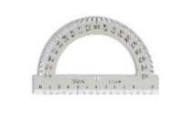 protractor set square 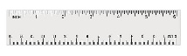 ruler

* **Complete the last word – an adjective describing a shape.**

1. A volumetric flask is shaped like a sphere, it is spherical
2. A test-tube is shaped like a cylinder, it is cylindrical
3. A funnel is shaped like a cone, it is conical
4. A salt crystal is shaped like a cube, it is cubical

(from: Evans, Dooley &Norton, 2015, Career Paths: Science)

**6. CHEMICAL APPARATUS** [ˈæpəˌreɪtəs]

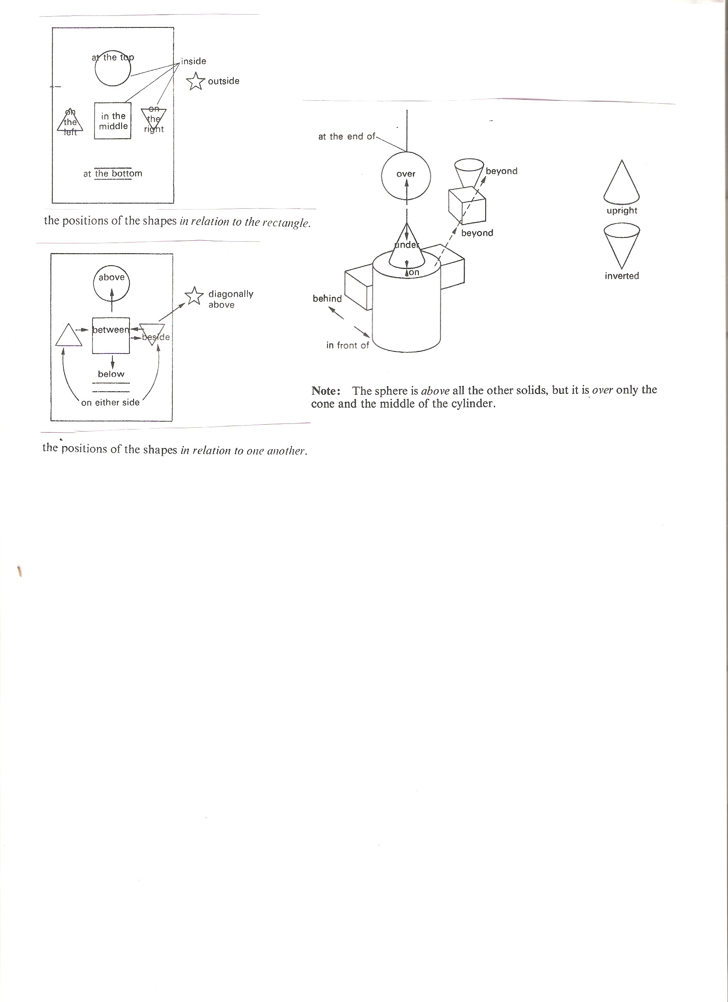



**Complete the description of the distillation apparatus with the prepositional phrases:**

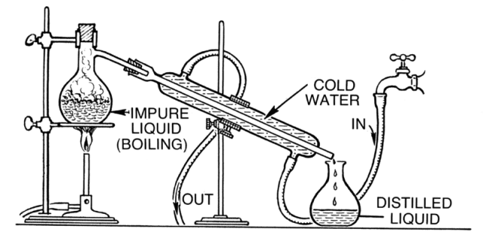

<https://www.thoughtco.com/how-to-set-up-distillation-apparatus-606046>

1……………………………….. there is a spherical flask placed on a gauze mat over the Bunsen burner. A condenser is placed diagonally 2………….……………………….. of the apparatus. The flask for collecting the drops of the condensate is 3……………….………………………. . The condenser is cooled by cold water from the tap. 4……………………………..…… of the condenser there is an inlet of the cold water and 5 …………………………………. there is the outlet of the cold water. The collecting flask stands right 6…………….…………. the bottom part of the condenser.

*1 on the left, 2 in the middle, 3 on the right /at the bottom on the right, 4 at the bottom, 5 at the top, 6 below/under*

**Another example of a description of an apparatus**

The apparatus for preparing hydrogen consists of a flask, a gas-jar, a beehive shelf, a trough, a delivery tube and a funnel. The flask is spherical and has a flat bottom. It contains zinc and hydro­chloric acid. The funnel and the delivery tube are fitted into the neck of the flask. They are held in place by a two-holed cork. The funnel leads down to the hydrochloric acid. The delivery tube leads from the flask to the hole in the beehive shelf. The beehive shelf is placed in the middle of the trough. The trough contains water. The gas-jar is supported by the beehive shelf. Hydrogen is collected at the top of the gas-jar.

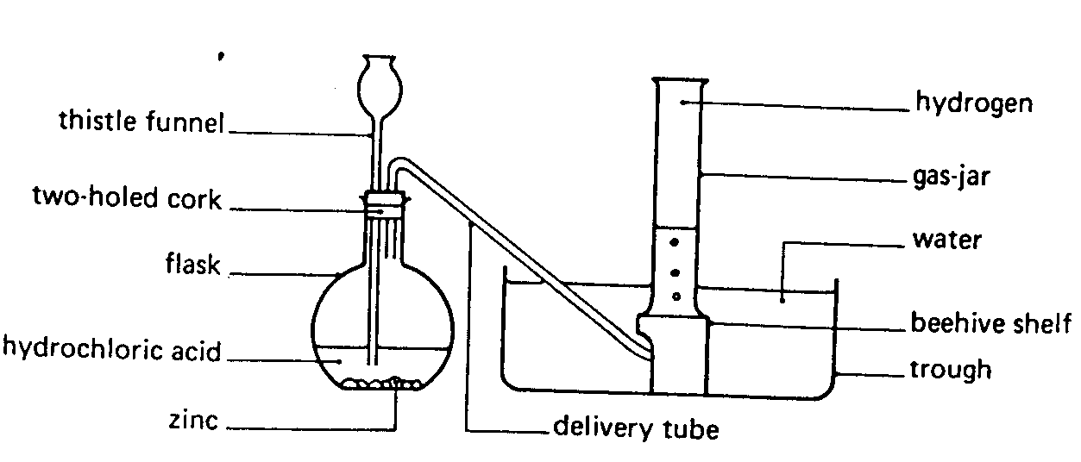

**7. DESCRIBING AN EXPERIMENT**

**A)**

# Purpose steps result conclusion

# <https://www.youtube.com/watch?v=bsshuMxcRuc> The reaction of aluminium and iodine 0.00 – 2.22

**B) Order the instructions correctly: see part C) below**

A) ……… the reaction starts, clouds of purple iodine vapour are released as heat is generated.

B) Put one or two drops of warm water onto the top of the mound using the dropper.

C) ………. grind 0.4 g of iodine in the mortar.

D) The mixture ……… bursts into flame, producing a white smoke together with the iodine vapour, and leaving a glowing, white residue of aluminium iodide.

E) …… mix the iodine with 0.1 g of aluminium powder and place the mixture in a small mound on the tin lid.

F) …….. the fume cupboard should be switched on, as iodine vapour is toxic.

G) There can be an induction period ….… the reaction starts but if there appears to be nothing happening add another one or two drops of water.

**Add the adverbs/ adverbial phrases into the text:**

*before at this point finely then carefully when*

**C) Use the headings to complete the gaps: *Result Purpose Steps Conclusion Materials***

**1………… *Purpose* ……………….**

To show how the properties of a mixture differ from the properties of a compound.

**2. ……… *Materials* ………………….**  
0.4 g of iodine, 0.1 g of aluminium powder, warm water  
tin lid, dropper, mortar and pestle, eye protection, access to a fume cupboard

**3. ………… *Steps* ……………….**Finely grind 0.4 g of iodine in the mortar.

Carefully mix the iodine with 0.1 g of aluminium powder and place the mixture in a small mound on the tin lid.

Put one or two drops of warm water onto the top of the mound. There can be an induction period before the reaction starts but if there appears to be nothing happening, add another one or two drops of water. A little detergent in the water assists wetting.

When the reaction starts, clouds of purple iodine vapour are released as heat is generated. At this point the fume cupboard should be switched on, as iodine vapour is toxic.

**4. ………… *Result* ……………….**

The mixture then bursts into flame, producing a white smoke together with the iodine vapour, and leaving a glowing, white residue of aluminium iodide.

**5. ………… *Conclusion* ……………….**

Oxidation of finely dispersed aluminium with iodine is initiated using drops of water. The reaction is strongly exothermic, producing the aluminium iodide. The excess iodine vaporises, forming a deep violet vapour. The reaction is 2Al(s) + 3I2(s) → Al2I6(s). It was demonstrated how the colour of the mixture of aluminium and iodine differs from the colour of the aluminium iodide compound.