**Numbers and Measurements KEY**

Vocabulary

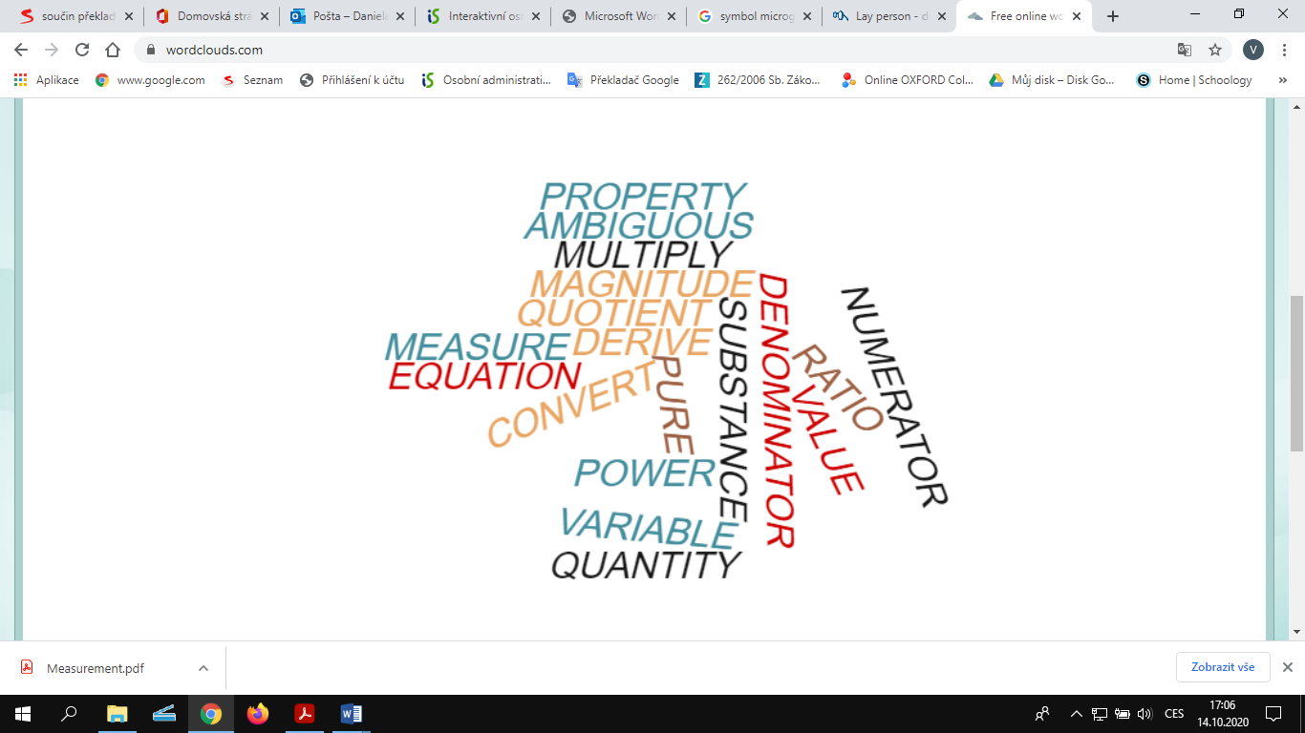

**These words are in the word cloud:** vlastnost, nejednoznačný, násobit, velikost, podíl, měřit, odvodit, rovnice, převést, mocnina, proměnná, veličina, čistá látka, jmenovatel, hodnota, poměr, čitatel

**Task 3**

1 values, 2 property, 3 compound, 4 unambiguous, 5 lay person, 6 pure,

In this section the language of measurement, which is central to chemistry, will be introduced. Chemists might measure a number of variables such as pressure, temperature, mass, and volume and use the experimental values to calculate some other property. The purity of a compound or the concentration of a compound in a commercial product are possible examples. The chemist needs to be able to record data and do calculations in a precise and unambiguous format. This requires a universally adopted language involving concepts, symbols and rules. While the average lay person knows little of these, knowledge of them is essential to the practising of chemistry. This section follows the recommendations of the International Union of Pure and Applied Chemistry (IUPAC), the international governing body for chemistry.

**Task 4**

a) a property that is measured, e.g. mass

b) a number with units

c) the units in the numerator and denominator cancel

d) by dividing the mass by the volume

e) 1 mile = 1.609 km, we multiply the length in miles by 1.609

**Task 5**

1 amount of substance, 2 electric current, 3 frequency, 4 force, 5 pressure, 6 electric charge, 7 area, 8 mass, 9 volume, 10 length

**Task 5**

A amount of substance B pressure C mass fraction

**Task 7**

a) 10 grams C:\Users\Admin\AppData\Local\Microsoft\Windows\INetCache\Content.MSO\E9BDBDB5.tmp b) 15 kg c) 273 kelvins d) 20 m/s e) 50 nanoseconds

**Task 8**

1. What was the dosage (dávky, dávkování) of fluoride per kilogram of body weight?
2. **0.166** b) 0.16 c) 0.616
3. What was the sensitivity of the assay (analýza, rozbor)?
4. 0.02 b) 2.0 c**) 0.2**
5. What is the output impedance (impedance - total resistance of a piece of electrical equipment) at the 5V end?
6. **0.02** b) 0.20 c) 0.92
7. What amperage (intenzita el.proudu) of flex (kabel) is used?
8. 0.6 **b) 6** c) 6.8
9. What is the temperature below which the superconductor conducts (runs, passes, vést) electricity with no resistance (obstruction, odpor)?
10. **b) 19** c) 90
11. What is the enthalpy (sum of internal energy, entalpie) change when 2 moles of water are formed at a pressure of one atmosphere and a temperature of 298 kelvin?
12. -517.6 b) -5716 **c) -571.6**
13. What is the lowest frequency at which young mice squeak when isolated from their mother?
14. 450 **b) 45** c) 405
15. What speed laser pulses were used?

a) 15 **b) 50** c) -50

**Stoichiometry: Mass – volume problem** <https://www.youtube.com/watch?v=UXRSHplX-zo> 0 – 3.30

What do the following expressions mean in connection with calculations?

*problem zadani equation rovnice significant figures platne cislice round a number zaokrouhlit*

**Problem: Calculate the volume of oxygen gas required to react with 50g of aluminium.** **You know that:**

One mole of an ideal gas at standard temperature and pressure occupies 22.4 litres.

Relative atomic masses: Ar (Al) = 27g/mol, Ar (O) = 16 g/mol, STP = standard temperature and pressure

**Summary of the tutorial**:

**1** We start with an ……equation.. : 4 Al + 3 O2 🡪 2 Al2O3  (check that the equation is …balanced… )

**2** We know we have 50g of aluminium and we have to go from grams to …moles….. of aluminium.

50 …divided….. by 27 is 1.852 moles of aluminium.

**3** Now we want to have moles of oxygen. Look at the equation - next to the moles of Al we have 4, next to the moles of O2 we have 3. 1.852 times three divided by four equals 1.3889 moles of O2

**4** We want to go from moles of O2 to liters of O2. We multiply ……1.3889 …. times …22.4….

**5** Pay attention to sig figs. You started with three sig figs, you should end with 3 sig figs , i.e.31.1 L. Do not round in the middle of the calculation but at the end .