**8** **CHEMICAL BONDING**

**1. Warm-up**

# What specific tendencies to form bonds can you predict from the position in the periodic table?

* **In general, what properties do the different types of bonds lead to?**

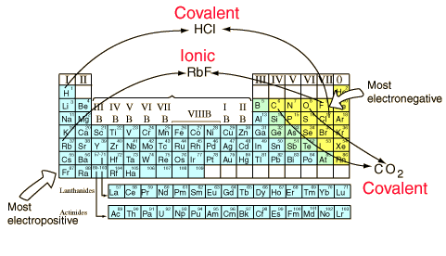

**2. Use these words to fill in the gaps 1 – 6.**

*upper right stable bottom left electronegativity covalent ionic*

You can anticipate some things about bonds from the positions of the constituents in the [periodic table](http://hyperphysics.phy-astr.gsu.edu/hbase/pertab/pertab.html#c1). Elements from opposite ends of the periodic table will generally form **1** ionic bonds. They will have large differences in **2** [electronegativity](http://hyperphysics.phy-astr.gsu.edu/hbase/Chemical/bondd.html#c3)   and will usually form positive and negative ions. The elements with the largest electronegativities are in the **3** upper right corner of the periodic table, and the elements with the smallest electronegativities are on the **4** bottom left. If these extremes are combined, such as in RbF, the [dissociation energy](http://hyperphysics.phy-astr.gsu.edu/hbase/tables/diatomic.html#c1) is large. As can be seen from the illustration above, hydrogen is the exception to that rule, forming **5** covalent bonds. Elements which are close together in electronegativity tend to form covalent bonds and can exist as **6** stable free molecules. Carbon dioxide is a common example.

## **3. Sort out the information a-h under the right heading: Ionic Compounds or Covalent Compounds**

1. Poor electrical conductors in all phases
2. Conduct electricity when melted
3. Many soluble in water but not in nonpolar liquid
4. Many soluble in nonpolar liquids but not in water
5. Crystalline solids (made of ions)
6. Low melting and boiling points
7. High melting and boiling points
8. Gases, liquids, or solids (made of molecules)

# Comparison of Properties of Ionic and Covalent Compounds

Because of the nature of [ionic](http://hyperphysics.phy-astr.gsu.edu/hbase/Chemical/bond.html#c4) and [covalent](http://hyperphysics.phy-astr.gsu.edu/hbase/Chemical/bond.html#c2) bonds, the materials produced by those bonds tend to have quite different macroscopic properties. The atoms of covalent materials are bound tightly to each other in stable molecules, but those molecules are generally not very strongly attracted to other molecules in the material. On the other hand, the atoms (ions) in ionic materials show strong attractions to other ions in their vicinity. This generally leads to low melting points for covalent solids, and high melting points for ionic solids. For example, the molecule carbon tetrachloride is a non-polar covalent molecule, CCl4. It's melting point is -23°C. By contrast, the ionic solid NaCl has a melting point of 800°C.

|  |  |
| --- | --- |
| **Ionic Compounds**  1. b 2. c 3. e 4. g | **Covalent Compounds**  1. a 2. d 3. h 4. f |

<http://hyperphysics.phy-astr.gsu.edu/hbase/Chemical/bond2.html#c1>

**4. Listen and** **take notes.** <https://www.youtube.com/watch?v=7DjsD7Hcd9U> 0.20 - 1.52

A) Complete the gaps in the diagram

*polar electrons shared unequally*

*electrons are shared covalent bonds*

*non-polar electrons shared equally*

*ATOMS*

*electrons are transferred ionic*

*electrons ‘collectively’ shared metallic*

B) Explain how you identify the type of bond and give examples 4.00 – 8.26

*Non-polar 0 – 0.5 difference in electronegativity of the elements diesel fuel C16H34*

*Polar 0.5 – 1.7 H2O*

*Ionic more than 1.7 Na Cl*

**5. Ionic bond**

* What happens when sodium reacts with chlorine?

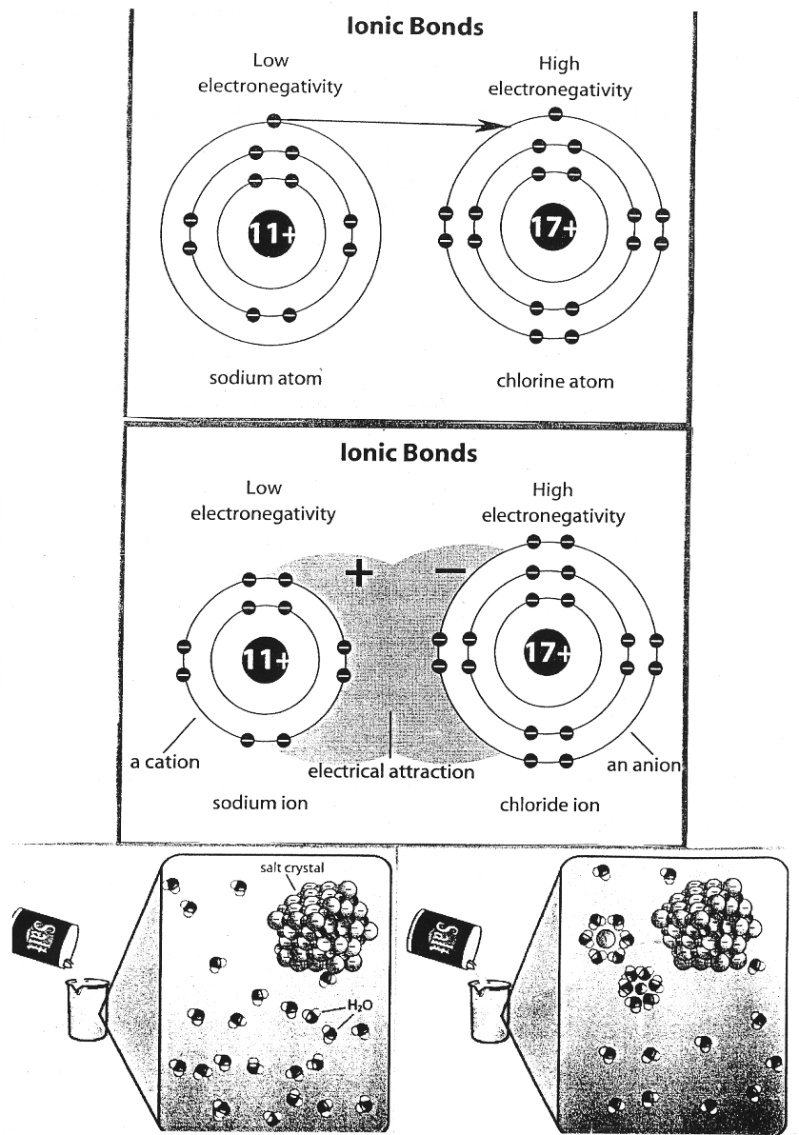 

1. The first thing that happens in the formation of an ionic bond is that the sodium atom loses an electron.
2. In the next step sodium lost an electron, that’s why it has a positive charge.
3. The two atoms take on electrical charges and are called ions.
4. Neutral Cl atom is called chlorine but after it has received an electron it becomes Cl-, called chloride.

3.30 – 5.19 Ionic Bonding Introduction by Tyler DeWitt <https://www.youtube.com/watch?v=Qf07-8Jhhpc>

* What happens while dissolving sodium chloride in water?



**Pronounce the words correctly:**

electronegativity chlorine loosely ions cation anion partial charges dissolve sphere

**6. Covalent bond: Read the text and suggest a word for each gap, then listen and compare.**

A covalent bond results when two atoms *s*hare electrons. In the case of two hydrogen atoms, each shares its single electron with the other. This sharing allows each to fill its electron *s*hell with two electrons. The pair of shared electrons constitutes a covalent *single* bond.

Let’s now consider oxygen, an atom with eight electrons. Two electrons fill the *inner* shell, and the other six electrons reside in the next shell. This outer shell needs two more electrons to *c*omplete it (the octet rule). Two oxygen atoms form a covalent *d*ouble bond by sharing two electron pairs from their outer shells.

Carbon is perhaps the most versatile element on Earth, in large part because it contains only four electrons in a shell that can *h*old eight. To fill its outer shell, carbon forms four covalent bonds with up to four other atoms.

In a molecule of *m*ethane, carbon shares electrons with hydrogen atoms, forming four covalent single bonds. Although this molecule is relatively simple, carbon often forms the *b*ackbone of large, complex molecules. With each carbon atom able to bond to four other atoms, carbon-based *m*olecules are incredibly diverse.

Triple bonds are rare, but nitrogen gas molecules (the most *a*bundant molecule in the air we breathe) form triple bonds. The two nitrogen atoms share three pairs of electrons, allowing each to have eight electrons in its *o*uter electron shell.

**7. What is specific for the types of bonds in the pictures below?**

**You can use this vocabulary:**

Interaction of positive and negative ions, attraction between (the constituents), result in electrical neutrality, achieve noble gas configuration, involve sharing of one, two, or three pairs of electrons, form of dipole interaction, cloud of delocalized electrons, structure of positively charged ions

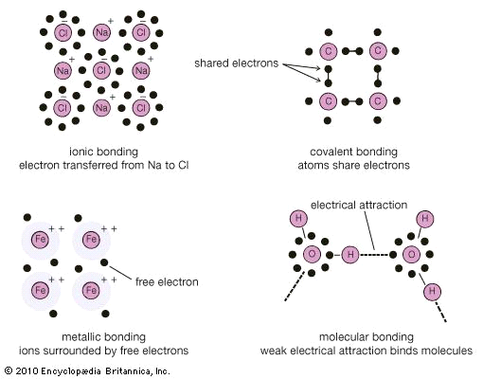

**8. Use the pictures and explain why graphite and diamond have different properties.**

DIAMOND & GRAPHITE
Allotropes are different physical forms of the same element. Allotropes have the same
chemical properti... DIAMOND & GRAPHITE
Allotropes are different physical forms of the same element. Allotropes have the same
chemical properti...

http://www.slideshare.net/matcol/carbon-chemistry

**Complete the text with the adjectives and nouns from the box.**

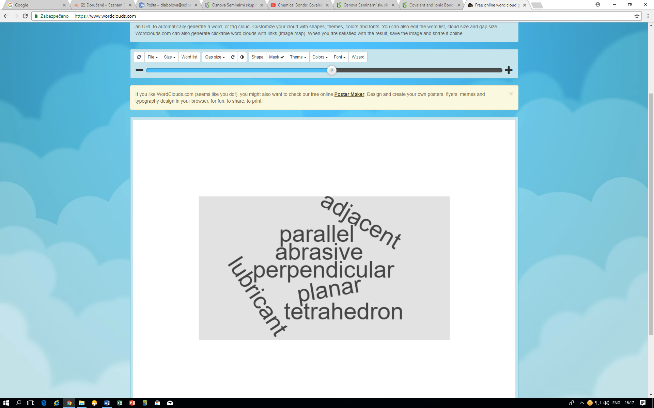

In [graphite](https://www.britannica.com/science/graphite-carbon) the carbon atoms are arranged in 1 parallel sheets, and each atom has only three near neighbours. The covalent bonds between 2 adjacent carbons within each layer are quite strong and are called [σ](https://www.britannica.com/science/sigma-bond) bonds. The fourth valence electron in carbon has its orbital 3 perpendicular to the plane. This orbital bonds weakly with the similar orbitals on all three neighbours, forming [π](https://www.britannica.com/science/pi-bond) bonds. The four bonds for each carbon atom in the graphite structure are not arranged in a 4 tetrahedron; three are in a plane. The 5 planar arrangement results in strong bonding, although not as strong as the bonding in the diamond configuration. The bonding between layers is quite weak and arises from the [van der Waals interaction](https://www.britannica.com/science/van-der-Waals-forces); there is much slippage parallel to the layers. Diamond and graphite form an interesting contrast: diamond is the hardest material in nature and is used as an 6 abrasive, while graphite is used as a 7 lubricant. <https://www.britannica.com/science/crystal/Types-of-bonds#ref506334>

Sources J. Shipman, J. Wilson, A. Todd, An Introduction to Physical Science, Houghton Mifflin, 2006, p.312 – 329