1. **How often do you have to explain / describe how something works in your discipline? What was it you had to describe this way last time? What are the characteristics of process description?**
2. **Look at the picture of a hydropower plant and try to label it with the words given. There are 2 words too many.**

*magnets, transmission lines, transformer, intake, waterfall, forebay, turbine, generator, tailrace, penstock 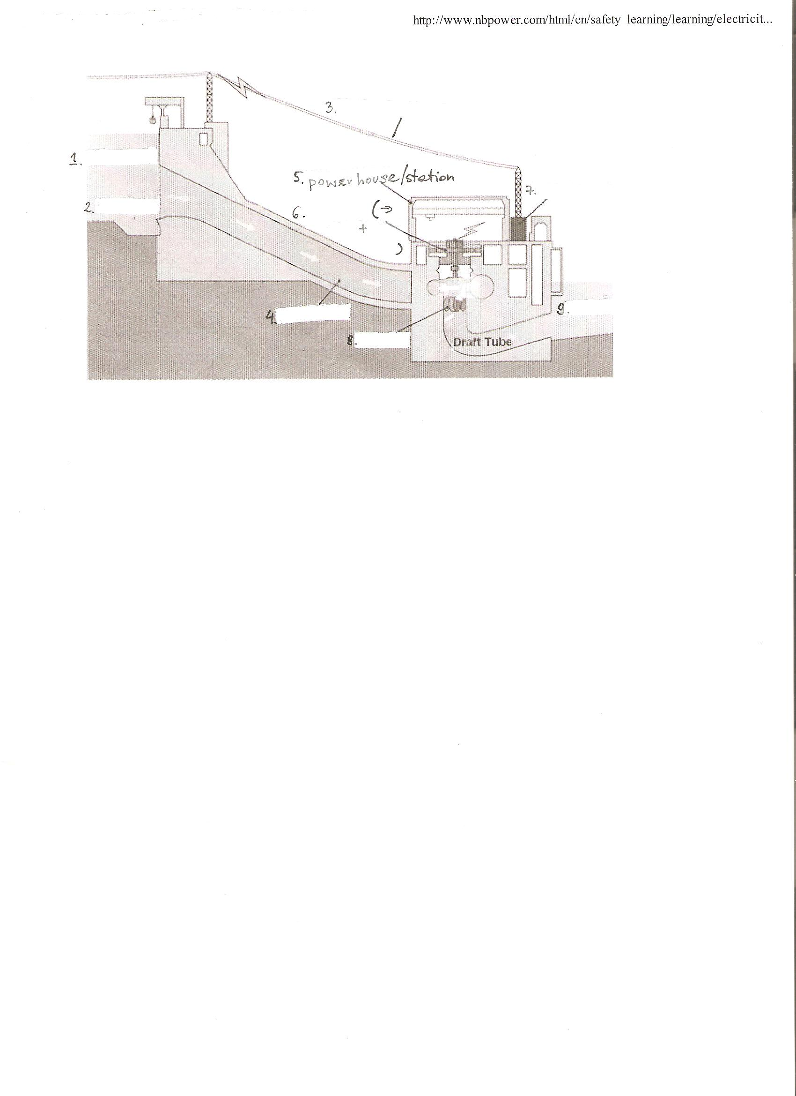adapted from:*<http://www.nbpower.com/html/en/safety>

1. **Listen to the recording and check your answers** [**http://www.darvill.clara.net/altenerg/hydro.htm**](http://www.darvill.clara.net/altenerg/hydro.htm)
2. **Listen to it again and complete the script with what you can hear.**

170 000 cubic metres of water will pass here every minute, and almost 60 kmph, that’s enough water to fill about a hundred thousand 1_______________________ every day. Standing here you can actually feel the power of the water. Harnessing that power is what hydroelectric stations have been designed to do for over a hundred years on Ontario. In essence, they’re factories that convert the energy of falling water into the 2_______________________, or what is commonly called the electricity; the electricity that powers the province.

Most hydroelectric stations use either water diverted around the natural 3_____________________, such as a waterfall, or a dam is built across a river to raise the water level and provide the drop needed to create the 4________________. Water at the higher level is collected in the forebay. It flows through the plant intake into a pipe called a penstock, which 5________________ to a turbine water wheel at the lower water level. The water pressure increases as it flows down the penstock. And it is this pressure and flow that drives the turbine that is connected to the generator.

Inside the generator is the rotor that is spun by the turbine. Large 6_______________ are attached to the rotor located within the 7__________________________ called the stator. As the generator rotor spins the magnets, a flow of electrons is created in the coils of the stator. This produces electricity, and can be stepped up in voltage through the 8_________________, and set across 9__________________.

The falling water, having served its purpose, exits the generating station to the tailrace, where 10________________________ of the river, to continue the cycle of creating the clean, renewable energy for Ontario.

1. **Text analysis.**
2. Now go over the second, third and fourth paragraphs of the text again and underline in a different manner what happens and where.
3. Descriptions of process very often contain verbs of movement. Can you identify them in the text?
4. Process descriptions often contain sequence adverbs to help the reader/listener orientate in the successiveness of the steps performed. Enrich paragraphs 2-4 with the sequence adverbs chosen by you (Process Description document in the interactive outline).
5. **Practice.** Now draw your own picture and with your own words describe how something relating to your field of study works/behaves.

Refer to the picture to facilitate the understanding of your potential audience.Have an introductory sentence, use phrases from the process description paper.

1. **HOMEWORK: Grammar revision – transition phrases**
2. **Linking Words: Cause and Result**

Complete the second sentence so that it has a similar meaning to the first using the word given. Use no more than SIX words and do not change the form of the word in capitals.

1. The accident happened because of terrible weather.  
   The accident ........ bad weather. (RESULT)
2. The train was cancelled so I missed my appointment.  
   ........ the train cancellation I missed my appointment. (CONSEQUENCE)
3. They decided to buy a new car because of the problems they were having with their old one.  
   They decided to buy a new car ........ problems with their old one. (SINCE)
4. We were unable to contact you as communications were so poor.  
   We couldn't contact you ........ communications were so poor. (OWING)
5. You have been late every morning this week so we have deducted the lost time from your wages.  
   We have deducted money from your wages ........ you have been late every morning this week. (DUE)
6. I was sent home from school because I was feeling sick.  
   The student was sent home ........ the fact that he was feeling sick. (ACCOUNT)
7. It was too far to walk so we caught the bus.  
   We got the bus as ........ to walk. (ENOUGH)

8. The film was so boring that we decided to leave early.  
 ........ we decided to leave early. (SUCH)

**b) Linking words: Time**

1. …….I didn´t really enjoy the course, but after a while I really started to enjoy it.

a) in the beginning

b) at the beginning

2. ……..of the film the main character arrives in town looking for somewhere to stay.

a) in the beginning

b) at the beginning

3. We waited ages for a bus…. We decided to walk home.

a) eventually

b) at last

4. The audience waited patiently for the delayed performance to start. ……the curtain rose. a) lastly

b) at last

5. I waited for you ….10.00. I finally decided you weren´t coming.

a) before

b) until

6. I managed to get the house tidy … my parents got home.

a) before

b) until

7. …..had I gone to bed than I heard the phone ring.

a) hardly

b) no sooner

8. I played a lot of tennis…I was on holiday.

a) during

b) while