**JAG01 Unit 8**

**I Past Life**

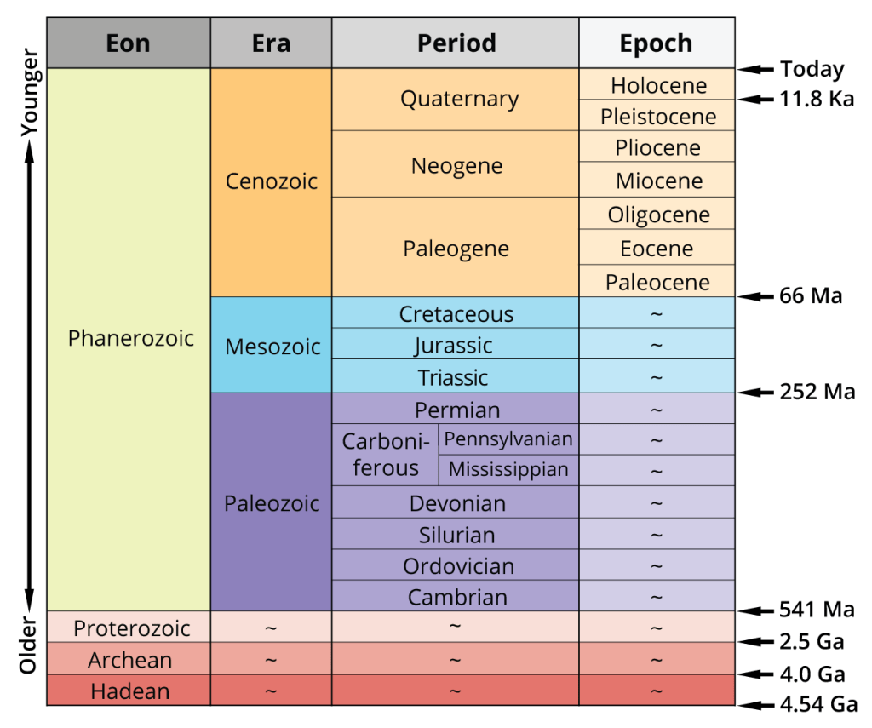

**Task 1 Match the events with one of the eras / periods / epochs:**

* first large mammals appear
* dinosaurs became the dominant animals
* the second largest mass extinction
* oldest rocks form as the Earth cools
* breakup of Pangea begins
* human ancestors appear
* trilobites are dominant
* photosynthesising cyanobacteria appear

**Can you add any other events?**

**Task 2 Speculating**

1. **Read the text. How did life on Earth begin?**
2. **In the first paragraph highlight expressions/ phrases used to speculate.**

The first microbes

It seems that life on Earth began maybe as long as 4 billion years ago, most likely in the form of microscopic single-celled organisms (microbes), like bacteria or less familiar group called archaea, on the fringes of underwater hydrothermal vents where they would have been nourished by the abundant supply of chemical energy. Chemical reactions occurring across the skin of tiny bubbles could have led to the origin of the first cell membranes. There are varieties of microbes still around today that obtain their energy chemically and can survive only in oxygen-free conditions. These are probably little changed from the primitive cells that developed beside those ancient hot vents.

After bacteria-like organisms had arisen, eventually new varieties evolved and migrated to less chemically rich regions where energy had to be extracted from sunlight (by photosynthesis). The simplest photosynthetic organisms today are cyanobacteria, formerly called blue-green algae. When these organisms spread and multiplied, they also began slowly to change the chemical balance of the atmosphere. In particular they liberated oxygen, which was at only 1 per cent of its present level about 2 billion years ago.

(Rothery, D. A. (2015). *Geology. A Complete Introduction.* McGraw-Hill.)

1. **Speaking**

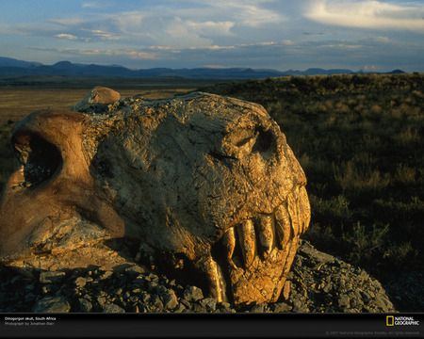

A quarter of a billion years ago, long before dinosaurs or mammals evolved, the 10-foot predator *Dinogorgon*, whose skull is shown here, hunted floodplains in the heart of today's South Africa. In less than a million years *Dinogorgon* vanished in the greatest mass extinction ever, along with about nine of every ten plant and animal species on the planet.

(https://www.nationalgeographic.com/science/prehistoric-world/permian-extinction/)

**What do you think caused the “great dying” (end Permian extinction)? Speculate about the following:**

* + asteroid impact
  + volcanism
  + widespread ocean anoxia (deficiency of oxygen)
  + formation of Pangea
  + exponential reproduction of microbes
  + dimming of the Sun

**You can use the phrases below:**

*It is**unlikely that… It seems to me that… I imagine that…*

*I´m not sure but I suppose/ I´d say that… It must / might / may have been caused by…*

**II Writing a formal email**

**Task 1 Preparation tasks**

**Speaking: What do you have to bear in mind when writing a formal email to a professor?**

**Match the vocabulary (1–6) with the more formal way of saying the same thing (a–f).**

1. at the moment

2. a problem

3. to tell you

4. to talk about it more

5. worried

6. to ask for

a. to inform you

b. to request

c. an issue

d. concerned

e. currently

f. to discuss the matter further

**Reading text: An email to your professor**

**What makes the email below formal? Highlight useful phrases.**

Dear Professor Henley,

I am writing to inform you that, unfortunately, I am unable to continue to attend the Logic II course this semester. I would like to request permission to defer as I understand that this is only possible with your approval.

The issue is that I am currently doing an internship with ABC Ltd. It started in July and will continue until the end of the semester. The internship takes up 25 hours per week and I am concerned that it does not leave me with enough time to study. I have already asked if I can reduce my hours there, but this is not possible.

With your approval, I could take Logic II next semester instead. I realise that this would mean a heavier workload than usual next semester, but I assure you that I would be able to manage my time and keep up.

Thank you for considering my request and I would be happy to come in and discuss the matter further.

Regards,

Sarah Price

**Task 2 Are the following tips true or false?**

1. Use the person’s job title if you don’t know their name (e.g. Dear Admissions Tutor, Dear Marketing Manager).

2. Start your email by clearly giving your reason for writing. Then you can explain the problem.

3. People are busy, so make it short by using contracted forms such as *isn´t* or *don´t*.

4. If you have a solution to the problem, suggest it and politely ask if it can be done. If you don’t, politely request help.

5. Finish by thanking the person for their help and offering to discuss the matter further if necessary.

6. Regards, (also With regards, Best regards, or Kind regards,) is a more formal sign-off than Yours sincerely.

**Task 3 Circle the correct answer.**

1. I am writing to _____ you of a change of address.

a. inform b. warn c. instruct

2. I sent an email last week to _____ information about the Philosophy course.

a. demand b. ask c. request

3. I _____ seven classes before I had to take time off for sickness.

a. assisted b. attended c. appeared

4. I am _____ about managing the workload of the course at the same time as my other responsibilities.

a. bothered b. concerned c. upset

5. I think one _____ has been the difficulty in accessing the library as a distance student.

a. mess b. subject c. issue

6. _____, family circumstances mean it is difficult for me to study in the evenings.

a. Currently b. Actually c. Momentarily

7. I would like to request your _____ for a change of timetable.

a. tolerance b. promise c. approval

8. I would be happy to come in and _____ it with you.

a. discuss b. argue c. dispute

**Task 4 Write one word in each gap to complete the email.**

(1)................... Professor Vazquez,

Many thanks (2)....................... your feedback on my assignment.

I’m writing (3).................. inform you that, unfortunately, I have had (4)................. postpone my current module until next term. I requested approval (5)............... the English department (6)............. this and I have (7)........... permission, as long (8 ).............. I am able to catch up with the work.

I (9)............ very much enjoyed your module and I hope (10)............. be able to rejoin the course (11)............. January, after (12)............ small operation on my foot. I wanted to explain (13)............. situation and to assure (14)............ that I will use my recovery time to keep (15)........... with the reading for the course.

I (16)............ be happy (17)............. come in and discuss the matter further.

Kind (18)...............,

Sylvia Rogers

(adapted from www.learningenglish.britishcouncil.org)