11 DESCRIBING COUNTRIES

1. Study the blank map of Great Britain. Supply the full name of the country and the names of its parts and the waters around.
1
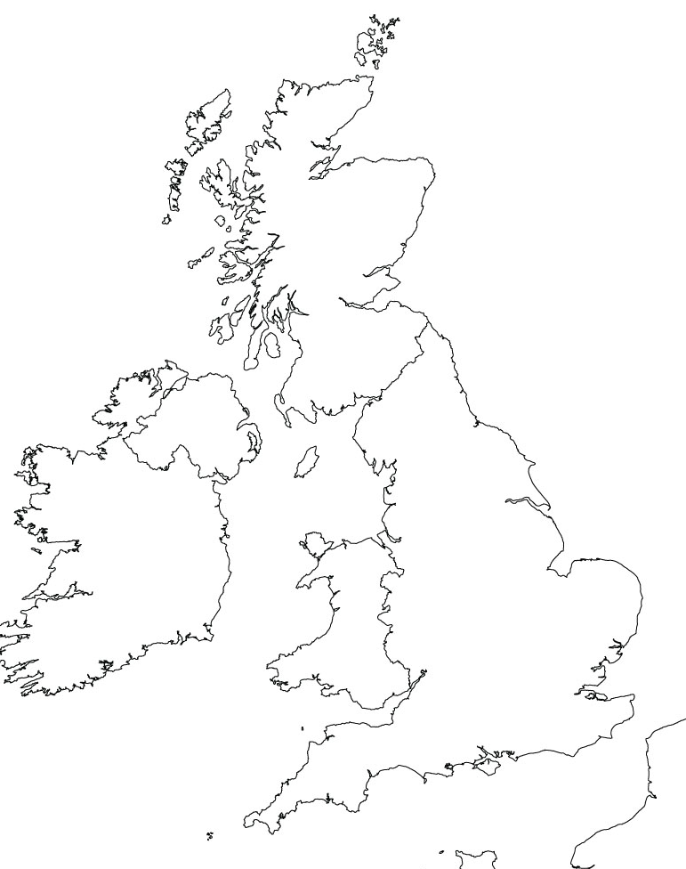
6

7
2

3
8

9
4

5

10

2. Add “the” to the names that are used with the definite article.

RULES for using “the” with geographical names
CONTINENTS AND THEIR PARTS
- The is not used with names of continents (e.g. Europe)
- However, it is used with some other geographical areas (the Middle East, the Far East)
- The + peninsulas (the Iberian Peninsula)
- The + groups of islands (the Canary Islands)

COUNTRIES
- The + names with an of- construction (e.g. the Republic of France)
- The in names modified by an adjective (the United Kingdom)
- Names which are collective or plural (the Netherlands, the Philippines)
- Other country names are not used with the (e.g. Denmark, France, China)

BODIES OF WATER
- The + names of oceans, seas, rivers (the Atlantic Ocean, the Mediterranean Sea, the Tigris)
- Not with names of individual lakes (Lake Baikal, Lake Superior, Lake Huron)
- The + bays, gulfs (the Persian Gulf, the Bay of Bengal)
- The + currents (the Gulf Stream, the Humboldt Current)
- The + strait(s), canals, channels (the Straits of Gibraltar, the Bering Strait, the Panama Canal)

MOUNTAINS
- The + names of mountain ranges (the Alps, the Himalayas)
- Some individual mountains are named with the (the Matterhorn) but in most cases, the is not used with mountains and volcanoes (Mont Blanc, Everest, Etna)

DESERTS
- The + names of deserts (the Sahara desert, the Gobi, the Kalahari Desert)
3. COMPOSITION – make sentences with the four verbs below.

consists of
Great Britain comprises
is composed of
……. constitute Great Britain.

LOCATION

lies is used for islands
is situated is used for mainland

in the south of the country - na jihu
to the north of the country - směrem na sever
is situated west of London - západně od

4. Complete the text with the following words.
composed comprises consists constitute separated surrounded
in to (2x) which while
Britain (or Great Britain) is an island that lies off the northwest coast of Europe. The nearest country is France, (1)___________ is 20 miles away and from which Britain is (2) ___________ by the English Channel. The island is (3) ___________by the Atlantic Ocean (4) ___________ the west, and the North Sea (5) ___________ the east. It (6)_____________ the mainlands of England, Wales and Scotland, that is, three countries. Scotland is in the north, (7) ___________Wales is in the west. Ireland, which is also an island, lies off the west coast of Britain. It (8) ___________of Northern Ireland and the Irish Republic. Britain together with Northern Ireland (9)____________ the United Kingdom (UK). Thus, the United Kingdom is (10)___________ of four countries, the largest of which is England. The capital city is London, which is situated (11) ___________ south-east England.

5. Read the following list of geographic facts about Great Britain and explain:
- What constitutes the topographic features?
- What are the climatic conditions in the country like?
- How is the typical weather characterized?
- What is the number of inhabitants and population density?
- What is the main economic sector?
- Supply the missing articles. Five names in the text need to be completed with “the.”

- Great Britain also includes the outlying areas of Isle of Wight, Anglesey, Isles of Scilly, Hebrides and the remote island groups of Orkney and Shetland.
- Great Britain is located to the northwest of continental Europe and east of Ireland. North Sea and English Channel separate it from Europe. The topography of Great Britain consists mainly of low gently rolling hills in the eastern and southern portions of the island and hills and low mountains in the western and northern regions.
- The climate of Great Britain is temperate and it is moderated by Gulf Stream. The region is known for being cool and cloudy during the winter and the western parts of the island are windy and rainy because they are more influenced by the ocean. The eastern parts are drier and less windy. London, the largest city on the island, has an average January low temperature of 2.4˚C and a July average temperature of 23˚C.
- Great Britain has a population of about 60 million people (2009 estimate) and a population density of 277 persons per square kilometer. The main ethnic group of Great Britain is British - particularly those who are Cornish, English, Scottish or Welsh.
- Great Britain's United Kingdom has the third largest economy in Europe. The majority of the UK's and Great Britain's economy is within the service and industrial sectors but there is also a small amount of agriculture.

6. Definite Article or Zero Article: World Geography & Landmarks. Complete the article where appropriate. https://www.youtube.com/watch?v=rPy89_4a1Eg 0.10 – 2.08; 4.45 – 6.45

- _____ Caribbean Sea
- _____ Atlantic Ocean
- _____ Panama Canal
- _____ Thailand
- _____ Canary Islands
- _____ Rainbow Mountains
- _____ Antarctica
- _____ Antarctic Desert
- _____ Czech Republic

- _____ United Arab Emirates
- _____ Northern Ireland
- _____ Lake Baikal
- _____ Dead Sea
- _____ Mallorca
- _____ Mount Everest
- _____ Himalayas
- _____ Saudi Arabia
- _____Australia

7. Geography now! Czech Republic https://www.youtube.com/watch?v=-kaF6SnSEo8 0.40- 5.24
till - obdělávat půdu
Complete your ideas in the table before watching and compare afterward.
Location
Regions
External territories
Official name
Landscape
Czech products
Favourite pastime
Economy
Demography
Type of language family

HOMEWORK: Articles (Places and Geographical Names) -- Lesson 24, Part 2 -- English Grammar
https://www.youtube.com/watch?v=Tqfi6V9tK5U&t=235s prepared by E. Čoupková
Watch the video and take notes. 0.30 – 3.10

Will you use the definite article before these names? Give examples:
rivers ………………………………… cities………………………………………………
groups of islands……………………… oceans……………………………………………
lakes…………………………………… continents……………………………………………
islands………………………………… geographical regions………………………………
states………………………………… mountain ranges……………………………………
planets………………………………… seas………………………………………………

Other names not mentioned in the video (give examples):
deserts valleys
peninsulas capes
straits currents
gulfs bays

Insert the definite article where appropriate:

1….. United Kingdom
2….. Germany
3….. Vltava
4….. Amazonia
5….. Mount Everest
6….. European Union
7….. Holland
8….. East Borneo
9….. USA
10….. Isle of Man
11….. Northern Africa
12….. Indian Ocean
13….. Baltic Sea
14….. Middle East
15….. Western Hemisphere

16….. Cape Horn
17….. Iberian Peninsula
18….. Niagara Falls
19….. North Pole
20….. Sahara
21….. Silicon Valley
22….. Kalahari Desert

