13 DEMOGRAPHY

1. Demography - reconstructing a definition from notes

2. Discuss the questions and give reasons for your answers

    - Why do some countries have higher life expectancy than others?
    - How did life expectancy change in the past?
    - In which countries do people live the longest lives?
    - Which countries have the shortest life expectancy?
    - Why do women generally live longer than men?
    - Why does life expectancy change as one gets older?
    - How can you influence how long you will live?

3. Happy planet index https://www.youtube.com/watch?v=M1o3FS0awtk&t=488s 3.30 - 9.55
Statistician Nic Marks gathers evidence about what makes us happy, and uses it to promote policy that puts the well-being of people and the planet first.

How does Nic calculate the index?
Look at the formula:
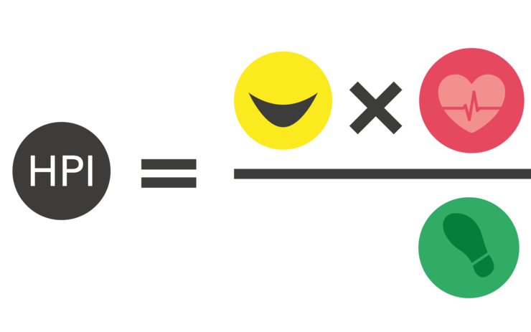

Describe the information shown in the graph: (3.30 – 7.54)
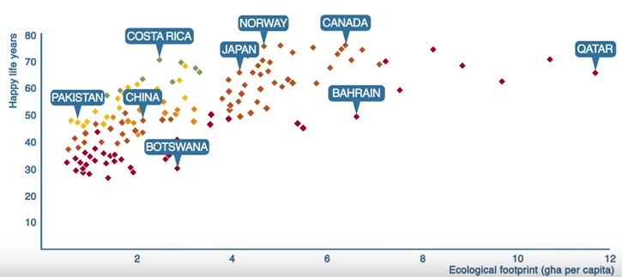

Vocabulary – what do these words mean in your language?
a measure goal array poll worthwhile

What’s happening in Costa Rica? Complete the sentences. (7.54 – 9.55)

invested in renewable resources commit according to literacy rates a quarter of the resources abolished from the bottom average connectedness

- They are, …………………… the latest Gallup world poll, the happiest nation on the planet.
- They are doing that on …………………… that are used typically in the western world.
- 99% of their electricity comes from ………………………
- Their government is one of the first to ………………… to be carbon-neutral by 2021.
- They …………….…. the army in 1949.
- And they …………….. social programs, health, and education.
- They have one of the highest ……………………. in Latin America and in the world.
- They have the social ………………………….. .
- And the challenge is to pull the global ……………… up there.
- We need to pull countries ………………………. .

4. GRAMMAR - IRREGULAR PLURALS
Complete plural forms.
index radius thesis
criterion nucleus axis
phenomenon locus analysis

5. Read the text and compare your answers in task 2 with the information:
Life expectancy from birth is a frequently utilized and analysed component of demographic data for the countries of the world. It represents the average life span of a new-born and is an indicator of the overall health of a country. Life expectancy can fall due to problems like famine, war, disease and poor health. Improvements in health and welfare increase life expectancy. The higher the life expectancy, the better shape a country is in.

As you can see from the map, more developed regions of the world generally have higher life expectancies (grey) than less developed regions with lower life expectancies (black). The regional variation is quite dramatic.

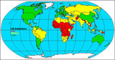

However, some countries like Saudi Arabia have very high GNP per capita but don't have high life expectancies. Alternatively, there are countries like China and Cuba that have low GNP per capita have reasonably high life expectancies.

Life expectancy rose rapidly in the twentieth century due to improvements in public health, nutrition and medicine. It's likely that life expectancy of the most developed countries will slowly advance and then reach a peak in the range of the mid-80s in age. Currently, microstates Andorra, San Marino, and Singapore along with Japan have the world's highest life expectancies (83.5, 82.1, 81.6 and 81.15, respectively).

Unfortunately, AIDS has taken its toll in Africa, Asia and even Latin America by reducing life expectancy in 34 different countries (26 of them in Africa). Africa is home to the world's lowest life expectancies with Swaziland (33.2 years), Botswana (33.9 years) and Lesotho (34.5 years) rounding out the bottom.

Women almost always have higher life expectancies than men. Currently, the worldwide life expectancy for all people is 64.3 years but for males it's 62.7 years and for females life expectancy is 66 years, a difference of more than three years. The sex difference ranges from four to six years in North America and Europe to more than 13 years between men and women in Russia.
The reasons for the difference between male and female life expectancy are not fully understood. While some scholars argue that women are biologically superior to men and thus live longer, others argue that men are employed in more hazardous occupations (factories, military service, etc). Plus, men generally drive, smoke and drink more than women - men are even more often murdered.

Life expectancy changes as one gets older. By the time a child reaches their first year, their chances of living longer increase. By the time of late adulthood, ones chances of survival to a very old age are quite good. For example, although the life expectancy from birth for all people in the United States is 77.7 years, those who live to age 65 will have an average of almost 18 additional years left to live, making their life expectancy almost 83 years. https://www.thoughtco.com/life-expectancy-overview-1435464 , updated 2019

Go through the text again and find words with the same meaning as the following:

1.because of
2.difference(s)
3.on the other hand
4.in the same order
5.loss, damage, or deaths
6.moves between some values
7.jobs
8.time in your life after your physical growth has stopped

6. Expressing cause and effect relationship – study the vocabulary in the table below:

CONJUNCTIONS because, as, since introduce a cause

so introduces an effect

T RANSITIONS therefore, consequently, as a result, introduce an effect

as a result of -ing introduces a cause

PREPOSITIONS due to, because of, owing to introduce a cause in the form of a noun phrase

VERBS lead to, result in, produce, cause introduce an effect

result from, be caused by introduce a cause
http://web2.uvcs.uvic.ca/elc/studyzone/570/pulp/hemp5.htm
Match possible causes of high or low LE and form sentences using appropriate linking words (e.g. be a cause of, due to, because of, as a result of, results from, etc.) Add any useful expressions.
Source: activity by E. Čoupková

HIGH LE LOW LE

regular medical check-ups
AIDS
famine ability to survive the first year

war poor health smoking

improved medical care good hygiene
high GNP

Example
Life expectancy grows as a result of the ability to survive the first year.

HOMEWORK: Supply the words described by these definitions.

A ……………….. the ​total ​value of all the ​goods and ​services ​produced by a country in a ​year ​including ​income from ​foreign ​investments, ​divided by the ​number of ​people ​living there.
B ……………….. statistical measure of how long a person may live, based on the year of their birth, their current age and other factors. At a given age, it is the average number of years that is likely to be lived by a group of individuals exposed to the same mortality conditions until they die.
C ……………….. graphical illustration that shows the distribution of various age groups in a population.
D ……………….. number of deaths in a particular population, scaled to the size of that population, per unit of time. It is typically expressed as the number of deaths per 1,000 individuals per year.
E ……………….. the ratio of total live births to total population in a specified community or area over a specified period of time. It is often expressed as the number of live births per 1,000 of the population in a year.
F ……………….. represents the number of children that would be born to a woman if she were to live to the end of her childbearing years and bear children in accordance with current age-specific rates. As a measure, it is the number of live births per 1,000 women of the childbearing age group (15-44).
G ……………….. a ratio determined by comparing the frequency of illness to the number of healthy people in a group over a certain time, it relates to the likelihood of developing or contracting a certain illness or event.

Clue (not in the right order)
natality GNP population pyramid morbidity life expectancy fertility mortality

