2 HISTORY OF THE CONTINENTS

1. Language for predicting:
a) What degree of probability do these groups of words express? What’s your idea in %?

will will possibly is unlikely cannot
is certain to might is improbable will definitely not
is sure to may is impossible
is bound to could
will definitely is likely to
must can

b) Sort out the sentence 1-12 according to probability in the two groups below.

Something will happen, you’re almost sure

Something may or may not come true

1. There could be a bug in the system.
2. There will definitely be a storm.
3. He is sure to win the championship.
4. Do you think the Prime Minister will resign? - No, that's unlikely.
5. We are likely to win the contract.
6. There might be an excursion next month - I'm not sure.
7. The counsellor may be able to help you.
8. Jan is bound to pass the exam. He’s worked really hard.
9. We'll possibly get the test results tomorrow.
10. Jan is certain to pass the exam.
11. It's possible that she will move to the dorms later.
12. They are bound to succeed!

2. Theorizing:
What do you think your life will be like in 10 years?
What do you think the main events in science in 10, 25 or 50 years will be?

3. Theory of plate tectonics - vocabulary

The Earth’s structure: name the different layers according to the composition and mechanical behaviour:
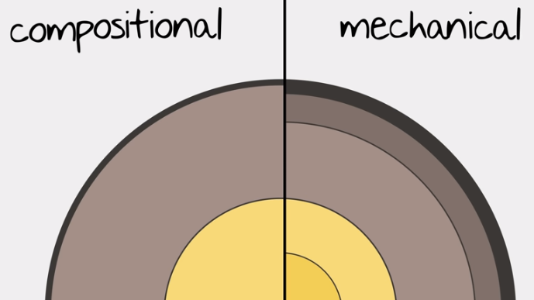

Show these on the map below: Mid-Atlantic Ridge, the Andes, the Himalayas, San Andreas fault.
At which plates do we find them?

4. Plate Tectonics Theory Lesson - Wegener
https://www.youtube.com/watch?v=zbtAXW-2nz0 0-2.20 ex.3, 2.20-3.06 ex.4 0-4.33
Finish the sentences about the origin of Plate tectonics theory with your own ideas.

- The scientist Alfred Wegener (1880-1930) noticed that the coastlines of some several continents …
- He thought that around 200 million years ago all of the continents …
- He believed that in the process called ‘continental drift’ …
- The reaction of the other scientists at the time …
- But today his ideas are … for the modern plate tectonics theory.

The theory says that the Earth’s outer mechanical layer is divided into large continent-sized plates that are constantly moving.

Using the pictures, explain the evidence that helped to accept the idea:

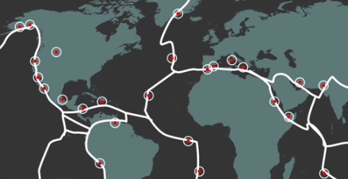
5. Complete the text about plate movement with the words from the list below:
can (expresses ability/possibility)
cannot (lack of possibility)
may (expresses possibility)
must (expresses certainty)
is likely to (= will probably)

Plate movement
As a result of the convection cells generated by heat from the centre of the Earth, plates 1_________________ move towards, away from or sideways along adjacent plates. It is at plate boundaries that most of the world’s major landforms occur, and where earthquake, volcanic and mountain-building zones are located. Before explaining the formation of these landforms, several points should be noted.

1. Due to its relatively low density, continental crust does not sink and so is permanent; being denser, oceanic crust 2_________________ sink. Oceanic crust is being formed and destroyed continuously.

2. Continental plates, such as the Eurasian Plate, may consist of both continental and oceanic crust.

3. Continental crust 3___________ extend far beyond the margins of the landmass.

4. Plates 4_____________overlap. This means that either they 5______________be pushed upwards on impact to form mountains, or one plate 6_________________ be forced downwards into the mantle and destroyed.

5. No ‘gaps’ 7____________ occur on the Earth’s surface so, if two plates are moving apart, new oceanic crust originating from the mantle 8____________ be being formed.

6. The Earth is neither expanding nor shrinking in size. Thus when new oceanic crust is being formed in one place, older oceanic crust 9_____________be being destroyed in another.

7. Plate movement is slow (though not in geological terms) and is usually continuous. Sudden movements are detected as earthquakes.

8. Most significant landforms (fold mountains, volcanos, island arcs, and deep sea trenches) are found at plate boundaries. Very little change 10_____________ occur in plate centres (shield lands).
D. Waugh, Geography, 2009

6. Discuss the questions about the Andes Mountains.

1. Which countries are situated in the Andes?
2. Which plates formed the Andes? How?
3. What causes the earthquakes and volcanoes?
4. What is the boundary between the plates called and how deep under the sea is it?
5. Why is it difficult to live in these mountains?
The Andes Mountains run the length of the West Coast of South America, rising in the north in Colombia and finishing in Chile and Argentina in the south. They are the world's longest mountain range running for over 7,000 km and covering 6 countries.
The mountains have been formed as a result of the convergence of the Nazca plate and the South American plate. The heavier oceanic crust of the Nazca plate is pushed towards the South American plate, and because it is denser it is subducted underneath. The South American plate is less dense so it sits on top of this subduction zone, but the rocks of the South American plate have been folded upwards and crumpled into fold mountains. There are also volcanoes and earthquakes along this destructive plate boundary - earthquakes are caused by stresses building up as the two plates try to move past one another, and volcanoes are caused by magma working its way up through vents in the Earth's crust. This has created a sequence of volcanoes and fold mountains, rising up to 6962 m at Aconcagua. The trench (marking the boundary between the Nazca and South American plates) to the West of the Andes mountains is called the Peru-Chile Trench, and reaches an incredible depth of 8066 m under the sea level.
These areas are very hard to live in because of the physical geography. The relief is very steep making farming difficult, and the high altitude makes breathing difficult. Due to the mountainous terrain it is hard to construct roads and railways.
http://www.coolgeography.co.uk/GCSE/AQA/Restless%20Earth/Andes/Andes%20Case%20study.htm

NOTE
fault - a break in the lithosphere along which movement has occurred
fold - flat and planar surfaces, such as sedimentary strata, are bent or curved as a result of permanent deformation

7. Use the phrases to complete the first column of the table. Add an example in the last column.

- constructive margins / divergence
- destructive margins / convergence
- passive margins / transform faults
- destructive margins / subduction zones

TYPE | DESCRIPTION | EXAMPLE
 | plates move away from each other, new oceanic crust appears forming mid-ocean ridges with volcanoes
 | oceanic crust moves towards continental crust but, being heavier, sinks and is destroyed forming deep trenches and islands with volcanoes
 | two continental crusts collide and, as neither can sink, are forced up into fold mountains
 | two plates move sideways past each other, land is neither formed nor destroyed
D. Waugh, Geography, 2009, p.15

