8 PROCESSES ON THE EARTH

**1. Cause and effect language** (adapted from Geography, An Integrated Approach, p.215)

**Underline the vocabulary for expressing a cause or an effect (verbs, connectors, prepositional phrases)**

**Dew point**

If unsaturated air is cooled and atmospheric pressure remains constant, a critical temperature will be reached when the air becomes saturated. This is known as the dew point. Any further cooling will result in the condensation of excess vapour.

**Radiation cooling**

Radiation cooling occurs on calm, clear evenings. The ground loses heat rapidly due to terrestrial radiation and the air in contact with it is then cooled by conduction. If the air is moist, some vapour will condense to form radiation fog or, if the temperature is below freezing, hoar frost.

**Advection cooling**

Advection cooling results from warm, moist air moving over a cooler land or sea surface. Advection fogs in the Atacama Desert are formed as a result of warm air from the land drifting over cold ocean water.

**Convective cooling**

In the process of convective cooling, air is warmed during the daytime and rises in pockets. As the air expands, it uses energy and so loses heat and the temperature drops. The air is cooled by the reduction of pressure with height rather than because of a loss of heat the surroundings.

**2. With the help of this picture, add the right term to each of the descriptions:**

Energy moves in three ways:

1) through a material, usually a solid object, without the material itself moving -

2) through a liquid or gaseous material, because of movement within the material -

3) through empty space or through air, water, without the aid of the material -

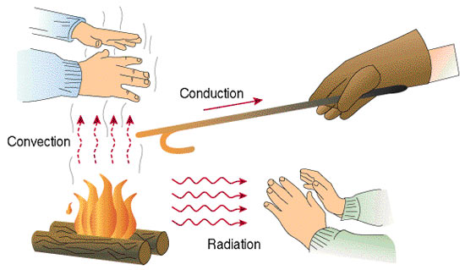

**3. Draw a picture or a scheme for the information you will get. Use the drawing and describe the process to your partner.**

**4. Khan academy: Thermal conduction, convection and radiation** <https://www.youtube.com/watch?v=8GQvMt-ow4w>

* Watch the first part 1.15 – 4.47 and see the drawings; do they correspond with yours?
* Watch the second part 4.47 – 9.08 and complete the text about radiation below.

Radiation occurs when charged particles are 1___________________ . For example, in the fire the heated molecules 2_________________, the protons and electrons in the atoms move at higher 3___________________ and release electromagnetic radiation. This radiation is in the form of light, in the 4___________________ that are visible for the eye. Everything that has some temperature releases electromagnetic radiation. If you are next to a flame, you will feel the 5___________________ . Radiation from the air particles that we 6___________________ as fire excites particles on your skin and 7___________________ energy in this way.

**5. Power in a Sea Breeze,** By Justin Gillis, NY Times.

**You will read a newspaper article. Look at the photo - what technology is the article about? In your opinion, what do the people in the picture think about it?**

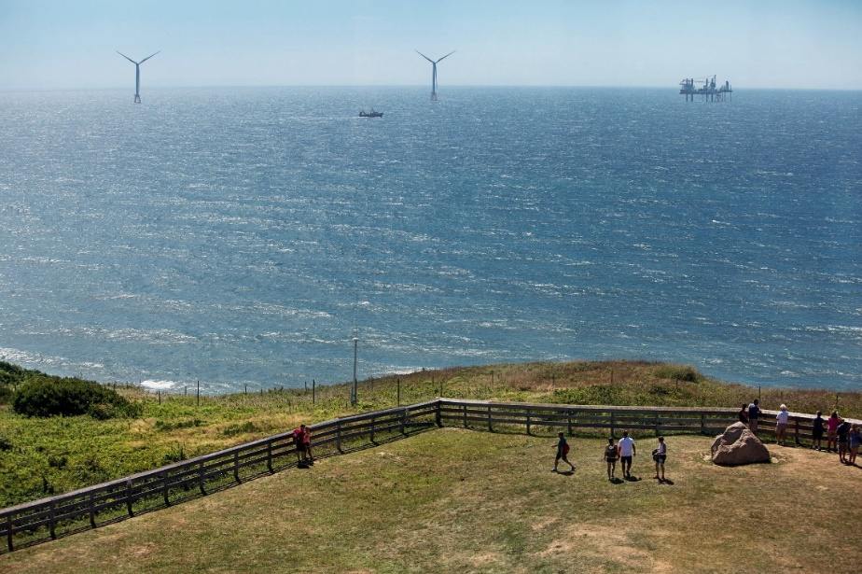

The towering machines stand a few miles from shore, in a precise line across the seafloor, as rigid in the ocean breeze as sailors reporting for duty. The blades are locked in place for now, but sometime in October, they will be turned loose to capture the power of the wind. And then, after weeks of testing and fine-tuning, America’s first offshore wind farm will begin pumping power into the New England electric grid. By global standards, the Block Island Wind Farm is a tiny project, just five turbines capable of powering about 17,000 homes. Yet many people are hoping its completion, with the final blade bolted into place at the end of last week, will mark the start of a new American industry, one that could eventually make a huge contribution to reducing the nation’s climate-changing pollution. The idea of building turbines offshore, where strong, steady wind could, in theory, generate large amounts of power, has long been seen as a vital step toward a future based on renewable energy. Yet even as European nations installed thousands of the machines, American proposals ran into roadblocks, including high costs, murky rules about the use of the seafloor, and stiff opposition from people who did not want their ocean views marred by machinery. “People have been talking about offshore wind for decades in the United States, and I’ve seen the reaction — eyes roll,” Jeffrey Grybowski said last week in an interview on Block Island. “The attitude was, ‘It’s not going to happen; you guys can’t do it.’” Mr. Grybowski and the company he runs, Deepwater Wind of Providence, R.I., have now done it. They had a lot of help from the political leadership of Rhode Island, which has seized the lead in this nascent industry, ahead of bigger states like New York and Massachusetts. Now, offshore wind may be on the verge of rapid growth in the United States.

<https://www.nytimes.com/2016/08/23/science/americas-first-offshore-wind-farm-may-power-up-a-new-industry.html>

**Read the text above and decide if the sentences are true or false:**

1. The wind farm has been working since October of that year.
2. It consists of a large number of turbines.
3. The offshore wind is strong enough to generate large amounts of power.
4. European countries are more open to the wind power than the USA.
5. Part of the opposition against wind farms is that it ruins the view of the landscape.
6. The bigger states such as Massachusetts are ahead of smaller ones in implementing the technology.

**6. Discussing advantages and disadvantages**

**What is your opinion about using wind power? Should the wind farms be built? If so, where?**

Before you answer, think about pluses and minuses

|  |  |
| --- | --- |
| PLUS | MINUS |
|  |  |
|  |  |
|  |  |
|  |  |

Try to use any **four** of the phrases below in your comment:

**General point of view**

* It is thought that...
* Some people say that...
* It is considered...
* It is generally accepted that…

**Personal point of view**

* In my experience…
* Speaking for myself…
* In my opinion…
* Personally, I think…
* I'd say that…
* I'd like to point out that…
* I believe that…
* What I mean is …