9 CLIMATE

**1. Read the description of an experiment. Then answer the questions and the true/false activity.**

The purpose of this experiment is to demonstrate the effect of a changing angle on the incoming energy.

1) Place the paper on a table or other flat surface. Make sure that the blinds are drawn and lights are turned off.

2) Shine the flashlight directly at a surface so that the light strikes the surface at a 90° angle.

3) Move the flashlight so that the light strikes the surface at a smaller angle than 90°.

**Questions:**

What does the light look like on the paper when it strikes the paper at a 90° angle?

How does the change in angle affect the size of the lighted area and the brightness of the lighted area?

**Are the points 1 – 3 true or false? Correct the false ones.**

1. The total energy striking the paper is the same both at 90° and at a smaller angle.

2. At one particular point, the amount of energy striking the paper stays the same when the angle changes.

3. The angle at which sunlight reaches the equator is close to 90°, therefore these places get a lot of energy and have high temperatures.

4. As the angle of the incoming sun rays increases from the equator to the poles, temperatures also increase.

5. Near the North and South Poles, the sun’s energy strikes the earth’s surface at a small angle.

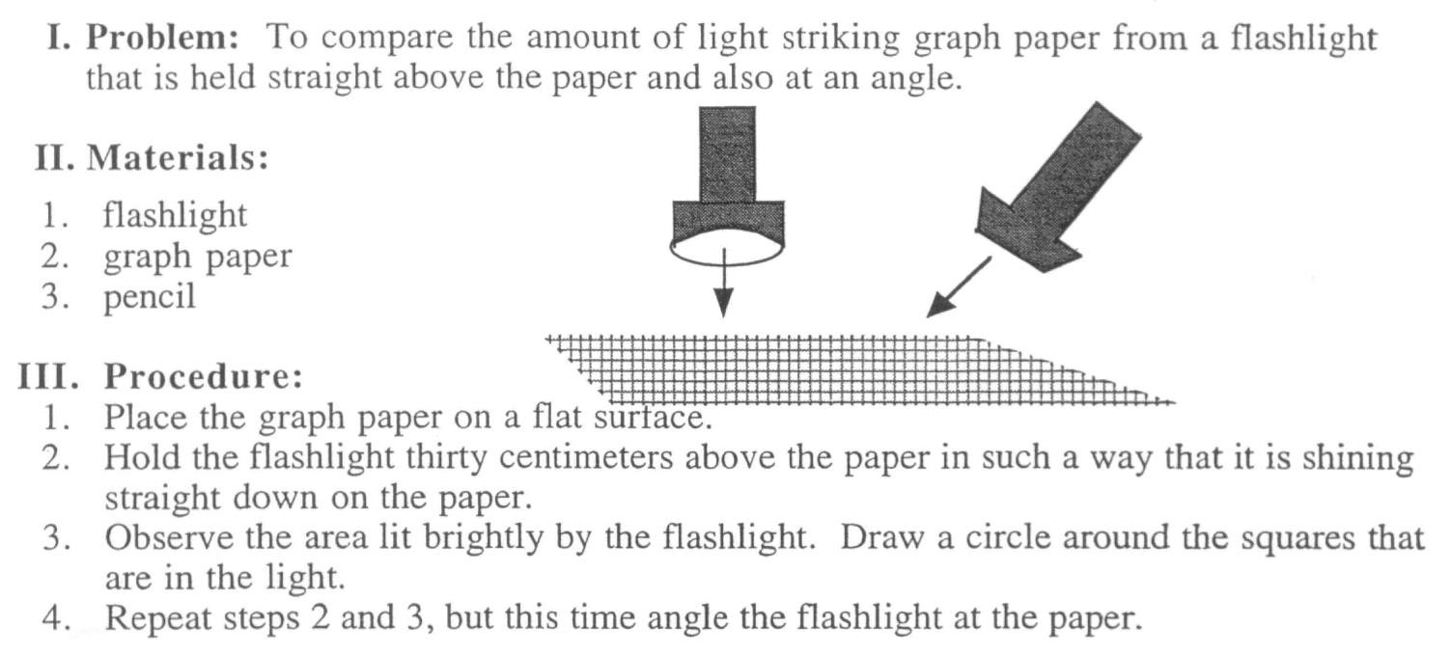

**2. Look at the picture of different zones. Then try to suggest a suitable word for each gap in the text below. (Most of the words are form ex. 1 and 2 on this page).**

<http://jrohnerweatherandclimate.weebly.com/factors-affecting-temperature.html>

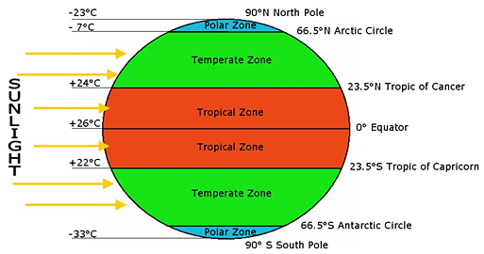

Latitude provides the location of a place north or south of the **1**______________ .

Latitude is expressed by angular measurements ranging from 0° at the equator to 90° at the **2**______________ .

Different latitudes on Earth receive different amounts of **3**______________, and are a key factor in determining a region’s **4**______________ .

For example, the higher the latitude of a given place (the farther away it is from the equator), the sharper the **5**______________ of the sun’s rays that reach it.

It means that the rays of the sun are spread across a broader **6**______________ .

Therefore, higher latitudes receive less heat than lower latitude areas nearer the equator.

The Earth’s **7**______________ is tilted 23.5°, meaning that the amount of sunlight that a particular latitude receives changes with the seasons.

From April to September, the **8**______________ Hemisphere is tilted toward the Sun, where it receives more energy; the **9**______________ Hemisphere receives this additional energy between October and March, when it is tilted toward the Sun.

Although there is no specific ‘type’ of climate, there are three general climate zones: arctic, **10**______________ , and tropical.

https://enviroliteracy.org/air-climate-weather/climate/latitude-climate-zones/

# 4. Factors affecting temperature and climate.

# Temperatures on the earth’s surface depend on three factors:

# The angle of energy waves coming from the sun

# The number of hours of sunlight

# The balance between energy received and lost by the earth’s surface

# In groups, make a list of factors which affect climate. Compare it with a group next to you.

# 

# Five Factors that Affect Climate https://www.youtube.com/watch?v=I2eZR15Q4G0

**Watch the video and fill in the missing information.** Source: Eva Čoupková, courses for the Faculty of Science

# 

# When you climb a mountain, the temperature would drop ………..ºC for every ……… meters.

# The tilt of the Earth is …………….°

# In July it is warmer in ……………..

# Topography means the Earth’s ………………….

# Mountains play a major role in ………………..……. levels.

# The sides of the mountain facing off the ocean are often ………..

# The effects of oceans and large lakes is that they ………………………. extreme weather conditions.

# Summers in St. Louis can be ……………………

# The warm ocean waters originate near ………………..

# The winds that meet near the Equator are called ………………

**5. Which zones do these countries / regions belong to?**  From K. Kelly, Geography, p.203

*North-west Europe Mediterranean basin Siberia 50 degrees N*

*Kalahari Amazon Serengeti plain*

tundra hot desert zone

**cold** **hot** equatorial

boreal savanna

**ZONES**

according to temperature

**warm**

warm temperate cold temperate

oceanic oceanic

**6. What climate is there in your home region? Compare with your neighbour’s home region.**

* Which one is hotter / drier / colder / wetter/ …?
* Why? What factors cause these features?
* Which place has got a more pleasant climate?

**7. Classifying: Suggest a word for the missing category in each of the following classification systems.** Source: Wikipedia

CLIMATE ON EARTH

**Köppen–Geiger categories** (based on temperature and precipitation)

*1. tropical*

*2. arid*

*3. mild (temperate)*

*4. continental*

*5. ………….…………..*

**Alisov categories**

(based on physical causes)

*1. equatorial*

*2. subequatorial (monsoon)*

*3. tropical*

*4. ……………………….*

*5. mild (moderate)*

*6. subarctic*

*7. polar (arctic)*

**according to Evžen Quitt**

(for the Czech Republic, based on temperature, precipitation, numbers of summer and winter days, etc.)

*1. ………………….. (5 types)*

*2. temperate (11 types)*

*3. cold (7 types)*

**For explaining how climate is classified, you can use the phrases below:**

can **be divided into** types / groups …

**according to** (two) main factors

can **be classified as** tropical, arid, ….

can **be put into several categories**

these categories **include** … / **comprise**

# 8. HAS SAHARA ALWAYS BEEN A DESERT?

# <http://news.softpedia.com/news/Has-Sahara-Always-Been-a-Desert-47128.shtml>

# Look at the vocabulary below and read the article. Use it as a source for the preparation of an interview with scientists.

# 

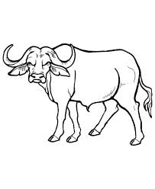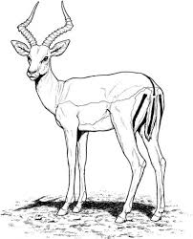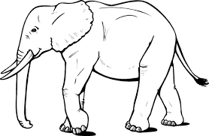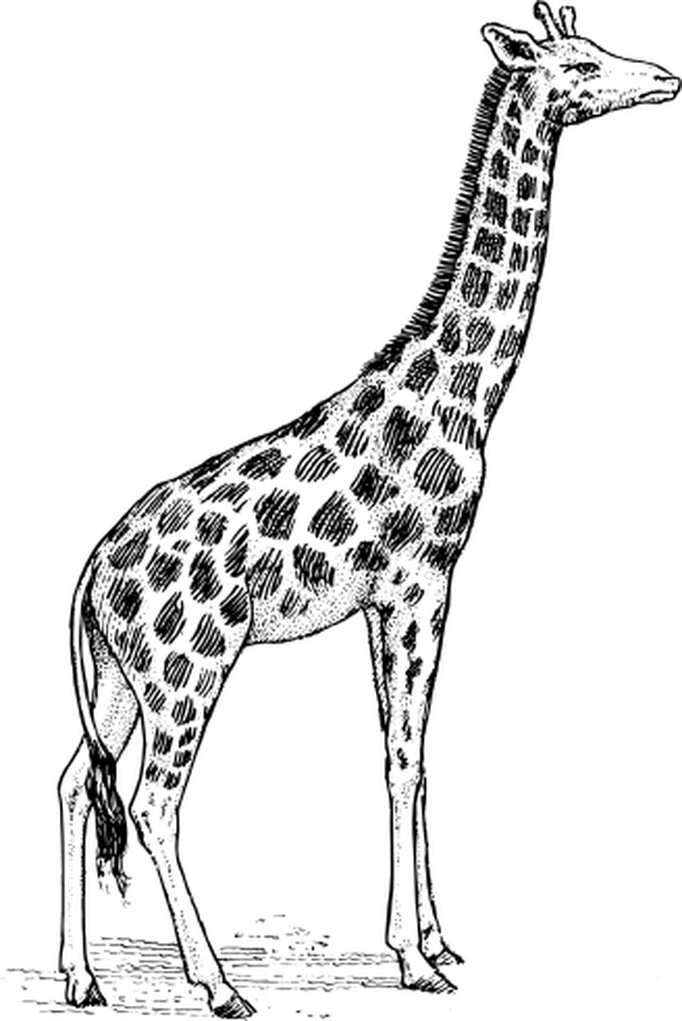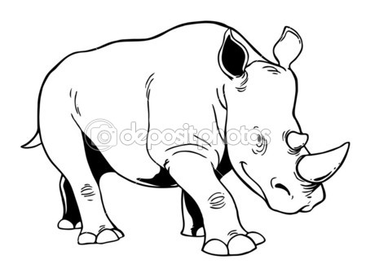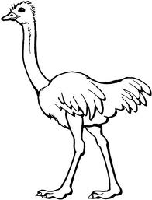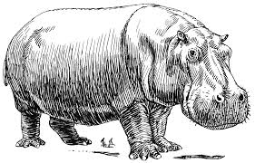

**b_ _ f _ _ o a_ _ _ _ _ _ e e_ _ ph _ _ _ g_ _ _ _ _ e rh _ _ _ _ _ _ _ s o_ _ _ _ _ h h _ _ _ _ po _ _ _ _ s**

At the time of 6,000-8,000 years ago, the rainfall was abundant, and in Sahara flourished the Neolithic culture which left the famous rock paintings found in Tassili n'Ajjer Mountains and other areas of Sahara, depicting crocodiles, ostriches, rhinos, giraffes, buffaloes, hippopotami and elephants, encountered today only in Africa at South of Sahara.

The Sahara was filled with lakes in the region of modern Niger and people hunted antelopes, while its mountains were covered by forests. Archaeologists encountered from hippopotamus and elephant bones to fishing harpoons.

Researchers using radar technology discovered in the depths of the rocks of the wide valleys a web of "channels," some small, others wider, as broad as the Nile, which represent the dry riverbeds of the rivers that crossed Sahara thousands of years ago. Niger River once originated in Sahara.

* **Roles:**

1 journalist, asks questions. Prepares specific questions for the guests based on the reading.

2 guests – experts in paleoclimatology. You have done research and answer the questions.

* **The purpose is to report science news to the public.**
* **Here is the introduction to the interview. Your task is to continue. Do not forget to introduce the guests.**

*Today's Sahara is a huge desert area, with dunes and plains covered by rocks, with less than 100 mm of rainfall a year, but it has not been like this in the past.*

*Let me welcome out guests,…*