JAZ03/ 2021 Lesson 1: A Career in Geography

1. TRUE OR FALSE ABOUT YOU?

- When I entered university, I didn‘t know much about geography.
- I came to university thinking ”I want to be a geographer.”
- I think the study should give people answers, it should not be leaving people with questions.
- I wouldn’t say that a big part of university courses should be written and oral communication skills.
- In my bachelor studies, there is/was a lot of overlap between human geography and physical geography emphasis.
- GIS is a very technically based major.

2. California State University, Northridge (CSUN)
http://catalog.csun.edu/about/
Check the link with brief information about CSUN. In your opinion, what is similar and what is different compared to Muni?

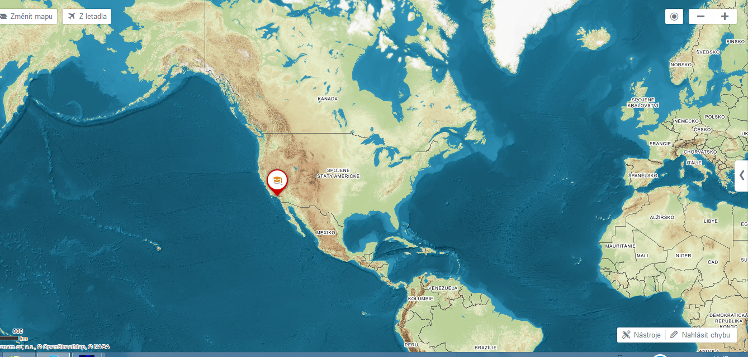

Find out what the professors from the Geography department at CSUN think about the statements 1-6 above.
https://www.youtube.com/watch?v=a_h0et9dOyk 0-1.18

3. VOCABULARY:

MAJOR ARSON PREDICT RETAIL VIBRANT INTERNSHIP
INTEGRATIVE APPROACH SURVEY DISCHARGE HAVE A DEGREE
INNOVATIVE I HAPPENED TO do something

4. Listen to another part (1.18. – 4.05) and answer the questions:
1. Where can students find work?
2. What exercise do students do in crime mapping?
3. What do geographers do for retail companies like McDonalds?
4. Where do the physical geography students intern?
5. What kind of survey are physical geography interns comfortable doing?
6. The professor’s passions were teaching and travelling but what was his major?
7. The other one asked Why certain cities are musically innovative; which disciplines didn’t give him answers?
8. The third one got keen on geography when she attended a class about …

5. Grammar: past tenses
Identify the three different past tense forms in this sentence.

“I’d already had two degrees, and I was just finishing up an extra class, and I had a class by a brilliant lecturer, and a light bulb came on and I realized I had been studying the wrong thing.”

1. I didn’t know who she was. I ……….. (never see her before)
2. When I last saw him, he ………….. (try to find a job)
3. The house was dirty. They ………. (not clean it for weeks)
4. Ken gave up smoking 2 years ago. He …………(smoke for 30 years)
5. We weren’t hungry. We …………. (just have lunch)
6. He took a photo of me while I ……… (not look)
7. Jane was waiting for me when I ……….. (arrive)
8. We arrived at work in the morning and found out that somebody …. (break into the office)

6. What Geographers Do
https://www.bls.gov/ooh/life-physical-and-social-science/geographers.htm#tab-2
Check the website or read the points below. Which of these things have you done before? Tell us more details about your projects…
- Gather geographic data through field observations, maps, photographs, satellite imagery, and censuses
- Conduct research via surveys, interviews, and focus groups
- Create and modify maps or other visual representations of geographic data
- Analyze the geographic distribution of physical and cultural characteristics and occurrences
- Collect, analyze, and display geographic data with Geographic Information Systems
- Write reports and present research findings
- Assist, advise, or lead others in using GIS and geographic data
- Link geographic data with data pertaining to a particular specialty, such as economics, the environment, health, or politics

7. Environmental Educator Position https://www.indeed.com/
This is an example of a free position for a geographer. Would you like to do this job? Why/ why not?
If you were this employer, would you hire anyone you know/ perhaps a friend of yours? If so, for which skills?

Primary Duties:
- Develop and teach cross-disciplinary, participatory programs using informal education methods for a wide variety of groups, including but not limited to school field trip, summer day-camp, professional development, and adult enrichment programs.
- Contribute to the expansion and maintenance of interpretive exhibits and displays, including display aquariums.
- Assist in project and funding proposal development in collaboration with fellow staff and community members.
- Draft, edit and submit written content for newsletters, annual reports, brochures, promotional materials, press releases, and social media.
Qualifications:
- Bachelor’s degree in environmental studies, education, or related science/natural resource field.
- Minimum 2 years of relevant teaching experience with youth audiences (informal, outdoor experience preferred).
- Ability to manage children ages pre-K to high school outdoors; must be able to observe behavior and implement appropriate behavior management techniques as needed.
- Knowledge of interpretive techniques and science communication.
- Love of the outdoors, knowledge of ecology and the Indian River Lagoon ecosystem, and leader in sustainable living.
Attributes
- Excellent oral and written communication skills.
- Ability to work outdoors under physically demanding conditions.
- Enjoy working with children.
- Enthusiasm for outdoor education.
- Flexible and determined attitude.
- Desire to work on a positive and supportive team.
HOW TO APPLY
Email: employment@discoverelc.org
Subject: ELC Environmental Educator
Include: Cover letter, resume, and three references
Applications will be accepted on a rolling basis. Electronic submissions preferred. No phone calls please. Applicant must pass basic background screening prior to hire.

