**Porphyrin-Flavonol Conjugates for Efficient Delivery of   
Carbon Monoxide**

Andrea Ramundo,1 Petr Klán*,1

*1Department of Chemistry and RECETOX, Masaryk University, Kamenice 5, 62500, Brno, Czech Republic*

*e-mail: andre.ramundo@gmail.com*

Carbon monoxide (CO) is known to be a toxic gas for mammals. It has been recognized as a signaling molecule with anti-inflammatory and cell-protective properties, with possible applications in clinical treatments.1, 2 Light-activated CO-releasing molecules (photoCORMs) can provide a high spatial and temporal control, allowing the drug to be delivered only into the targeted tissues when required. However, many of well-known photoCORMs are based on heavy metal complexes, and short irradiation wavelengths may be required for their release with evidently limited use under a clinical scenario.

Herein, we present a platform that combines the excellent photoproperties of porphyrin, which acts as an antenna and triplet sensitizer, with the CO releasing abilities of a flavonol derivative.3

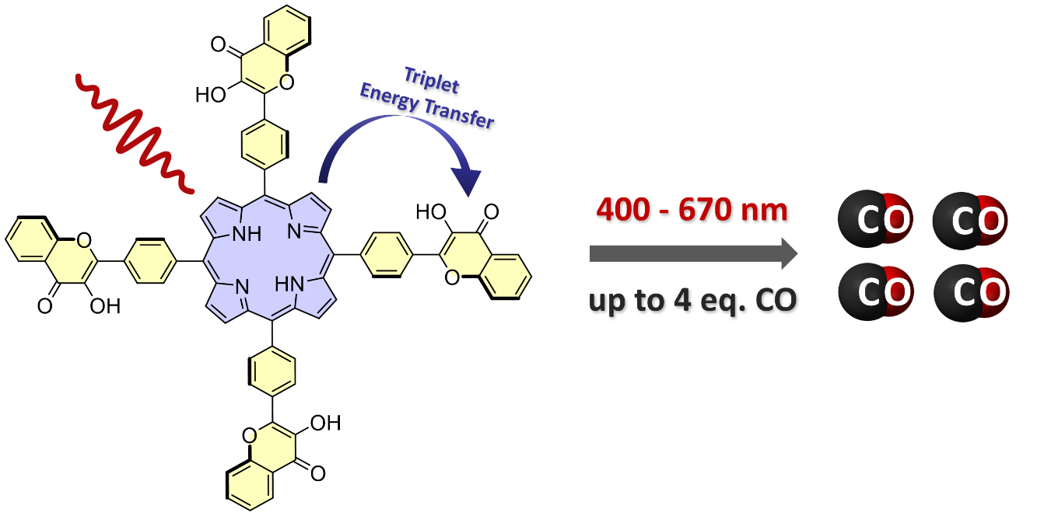

*This work was supported by the Czech Science Foundation (GA21-01799S).*

1 Verma, A.; Hirsch, D.; Glatt, C.; Ronnett, G. *Science* **1993,** *259*, 381-384.

2 Motterlini, R.; Otterbein, L. E. *Nat. Rev. Drug Discov*. **2010**, 9, 728-743.

3 Studer, L. S.; Brewer W. E.; Martinez, M. L.; Chou, P. *J. Am. Chem. Soc.* **1989**, 111, 7643-7644.