**Protocol: Preparation of hemolymph smear**

**Theory:** Observation of hemocyte cells, hemolymph in invertebrates

**Objective:** to prepare a smear from one insect representative (*Galleria mellonella*) to monitor hemocytes in insects.

**Material:**

*Galleria mellonella* larvae, staining cuvettes, Leukodif staining kit (Biolatest), underlay glasses, gloves, glass cleaning alcohol, adjustable micropipettes, tips, eye scissors, thermal water bath

**Workflow:**

We cut 1 leg of the larva and catch the escaping hemolymph with a drop on a slide and rub the drop and heat the coated glass on heating. The cells adhere better to the glass.

**Spread:**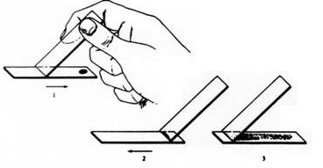

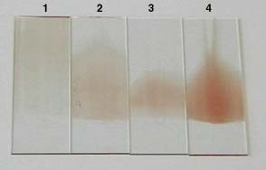

1. Too thin and long

2. good

3. Too short, the drop of blood was too small

4. Too strong, a drop of blood was too big

Retrieved from http://www.aum.iawf.unibe.ch/hemosurf/Demo_E/Lab/smears_quality.htm

**Leukodif 200 staining method**

immerse 5x1s in fixing solution No. 1 (methanol), wipe the drops against the wall of the container

immerse 3x1s in reagent No. 2 (Eosin dye), wipe the drops against the wall of the container

immerse 5x1s in reagent No. 3 (Azur dye), wipe the drops against the wall of the container

rinse in dest.H2O and allow to air dry

We will make simpler staining using Leukodif red

**Evaluation:** in the smear from hemolymph we observe hemocytes and draw

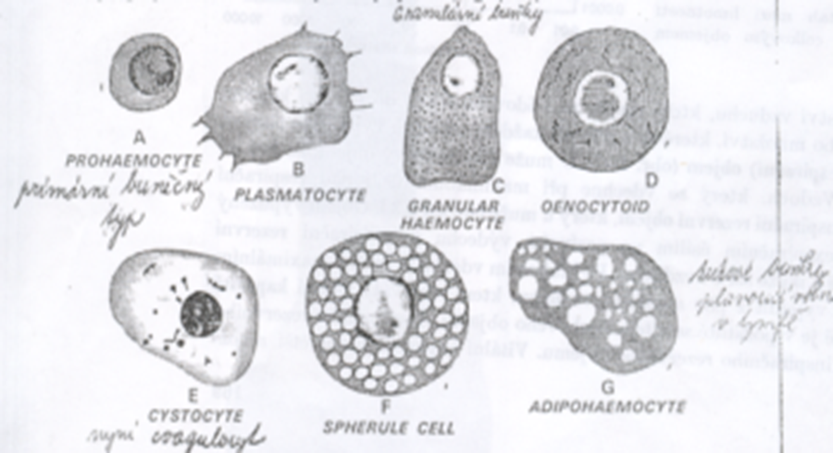

**Protocol**

**Monitoring of phagocytic abilities of hemocytes of** ***Galleria mellonella* larvae.**

**Theory:** The following types of hemocytes are found in hemolymph: prohemocyte, plasma cell, granulocyte, eonocytoid, coagulocyte, spherulocyte, adipohemocyte. In Galleria mellonella plasma and granulocyte hemocytes phagocytose microorganism or some material. The aim will be to learn to recognize hemocytes and observe their phagocytic activity.

**Aim:** Monitoring of phagocytic activity of hemocytes, calculation of phagocytic index and% phagocytosis

Material: ***Galleria mellonella***, starch grain solution, starch dilution: 15ml physiol. solution plus 0.25g starch, phenylthiourea, syringe - insulin, scissors, slides, staining solutions, eppendorfs, tips, adjustable micropipettes, microscope

**Method:**

1.Cut 1 leg of the larva and catch the escaping hemolymph with a drop on the slide and rub the drop and heat the coated glass (for heating)

From haemolymph drop - transfer 15 μl to an eppendorf tube containing phenylthiourea so that the hemolymph does not clot, add 7 μl of starch particle solution and let it cultivate together for 20 minutes

3.after culturing, drop of hemolymph on the slide in the same way and grind and heat the coated slide (in vivo method)

4. we inject 20 μl of a solution of inert particles into the next larvae, let the larvae cultivate in the heat for 20 min (do not stretch the larvae during the injection), (in vitro way)

5. After culturing the particles (starch) in the larva, cut off 1 leg of the larva and catch the flowing hemolymph with a drop on the slide and rub the drop and heat the coated glass.

6.coat stains with Leukodif staining system.

Result and evaluation: 1. We observe hemocytes (we draw and photograph at least three species) without phagocytosis and the same with phagocytosis. 2. Calculate the ratio of the amount of phagocytosed particles and the number of phagocytes and calculate the phagocytic index (FI) and the% of phagocytosis separately for phagocytosis with starch particles (in vitro method).

FI = (number of phagocytosed particles) / (number of phagocytic cells)

% phagocytosis = (number of phagocytic cells) / (total number of cells capable of phagocytosis in a given area) x 100

1. Smears are evaluated using the differential number of hemocytes, in which we denote as phagocytic only those particles that have absorbed 3 or more particles.

2. Calculate the phagocytic index FI by dividing the number of phagocytosed particles by the number of phagocytic cells.

3. Calculate the% phagocytosis by dividing the number of phagocytic cells in a given space by the number of all cells capable of phagocytosis and multiplying by 100.

**Evaluation example:**

|  |  |  |  |
| --- | --- | --- | --- |
| **plasmatocyte** | **granulocyte** | **unknown** | **summa** |
| 3 |  |  | 3 |
| 13, 12 | 1 |  | 3 |
| 3 |  |  | 3 |
|  |  |  |  |

**Table: numbers of phagocytic hemocytes in insect hemolymph smears**

**FI = number of phagocytosed particles / number of phagocytic cells = X**

**% F = number of phagocytic cells / number of cells capable of phagocytosis = x%**

**Experiment scheme**

|  |  |  |  |
| --- | --- | --- | --- |
| **METODA** | | **Without phagoc. (control)** | **Phagocytosis in vivo, in vitro** |
| larva | Hemolymph smear on  glass | drop on →  → spread, staining | 15 μl hemol with phenylthio + 7 μl (starch) → cultivation →  → spread, staining , |
|  |  |  | larva + 20 μl (starch) →  → 20 min cultivation →  → spread, staining |

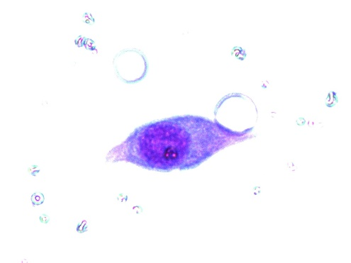 plasmocyte

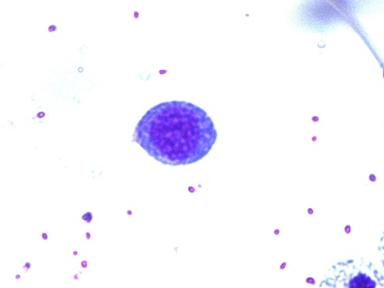 granulocyte

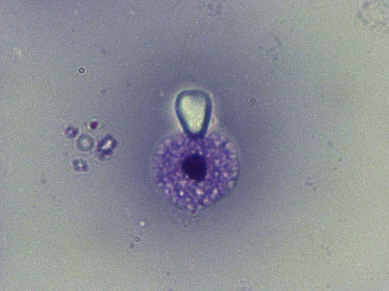 phagocytosis in vitro

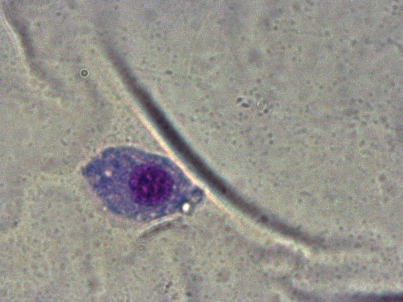 phagocytosis in vivo

Phagocytosis in vitro

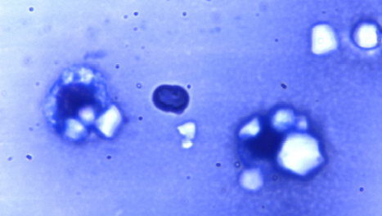

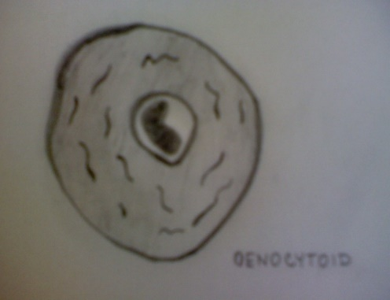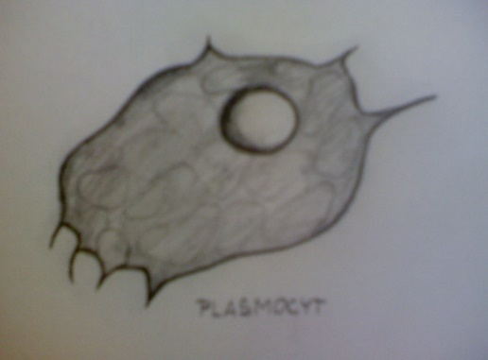

plasmocyt

oenocytoid