Preparation of blood serum from human blood

Theory:
Blood serum is obtained from the blood for quantitative and qualitative determination of various substances found in the serum and characterizing the current state of health of the individual (eg determination of immunoglobulins, C-reactive protein, complement components, acute phase proteins, autoantibodies against self-tissues, antibodies against microorganisms, hormones, etc.).

Task:
Preparation of human serum from blood for further processing for quantitative and qualitative determination of various substances, photos of cells, pattern

Tools:
Ajatin - desinfection, gloves, sterile spikes, micropipettes and tips, eppendorfs, labels, marker, centrifuge.

Workflow:
Gently and in gloves, we take sterile blood from the finger to the eppendorf tube, mark it with a label and put it in the refrigerator until the next day. The next day we carefully peel off the blood cake from the epin, then centrifuge at 1500 rpm for about 5-10 minutes, remove the yellowish fluid (ie serum, excreted on the surface of the resulting blood clotting), transfer to another eppendorf, we will label it and freeze it for use in the next exercise.

Blood differential of leukocytes
Task: finding the blood differential in human blood and a photo or picture of three representatives of white blood cells

Aids: staining cuvettes, Leukodif staining kit (Biolatest), slides, gloves, glass cleaning alcohol, blood smear, microscope, immersion lens, oil or glycerol

Design: Stain the blood smear with the Leukodif staining kit according to the instructions. Then, according to the scheme, we examine the blood smear and record the determined leukocyte counts in a table. After entering 100 leukocytes, we add up the individual columns to find out the percentage of individual leukocyte species. The blood smear contains the following blood elements: red (erythrocytes) and white (leukocytes) blood cells, and platelets (platelets).
Leukocytes are divided into granulocytes (neutrophil, eosinophil, basophil) and agranulocytes (monocyte, lymphocyte).
In a healthy individual, the result should be as follows:
leukocytes
(precurzor of neutrophil) | 1-2 %
neutrophil | 55-60 %
eozinophil | 2-3 %
bazophil | 0,5 %
monocyte | 5-7 %
lymfocyte | 30-40 %

The determined cell numbers are recorded in a special table (see below).
neutrophil | precurzor neutrophil | lymphocyte | monocyte | eosinophil | bazophil | unknown | summa
 |  |  |  |  |  |  | 10
 |  |  |  |  |  |  | 10
 |  |  |  |  |  |  | 10
 |  |  |  |  |  |  | 10
 |  |  |  |  |  |  | 10
 |  |  |  |  |  |  | 10
 |  |  |  |  |  |  | 10
 |  |  |  |  |  |  | 10
 |  |  |  |  |  |  | 10
 |  |  |  |  |  |  | 10
 |  |  |  |  |  |  | 100

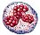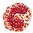

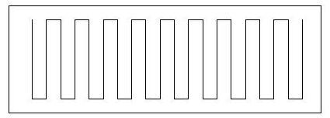
Preparation of blood serum from human blood

Theory:
Blood serum is obtained from the blood for quantitative and qualitative determination of various substances found in the serum and characterizing the current state of health of the individual (eg determination of immunoglobulins, C-reactive protein, complement components, acute phase proteins, autoantibodies against self-tissues, antibodies against microorganisms, hormones, etc.).

White blood cell counts are performed by shifting the fields of view according to this figure
The blood differential is determined during a routine examination of a person's state of health. Changes in the number of white blood cells can foreshadow a number of blood and other diseases for which these changes are typical.
Leucodif coloring method

Leukocytes:
eozionophil
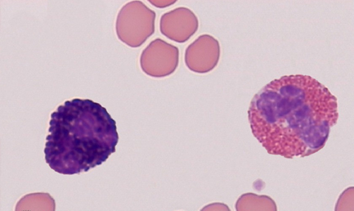 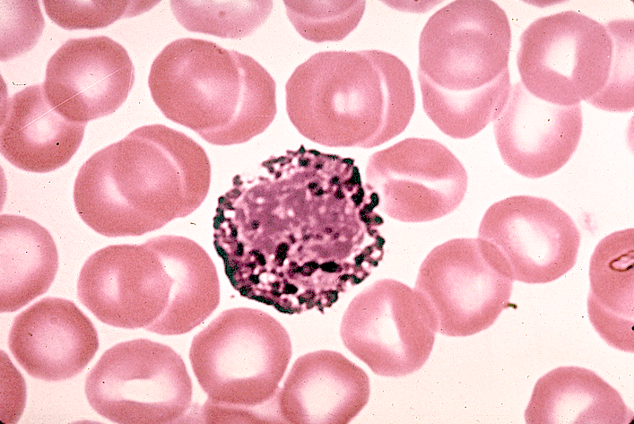 bazophil
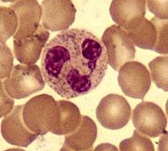 neutrophil
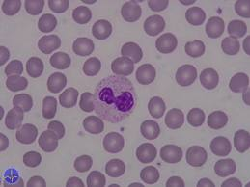 precursor neutrophil 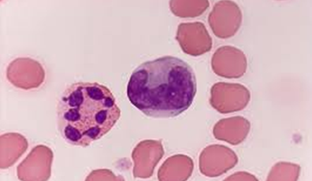 neutrophil, monocyte
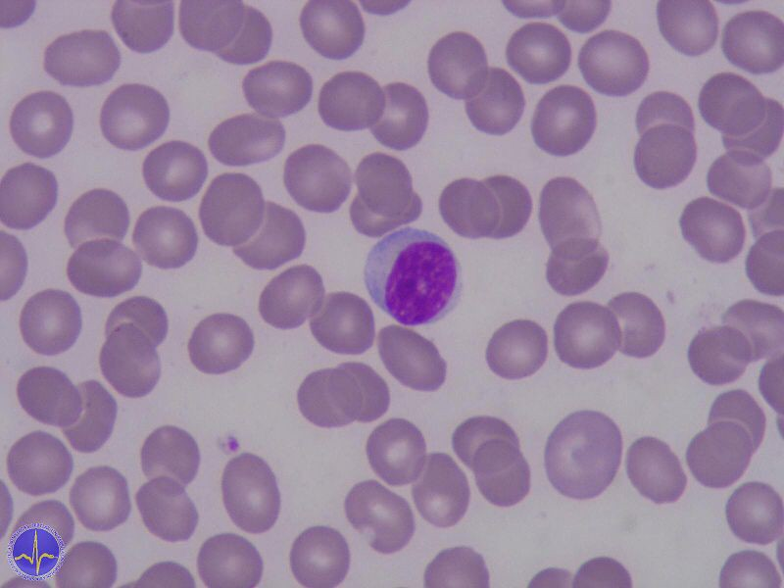 lymphocyte
literature http://www.google.cz/search?tbm=isch&hl=cs&source=hp&biw=1280&bih=571&q=bazofil&gbv=2&oq=bazofil&aq=f&aqi=g3gS7&aql=&gs_sm=s&gs_upl=1328l4406l0l6172l7l7l0l1l1l0l78l328l6l6l0#hl=cs&gbv=2&tbm=isch&sa=1&q=neutrofil&oq=neutro

