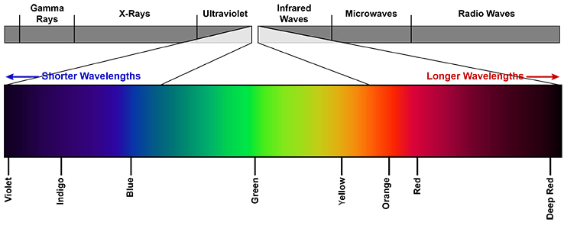

**Protocol 1**

**Model of HeLa 8 Fucci cells – measurement and analysis of the cell cycle using fluorescent proteins**



**Aims**

* the aim of the experiment is to understand the model cell line HeLa 8 Fucci, which allows the analysis of the cell cycle on living cells without the need for fixation and labeling
* the measurement will be done using BD FACS Verse flow cytometer
* a demonstration of data evaluation will be performed using the FlowJo program
* in addition to flow cytometry, we will also analyze cells on a confocal microscope after exposure to various substances

**Theory**

**Buněčná linie HeLa 8 Fucci**

* Cell line HeLa – human transformed cell line derived from cervical carcinoma
* The oldest and one of the most cited human cell lines
* Fucci probe (fluorescent ubiquitination-based cell cycle indicator) – allows visualization of cell cycle in the living cells
* Fucci cells in G1 phase are emitting red signal and cells in S/G2/M phase are emitting green signal
* check files in study materials for more informations

*(Sakaue-Sawano et al., 2008; see study materials)*

**1) FLOW CYTOMETRY ANALYSIS**

**Material**

* **HeLa 8 Fucci** cell line in culture
* **solution of PBS+EDTA** (ethylenediaminetetraacetic acid). EDTAje chelating agent that, among othes, absorbs Ca2+ ions, thereby disrupting intercellular junctions
* **trypsin** - pancreatic enzyme (serine protease), cleaves amide and ester bonds of arginine and lysine. The action of trypsin releases adherent cells from the culture surface
* non-sterile **medium with serum** - inactivation of trypsin
* **PBS** – for rinsing of the cell suspension

**Procedure:**

**Sample collection and preparation**

* aspirate the medium from the cells
* add 2 ml of PBS+EDTA – incubate for 1-2 minutes
* aspirate PBS+EDTA
* add 0.5 ml of trypsin - incubate in a thermostat (37°C) until the cells are released (approx. 1-2 minutes)
* add 2.5 ml medium with serum (trypsin inactivation)
* transfer the suspension to a test tube and rinse the dish with 1 ml of PBS, add the PBS to a test tube with the cell suspension
* centrifuge 200g for 5 minutes
* aspirate the supernatant
* resuspend the pellet in 1 ml of PBS
* centrifuge 200g 5 min
* aspirate the supernatant
* resuspend the pellet in 300 ul PBS and measure

**Results**

**Describe the cell cycle measurement procedure + attach the measurement results obtained by evaluating in the FlowJo program2) CONFOCAL MICROSCOPY ANALYSIS**

**Procedure:**

**Day 1:** **Seeding of HeLa 8 Fucci cells for microscopic analysis**

**Day 2: Treatment with inhibitors**

**MLN-4924** (stock concentration 10 mM, final concentration 1 µM)

**TRAIL**  (100 ug/ml stock concentration, 50 ng/ml final concentration)

**Mitomycin** (stock concentration 1 mg/ml, final concentration 1 µg/ml)

**Complete the notes on TRAIL and Mitomycin (what they are, what they cause and what they are used for, see notes for MLN-4924 in protocol #2)**

**Calculate the amount of substances that will be added to the cells (In total = 300uL)**

**Day 3: Analysis of cells on the microscope**

**Describe the microscopic analysis procedure and the changes you observed in the cells affected by the inhibitors**



**Protocol 2**

**Detection of proliferation, cell cycle and viability in DU145 cella after treatment with inhibitor of neddylation**



**Aims:**

* Treat the prostate cancer cell line DU-145 with inhibitor of neddylation (MLN-4924 – **0,11uM**) and analyse the effect on cell cycle, proliferation and viability of cancer cells with click-iT reaction
* Measeure the click-iT reaction on Attune Classic Flow Cytometer

**Theory:**

**MLN-4924 (Soucy et al., 2010)**

* Is an ATP competitive inhibitor
* In Phase I. of clinical testing for lymphoma, multiple myeloma, acute myeloid leukemia, acute lymphocytic leukemia, melanoma and other non-hematological tumors
* MLN-4924 forms a very stable aduct with NEDD8, which blocks the process of neddylation.
* Neddylation is crutial step for ubiquitin ligaze Skp2SCF activation involved in cell cycle regulation
* ubiquitin ligaze Skp2SCF targets its substrates (p21, p27, Ctd1) for proteasomal degradation, regulation of DNA replication and cell cycle progression.
* Treatmnet with MLN-4924 for 24 hours blocks the neddylation, subsequently the ubiquitination of substrates which leads to cell cycle arrest in G2/M phase, re-replication and inhibition of cancer cells proliferation

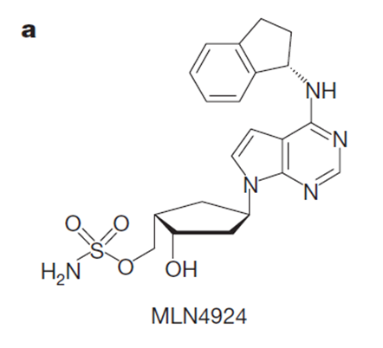

**Figure 1:** Structure of inhibitor MLN-4924. (Soucy et al., 2009 Nature)

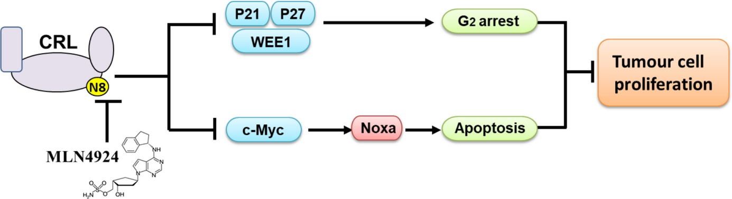

**Figure 2:** Scheme of MLN-4924 action in blocking the neddylation and proliferation process. (Wenjuan Zhang et. al., 2018, Cell proliferation)

**ANALYSIS OF CELL CYCLE AND PROLIFERATION WITH CLICK iT REACTION**

**Material**

* Cell line DU-145 (control and treated cells)
* PBS/EDTA solution
* trypsin
* non-sterile medium with serum – inactivation of trypsin
* non-sterile FACS tubes, pipette tips, pipettes
* PBS + 1% BSA
* Live Dead Fixable stain kit Red
* Edu click-iT AF488 kit (Molecular Probes C10420)
* Fx cycle Violet (Theromofisher Scientific F10347)

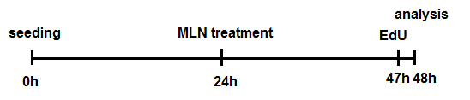

**Figure 3:** Experimental design.**Protocol**

**1. Samples collection and preparation**

* Aspire medium from dishes
* Add 3 ml PBS+EDTA, incubate 2 min at RT
* Aspire PBS+EDTA
* Add 0,5 ml of trypsin, incubate at 37oC for 2 min (cells must detache from plastic)
* Add 2,5 ml non-sterile medium with serum – Trypsin inactivation
* Centrifuge at 200 x g for 5 min, discart the supernatant

**2. Viability staining**

* Dilute Live Dead Fixable stain kit Red in PBS (1:1000)
* add 100 µl/sample, incubate for 15 min at 4°C
* wash with 1 ml of PBS + 1% BSA
* Centrifuge at 200 x g for 5 min, discart the supernatant

**3. Fixation**

* Resuspend the cells in 100 µl 4% PFA (in fume hood)
* incubate for 15 min at RT in dark
* wash with 1 ml of PBS + 1% BSA
* Centrifuge at 200 x g for 5 min, discart the supernatant

**4. Permeabilisation**

-Resuspend the cells in 100 µl of 0,15% Triton X-100

* incubate for 15 min at RT in dark
* wash with 1 ml of PBS + 1% BSA
* from each sampl pipette 250 µl into new FACS tube and label it as ISO control
* Centrifuge at 200 x g for 5 min, discart the supernatant

**5. Click-iT reaction**

* prepare click-iT reaction according to table bellow
* add 125 µl of the reaction/sample and 125 µl of the PBS/ ISO control sample
* incubate for 30 min at RT in dark
* into all tubes add 1 ml PBS + 1% BSA
* Centrifuge at 200 x g for 5 min, discart the supernatant

|  |  |
| --- | --- |
|  | 1 reaction |
| PBS | 109,5 μl |
| CuSO4 | 2,5 μl |
| Fluorescent dye azide | 0,625 μl |
| Reaction buffer additive (diluted 10x) | 12,5 μl |
| Total reaction volume | 125 μl |

**6. Cell cycle staining**

* Dilute the Fx cycle staining dye in PBS (1:1000) and RNAse (1:1000)
* add 500 µl/all samples
* incubate for 30 min at RT in dark

**Results**

**Describe the workflow of measurement and analysis of cells on flow cytometer (Attune Classic). Attach the analysed data from FlowJo and comment the observed results.**



**Protocol 3**

**Immunophenotyping of Human blood**



**Aim**

* The aim of the experiment is to determine the particular populations of blood cells based on granularity, size and the expression of typical surface markers.
* In the case of neutrophil granulocytes, we will determine their activation status after stimulation with G-CSF (granulocyte colony stimulating factor), which is proinflammatory cytokine typically activation myeloid cells.
* The samples will be measured on the spectral flow cytometer SONY SP6800 and the data will be analysed using FlowJo software.

**Theory**

* Immunophenotyping is the analysis of heterogeneous populations of cells within human blood for the purpose of identifying the presence and proportions of various cell populations.
* This identification is based on the detection of the expression of selected surface CD antigens (markers) using fluorescently labelled monoclonal antibodies specific against antigens expressed by these cells. Typically, these markers are essential for the proper function of the cell (cell communication, adhesion, metabolism, etc.).
* The main cell populations can be divided based on the light scattering. The forward scatter (FSC) is proportional to the size of the cell and side scatter (SSC) to the cell granularity (Obr. 1).
* This method is used research as well as in clinical laboratories for the diagnosis of hematological malignity.

**Tab. 1:** Frequency of human cell populations in the peripheral blood.

|  |  |
| --- | --- |
| **Cell type** | **Frequency (%)** |
| T lymphocytes | 10-25 |
| B lymphocytes | 3-10 |
| Granulocytes (eos, bas, neu) | 45-65 |
| Monocytes | 3-10 |
| NK cells | 2-5 |
| Dendritic cells (DC) | 0.5-1 |
| Stem cells | 0.01-0.05 |

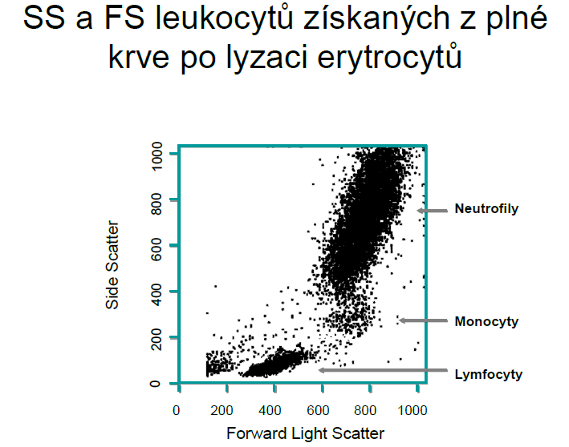

**Obr. 1:** FSC and SSC of leukocytes from the blood after erythrocyte lysis

**Procedure**

1. The blood of healthy donor will be drawn by a nurse in a presence of anticoagulant (40 μL of heparin/1 mL of blood)
2. Divide the blood sample into half, one half will be stimulated for at least 120 min with G-CSF (1 μg/mL)
3. Prepare mix of antibodies – see Tab. 2
4. After incubation, add 100 µL of cell suspension into each flow tube (2x tubes with unstained cells + 1x isotype + 2x stained cells)
5. Fix cells in the tube with 3.2% formaldehyde 1:1 for 10 min, RT
6. Next, lyse erythrocytes with 4 mL dH20, 5 min, RT
7. Spin tubes with prepared suspensions (350 x g, RT, 5 min) and resuspend in 120 μL of PBS with 1% FBS
8. Add mix of antibodies into tubes marked as 2, 3 and 4 - incubate 15-20 min on the ice
9. Wash cells in 4 mL of PBS
10. Spin tubes (350 x g, RT, 5 min) and resuspend in 150 μL of PBS, store on the ice
11. FACS analysis

|  |  |  |  |  |  |  |
| --- | --- | --- | --- | --- | --- | --- |
| **Tube no.** | **CD marker** | **Fluoro-chrome** | **Cell population** | **dilution** | **Cat. no.** | **Excitation/ emission (nm)** |
| 1A (bez G-CSF) | unstained ctrl | --- | --- | --- | --- | --- |
| 1B (G-CSF) | unstained ctrl | --- | --- | --- | --- | --- |
| 2 (bez G-CSF) | Isotype | PerCP | --- | 1:40 | 2603150 | 482/675 |
| Isotype | PE | --- | 1:50 | 2600565 | 496/578 |
| Isotype | PE/Cy7 | --- | 1:50 | 2600630 | 496/785 |
| Isotype | APC/Cy7 | --- | 1:50 | 2600635 | 650/785 |
| Isotype | APC | --- | 1:50 | 2600705 | 650/660 |
| 3 (bez G-CSF) | CD11b | PerCP | Neutrophils - activation | 1:40 | 1106150 | 482/675 |
| CD3 | PE | T lymphocytes | 1:50 | 2324030 | 496/578 |
| CD4 | PE/Cy7 | Helper  T lymphocytes | 1:50 | 2102560 | 496/785 |
| CD8 | APC/Cy7 | Cytotoxic  T lymphocytes | 1:50 | 2323570 | 650/785 |
| CD19 | APC | B lymphocytes | 1:50 | 2111060 | 650/660 |
| 4 (G-CSF) | CD11b | PerCP | Neutrophils - activation | 1:40 | 1106150 | 482/675 |

**Tab. 2:** Antibodies for FACS (all SONY Biotechnology).

**Results**

**Describe the procedure of measurement and gating of particular populations + attach results analyzed in the FlowJo software.**