Article Summary

In this assignment, you will be asked to write an analytical summary of a short scientific article.

**1 Choose one article** that is close to your interests from one of the following websites or any other source of your choice:

[EurekAlert](https://www.eurekalert.org/) : All disciplines

<https://www.mdpi.com/journal/mathematics>: Mathematics

If you are not able to find an article you would be interested in on the websites listed above, find an article of similar length from another source of identical academic quality as those suggested here

**2 Include the link** to the article into the summary you will submit

**3 Write an analytical summary** of the article by answering the questions in the box. Keep the structure of the summary as suggested in the box (structure your summary into 3 paragraphs):

|  |
| --- |
| 1st Paragraph:  1 What is the topic of the article? (For example - Alzheimer’s disease)  2 What do you already know about the topic and why is it important?  2nd Paragraph:  3 What is the specific problem of the article? (For example - the relationship between Alzheimer’s disease and obesity)  4 What did the author find? And how did they find it?  5 What details or points support the main idea? Give one or two examples of the supporting points from the article  3rd Paragraph  6 How do the results of this article relate to your research interest?  7 What other articles or authors should you read to learn more about this topic? (optional, you can skip this one if you want) |

Your summary should be **200-300 words** long

Writing Strategies

Put the ideas from the article **into your own words**. Do not change the terminology but avoid copying phrases and sentences from the article.

Use some **linking words** to connect your ideas.

Make sure that each paragraph logically follows from the preceding paragraph. Make sure that there is some sort of **logical connection between the last sentence of the preceding paragraph and the first sentence of the following paragraph**.

Reading Strategies

Before writing your summary you should read the article **more times (twice is the minimum)**

You can highlight, circle and otherwise mark the most relevant information while you read

After writing your summary

1 Re-read the summary and correct any obvious mistakes

2 Read your summary aloud and fix anything that does not sound good or natural

3 Use spell check to avoid spelling mistakes

**Some useful phrases:**

The article **articulates** some of the reasons … His research **suggests** that ...

The article **examines** The article **provides** explanations

His **analysis suggests** that His research **has addressed the question of**

Recent experiments **indicate** that Research **supports this theory**

**Other research** indicates that His article **shows** that

These **findings suggest** that The author **argues** that

The author **implies** that **In conclusion**, Johnson elaborates on …

The author **criticizes** … **According to Johnson**, …

For more useful verbs, see below

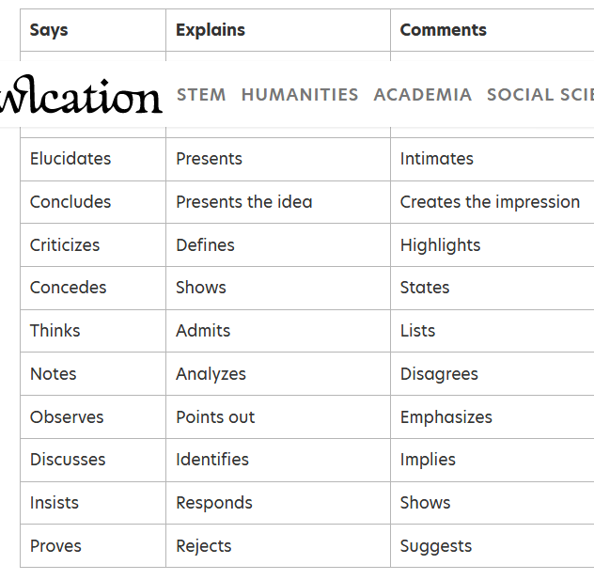

More info: <https://owlcation.com/academia/How-to-Write-a-Summary>